Table of Contents
Intersection Tutorials 2
Tutorial: Creating Intersections 3
Exercise 1: Creating a Peer Road Intersection 4
Exercise 2: Creating a Primary Road Intersection with Turn Lanes 13
Exercise 3: Creating an Intersection with Existing Geometry 17
Tutorial: Editing Intersections 25
Exercise 4: Editing the Horizontal Geometry of an Intersection 26
Exercise 5: Editing the Vertical Geometry of an Intersection 33
Exercise 6: Creating and Editing a Corridor in the Intersection Area 41

Intersection Tutorials
These tutorials will get you started working with intersections.
Intersections
An intersection object is created from two intersecting alignments that have design profiles. During the intersection creation process, alignments and profiles are automatically generated for the offset and curb return geometry. The horizontal and vertical geometry of the offsets and curb returns is dynamically linked to the intersection object. When changes are made to the centerline alignments or profiles, the offset and curb return geometry is automatically updated.
Note:
All drawings used in these tutorials are available in the tutorials drawings folder. If you want to save your work from these tutorials, save the drawings to the My Tutorial Data folder so that you do not overwrite the original drawings.
Topics in this section
- Tutorial: Creating Intersections
This tutorial demonstrates how to create several types of intersections.
- Tutorial: Editing Intersections
This tutorial demonstrates how to modify an existing intersection object.

Tutorial: Creating Intersections
This tutorial demonstrates how to create several types of intersections.
You will create two basic types of intersections, which differ in how the intersecting road crowns are blended:
- In a peer road intersection, the crowns of both roads are maintained. The primary road centerline profile is maintained, and a locked PVI is created on the secondary road centerline profile where it intersects with the primary road centerline. The pavement of both roads is blended into the curb returns.
- In a primary road intersection, the primary road crown is maintained. The primary road centerline profile is maintained, and a locked PVI is created on the secondary road centerline profile where it intersects with the primary road centerline. Two additional locked PVIs are created on the secondary road centerline profile at the primary road edges of pavement. The primary road cross-slope is maintained, and the secondary road pavement is blended from the primary road edges of pavement along the secondary road pavement edges.
You will also experiment with curb return widening parameters, which are used to create turn lanes.
For information on adding widening regions to offset alignments that are outside the intersection area, see the Adding a Widening to an Offset Alignment exercise.
Topics in this section
- Exercise 1: Creating a Peer Road Intersection
In this exercise, you will create a three-way intersection and generate a corridor that maintains the crowns of both roads.
- Exercise 2: Creating a Primary Road Intersection with Turn Lanes
In this exercise, you will create an intersection with entry and exit turn lanes at the primary road. The secondary road crown will blend into the primary road edge of pavement.
- Exercise 3: Creating an Intersection with Existing Geometry
In this exercise, you will use the existing offset alignments and profiles of the primary road to create an intersection, and then add the new intersection to the existing primary road corridor.

Exercise 1: Creating a Peer Road Intersection
In this exercise, you will create a three-way intersection and generate a corridor that maintains the crowns of both roads.
To create a complete intersection model, you must have a centerline alignment and profile for each of the intersecting roads. The horizontal and vertical geometry for the remaining elements, including the offsets and curb returns, is generated based on the parameters you specify.
In a peer road intersection, the crowns of all intersecting roads are held at a common grade. The pavement for both roads is blended into the curb return regions, which form the transitions between the intersecting roads.
The drawing for this exercise contains a corridor along each of the intersecting roads. Each corridor is made up of a corridor assembly and a centerline alignment and profile.
At the end of the exercise, the drawing also will contain the following elements:
- An intersection object
- Two curb return alignments and profiles
- Four offset alignments and profiles (two for each centerline alignment)
- Several new corridor regions
- Corridor assemblies for each region of the intersection
Specify the intersection location
- Open Intersection-Create-1.dwg, which is located in the tutorials drawings folder.
- Click Home tab Create Design panel Intersections drop-down Create Intersection .
- In the drawing, click the intersection point of the two alignments.
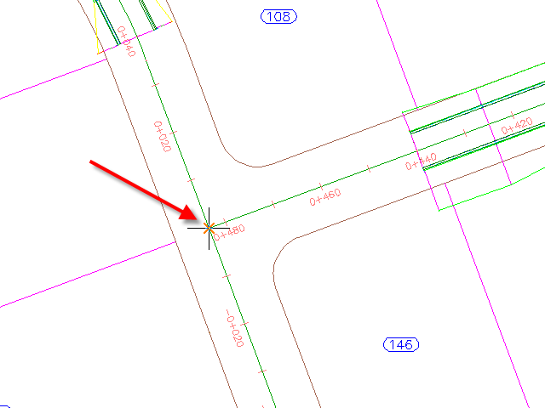
Specify the corridor grade parameters
- In the Create Intersection wizard, on the General page, under Intersection Corridor Type, select All Crowns Maintained.
- Click Next.
Specify the geometry of the offsets and curb returns
- On the Geometry Details page, click Offset Parameters.
Default parameters are stored in the drawing settings. You can modify the default parameters during the intersection creation process.
- In the Intersection Offset Parameters dialog box, specify the following parameters:
  - Secondary RoadLeft Offset Alignment DefinitionOffset Value: 3.5000
  - Secondary RoadRight Offset Alignment DefinitionOffset Value: 3.5000
  - Create New Offsets From Start To End Of Centerlines: Cleared
When this option is selected, offset alignments are created along the entire length of the centerline alignment. This option is useful when you need to use offset alignments and profiles as targets for other objects, including other intersections along the same road.
- Click OK.
- On the Geometry Details page, click Curb Return Parameters.
- In the Intersection Curb Return dialog box, under Curb Return Parameters, specify the following parameters:
  - Curb Return Type: Circular Fillet
  - Radius: 7.5
Note:
In the drawing, temporary graphics highlight the currently selected curb return.
- Right-click Curb Return Parameters. Click Copy These To All Quadrants.
This command copies the curb return parameters to all intersection curb return regions. The number of curb return regions is automatically generated based on the existing horizontal geometry. For example, if this was a four-way intersection, four curb return regions would be available.

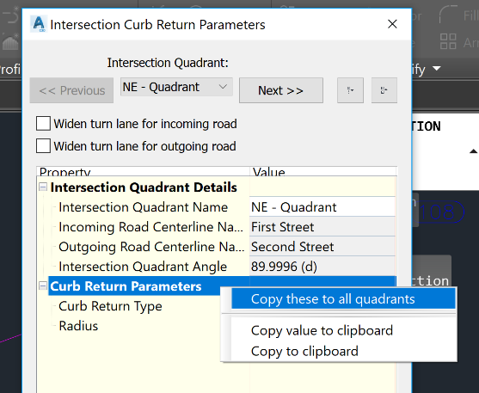
- Click OK.
- In the Create Intersection – Geometry Details wizard, under Offset And Curb Return Profiles, Select Create Offset And Curb Return Profiles.
To produce a complete corridor model of the intersection, it is necessary to create profiles for the offset alignments and curb return alignments. For this exercise, you will accept the default offset and curb return profile settings.
- Click Next.
Specify the corridor parameters
- On the Corridor Regions page, specify the following options:
  - Create Corridors In The Intersection Area: Selected
  - Add To An Existing Corridor: Selected, Second Street
  - Select Surface To Daylight: EG
- Under Select Assembly Set To Import, click Browse.
- In the Select Assembly Set File dialog box, navigate to the tutorial folder.
- Select Intersection-Assembly-Set_All Crowns.xml. Click Open.
An assembly set enables you to quickly import a group of existing corridor assemblies, and then apply them to specific section types.
- Click Create Intersection.
The intersection is created, and new corridor regions are created in the intersection area.
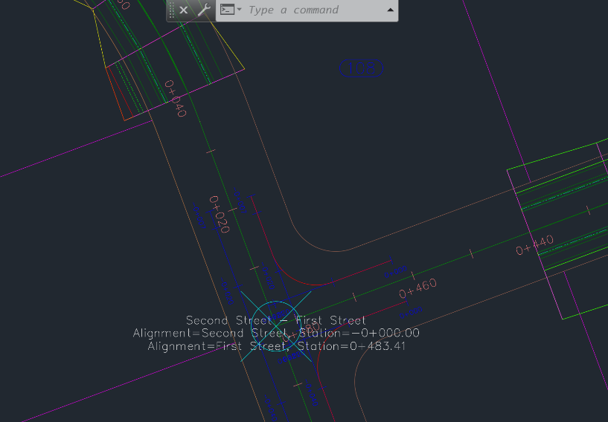
Examine the new objects
- In Toolspace, on the Prospector tab, expand the Alignments collection.
New alignments collections are available.

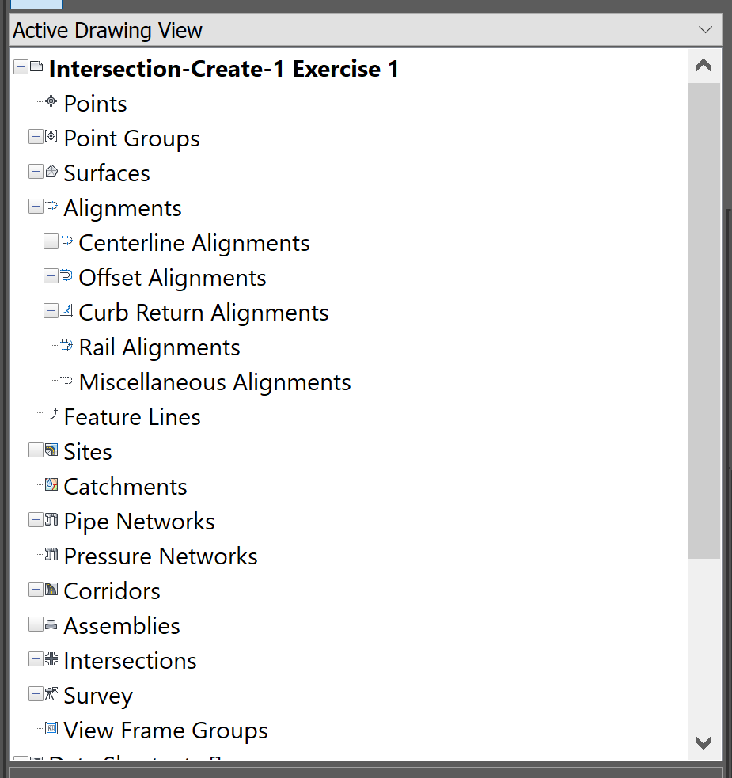
- Under Alignments, expand the Centerline Alignments, Offset Alignments, and Curb Return Alignments collections.
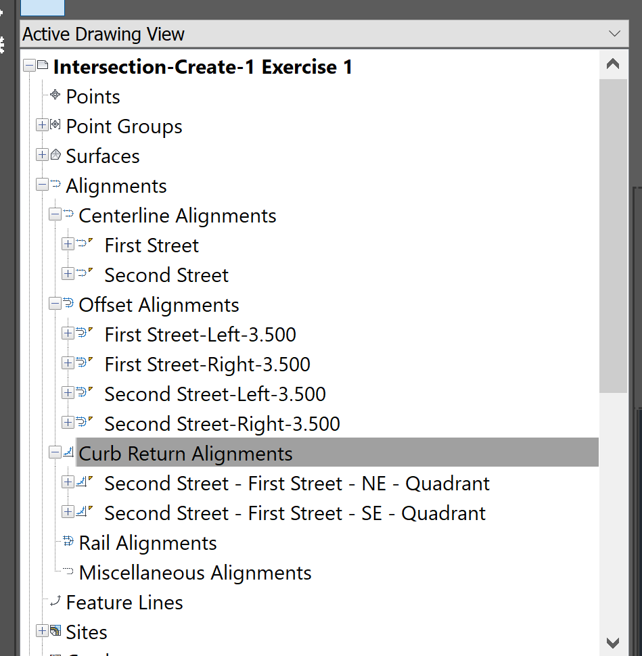
At the beginning of this exercise, only Centerline Alignments existed. The Offset Alignments and Curb Return Alignments were created using the parameters that you specified in the Create Intersection wizard.
Note:
In the drawing, the offset alignments and station labels are blue, and the curb return alignments are red.
- Under Offset Alignments, expand the First Street-Left-3.500Profiles collection.
Layout profiles for the Offset Alignments and Curb Return Alignments were created using the parameters that you specified in the Create Intersection wizard.
Closing gaps in the corridor
- In the drawing space, select the corridor in the intersection area.
Slider grips are displayed at the start and end stations of the corridor regions.

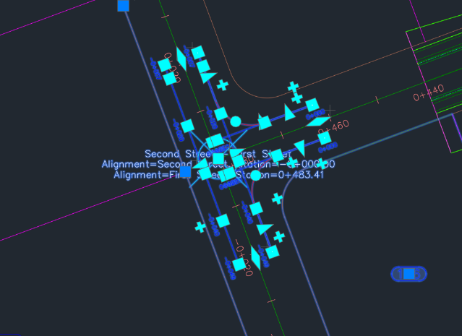
- Click Home Modify Corridor tab Modify Region panel Copy Region .
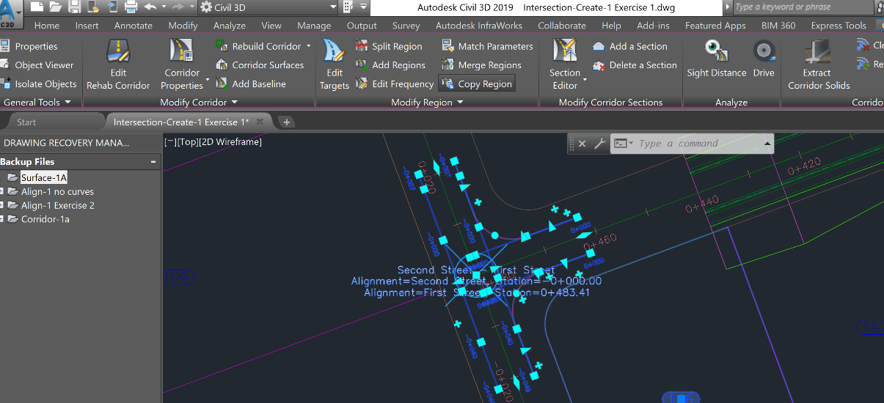
- Select the portion of the Second Street corridor loops around the site.
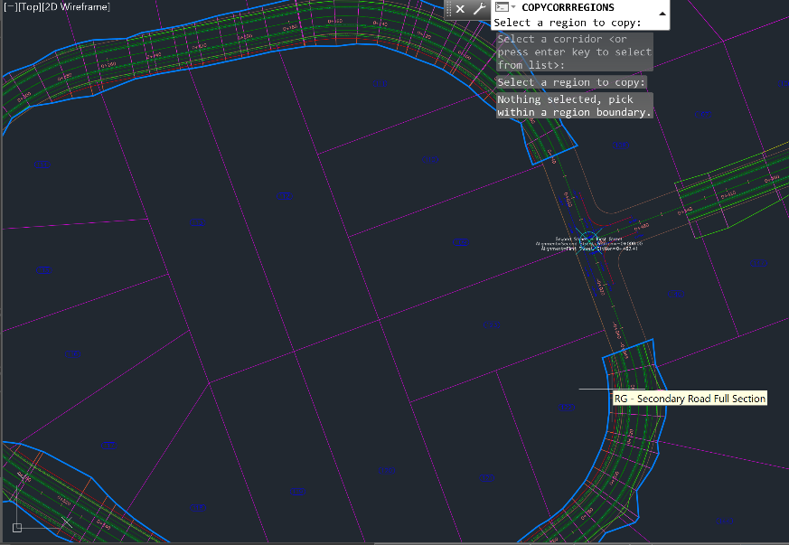
- On the command line, enter F to fill a gap in the corridor.
- Move the cursor toward the gap in the corridor.
A red graphic indicates that the gap may be filled.

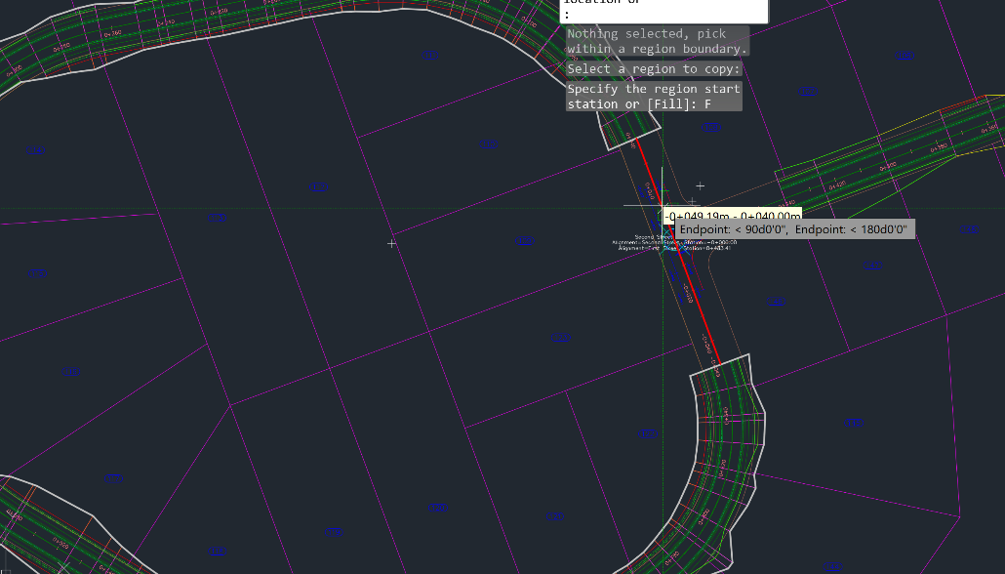
- Click when the red graphic is visible.
The gap is filled.

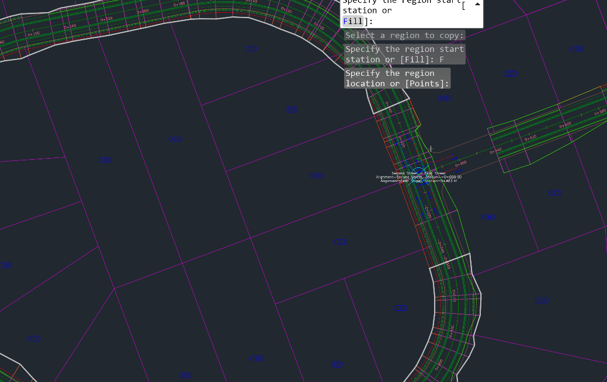
- Press Enter to end the command.
- Repeat step 2-8 to close the other gap in the Second Street
- From the Rebuild Corridor Drop Down Menu Rebuild Corridor
The corridor rebuilds, eliminating the gaps.
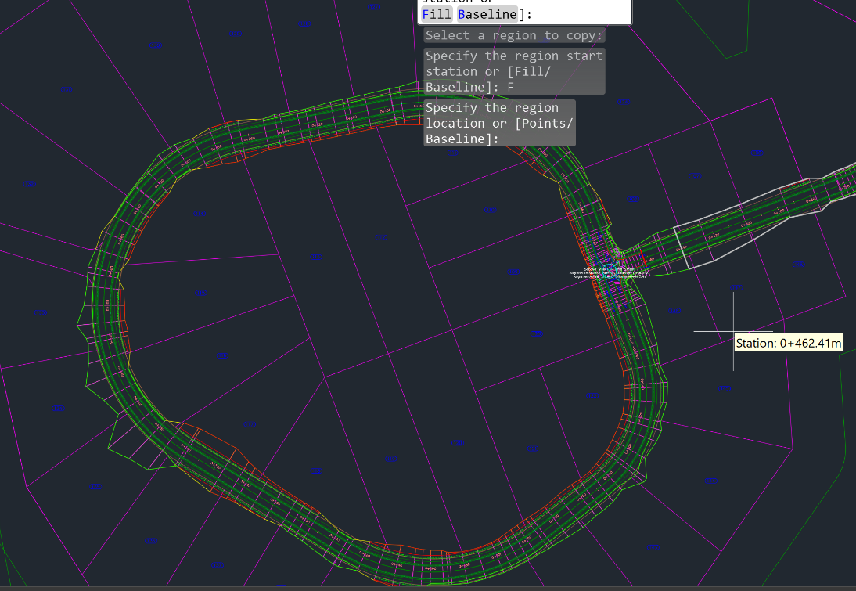
- Select the First Street corridor.

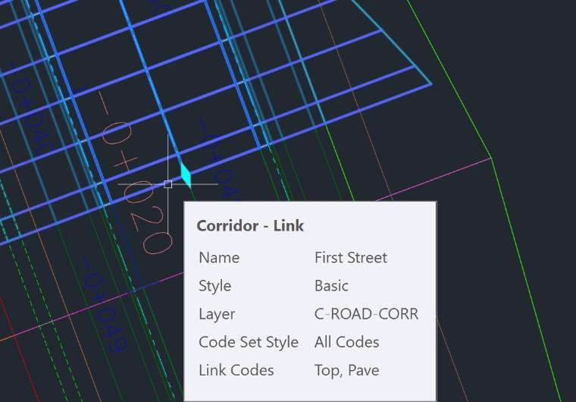

Select the grip at Station 0+449. It turns red.
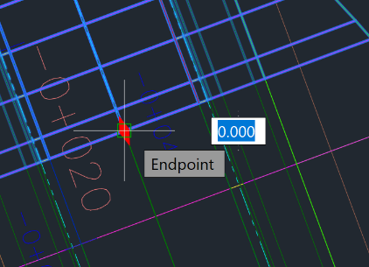

- Drag the grip to Sta. 0+025.00. Click to place the grip at this point.
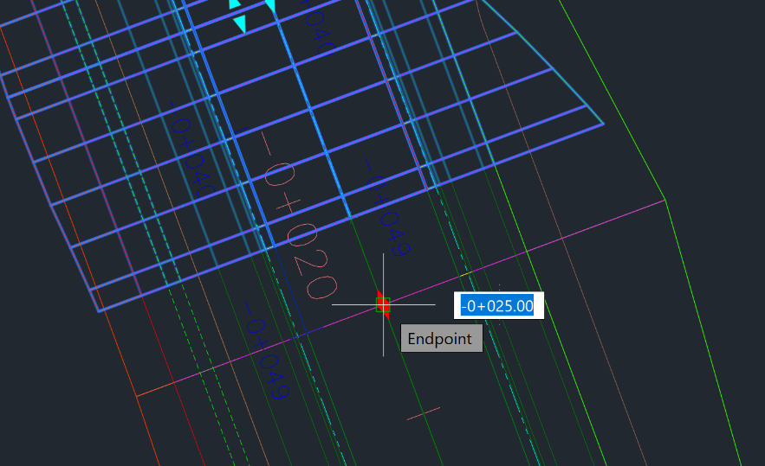

The corridor rebuilds, eliminating the gaps between it and the intersection.

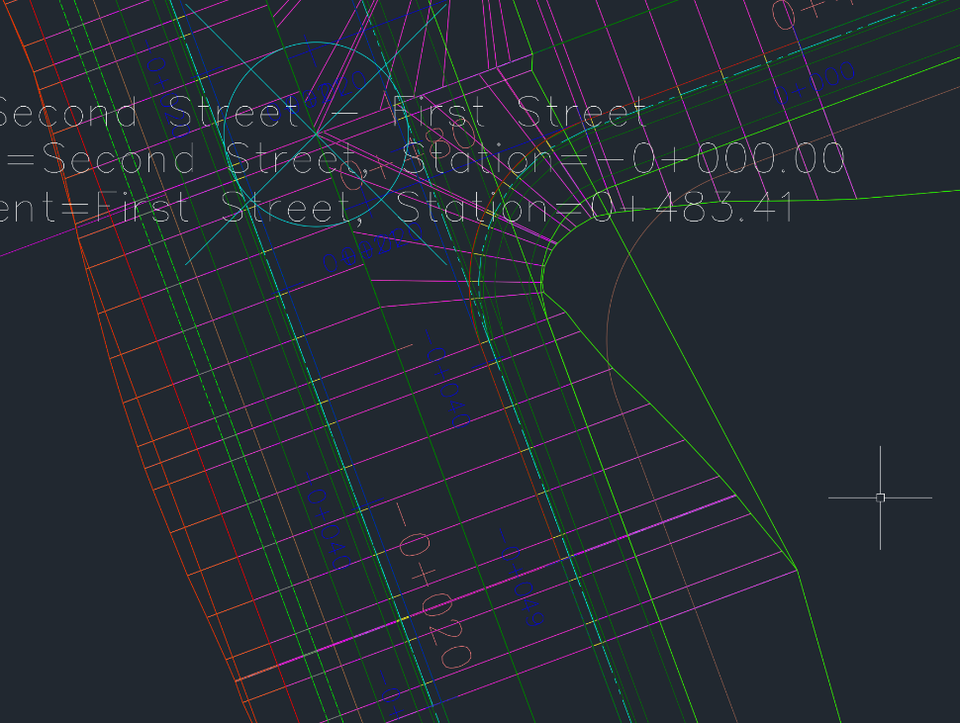

To continue this tutorial, go to Exercise 2: Creating a Primary Road Intersection with Turn Lanes.
Parent topic: Tutorial: Creating Intersections
Save this file as Intersection-Create-1 Exercise 1 Lastname Firstname.dwg and submit to Canvas

Exercise 2: Creating a Primary Road Intersection with Turn Lanes
In this exercise, you will create an intersection with entry and exit turn lanes at the primary road. The secondary road crown will blend into the primary road edge of pavement.
You can use the workflow that is demonstrated in this exercise to create an intersection with any combination of turn lanes at the curb returns.
Specify the intersection location and primary road
- Open Intersection-Create-2.dwg, which is located in the tutorials drawings folder.
- Click Home tab Create Design panel Intersections drop-down Create Intersection .
- In the drawing, click the intersection point of the Road A and Road B alignments.
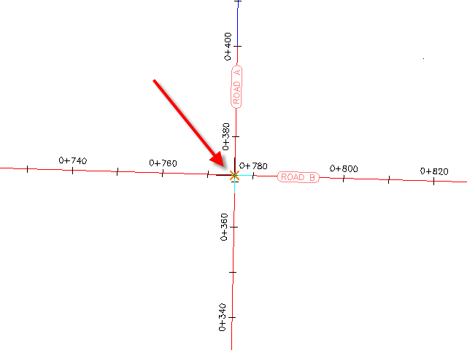
- Click the Road A alignment to specify it as the primary road.
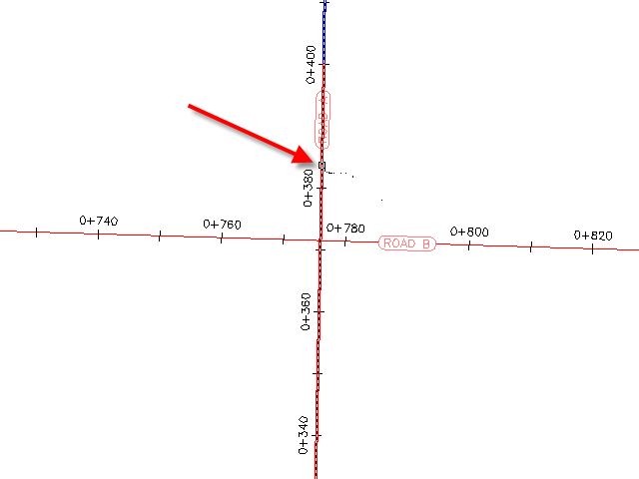
Specify the corridor grade parameters
- In the Create Intersection wizard, on the General page, under Intersection Corridor Type, select Primary Road Crown Maintained.
- Click Next.
Specify the horizontal and vertical geometry parameters
- On the Create Intersection Geometry Details page, click Offset Parameters.
Default horizontal and vertical geometry parameters are stored in the drawing settings. You can modify the default parameters during the intersection creation process.
- In the Offset Parameters dialog box, specify the following parameters:
  - Primary RoadLeft Offset Alignment DefinitionOffset Value: 6.0000
  - Primary RoadRight Offset Alignment DefinitionOffset Value: 6.0000
  - Secondary RoadLeft Offset Alignment DefinitionOffset Value: 3.0000
  - Secondary RoadRight Offset Alignment DefinitionOffset Value: 3.0000
  - Create New Offsets From Start To End Of Centerlines: Selected
- Click OK.
- On the Geometry Details page, click Curb Return Parameters.
The default parameters for the first intersection quadrant are displayed in the Intersection Curb Return Parameters dialog box. In the drawing, the first quadrant is highlighted, and arrows indicate the direction of incoming and outgoing traffic.
Note:
If you cannot see the temporary graphics, move the dialog box.
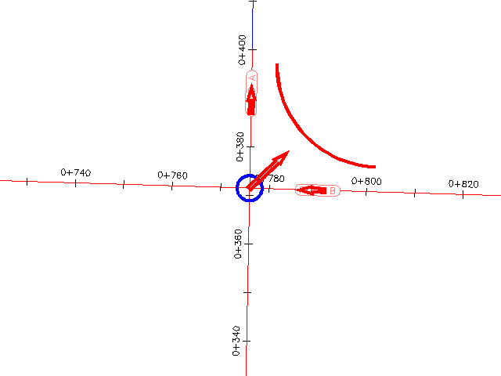
- In the Intersection Curb Return Parameters dialog box, select the Widen Turn Lane For Outgoing Road check box.
The Widening Details At Outgoing Lane parameter collection is displayed in the property tree. When you highlight a property, the preview graphic at the bottom of the dialog box updates to illustrate the property in a typical intersection. Examine the default values that have been specified for this drawing, but do not change any of them.
- Click Next.
- For SE - Quadrant, select the Widen Turn Lane For Incoming Road check box.
- Click Next.
- For SW - Quadrant, select the Widen Turn Lane For Outgoing Road check box.
- Click Next.
- For NW - Quadrant, select the Widen Turn Lane For Incoming Road check box.
- Click OK.
- In the Create Intersection – Geometry Details wizard, make sure that the Create Offset And Curb Return Profiles check box is selected.
- Click Next.
Specify the corridor parameters
- On the Corridor Regions page, specify the following options:
  - Create Corridors In The Intersection Area: Selected
  - Create A New Corridor: Selected
  - Select Surface To Daylight: Existing Ground
- Select _Autodesk (Metric) Assembly Sets.xml. Click Open.
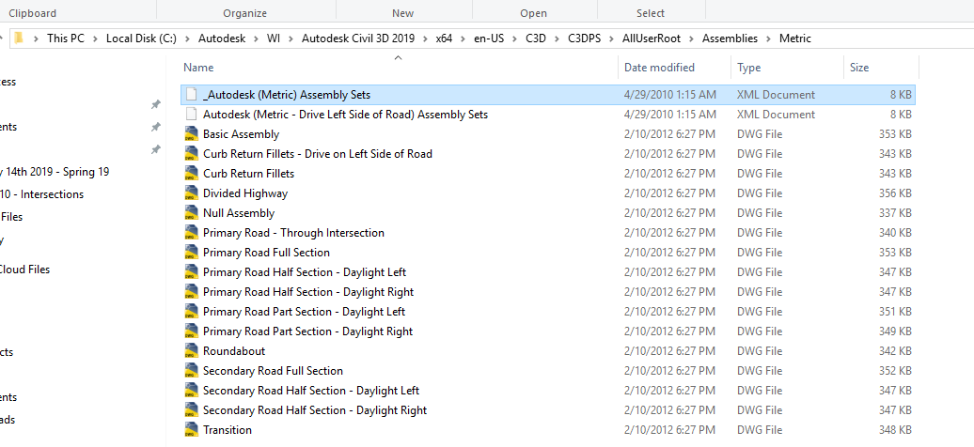
- Click Create Intersection.
The intersection is created, and new corridor regions are created in the intersection area. Notice that the curb returns have widening regions to allow traffic to exit from and merge onto Road A.
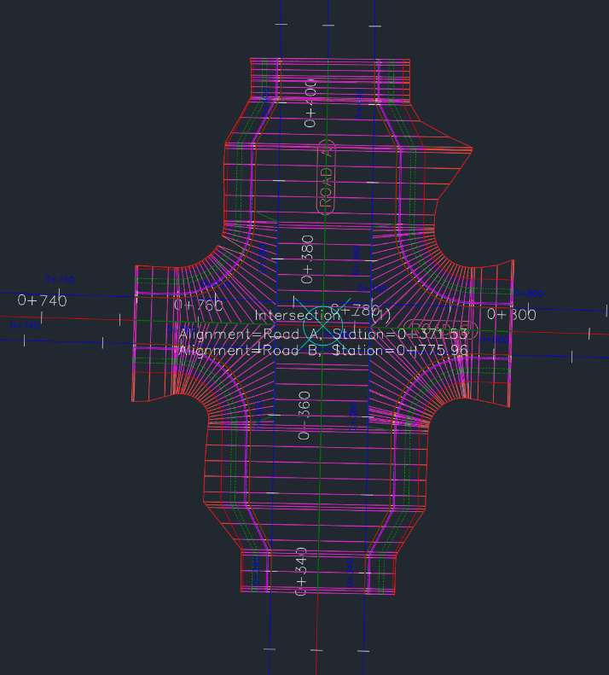

Save this file as Intersection-Create-2 Exercise 2 Lastname Firstname.dwg and submit to Canvas
To continue this tutorial, go to Exercise 3: Creating an Intersection with Existing Geometry.
Parent topic: Tutorial: Creating Intersections

Exercise 3: Creating an Intersection with Existing Geometry
In this exercise, you will use the existing offset alignments and profiles of the primary road to create an intersection, and then add the new intersection to the existing primary road corridor.
The workflow that is demonstrated in this exercise is useful when you need to create several intersections along a single corridor. You define the offset geometry for the primary road, and then reuse it for subsequent intersections.
Specify the intersection location and primary road
- This exercise continues on Intersection-Create-2.dwg, with modification you made earlier.
This drawing contains an intersection of two alignments, Road A and Road C. Offset alignments exist on either side of Road A, and there is an existing intersection north of Road C.
- Click Home tab Create Design panel Intersections drop-down Create Intersection .
- In the drawing, click the intersection point of the Road A and Road C alignments.
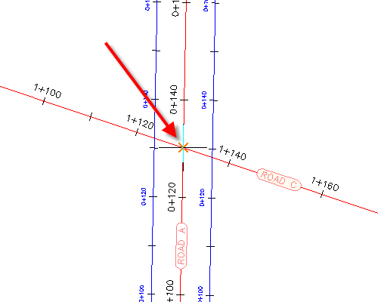
- Click the Road A alignment to specify it as the primary road.
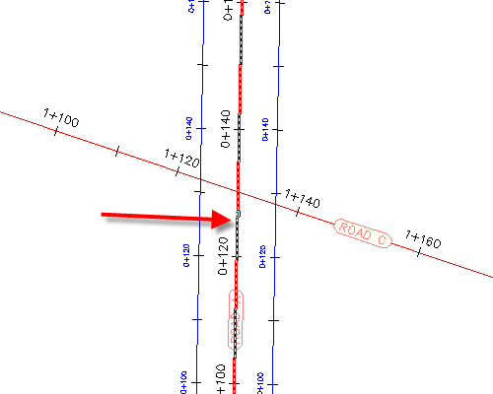
Specify the corridor grade parameters
- In the Create Intersection wizard, on the General page, under Intersection Corridor Type, select Primary Road Crown Maintained.
- Click Next.
Specify the horizontal geometry parameters
- On the Geometry Details page, click Offset Parameters.
- In the Offset Parameters dialog box, under Primary RoadLeft Offset Alignment Definition, for Use An Existing Alignment, select Yes.
- For Alignment Name, click .
- In the Intersection Offset Alignment Name dialog box, click .
- In the drawing, select the offset alignment on the left-hand side of the Road A alignment.
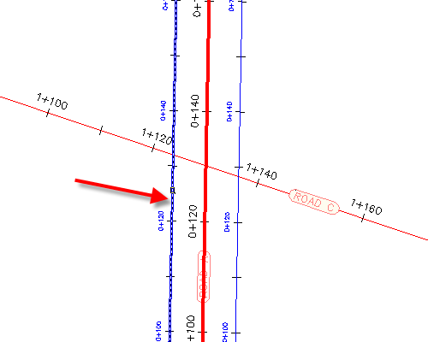
- Click OK.
- In the Intersection Offset Parameters dialog box, for Right Offset Alignment Definition, repeat Steps 2 through 6 to assign the offset alignment that is on the right-hand side of the Road A alignment.
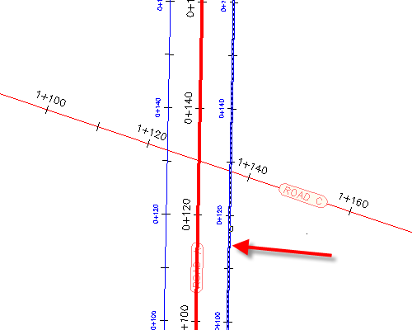
- Click OK.

- On the Geometry Details page, click Curb Return Parameters.
The default parameters for the first intersection quadrant are displayed in the Intersection Curb Return Parameters dialog box. In the drawing, the first quadrant is highlighted, and arrows indicate the direction of incoming and outgoing traffic.
- In the Geometry Details Curb Return Parameters dialog box, under Intersection Quadrant, select SE - Quadrant.
- SE - Quadrant, select the Widen Turn Lane For Incoming Road check box.
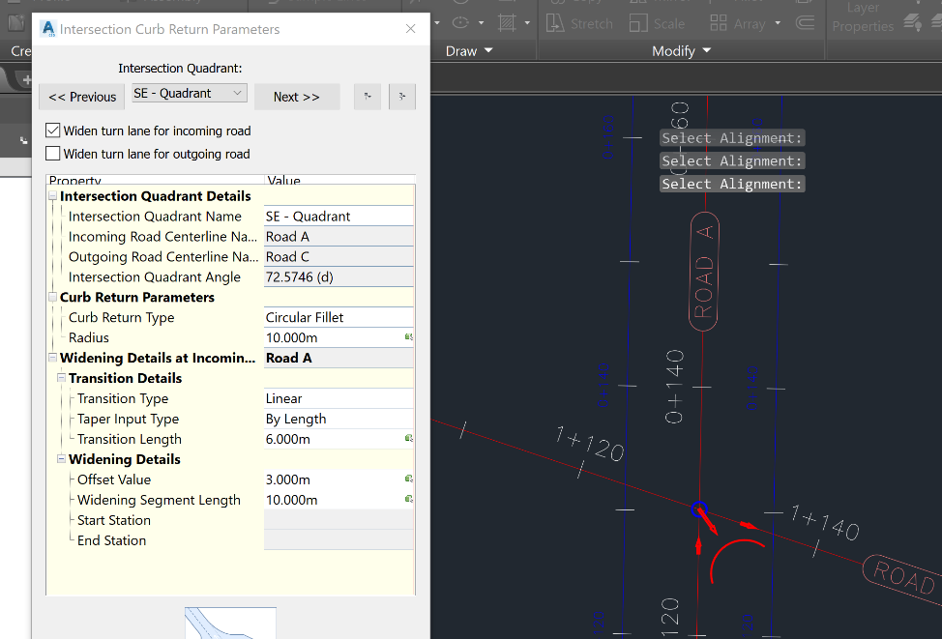
- Under Intersection Quadrant, select NW - Quadrant.
- NW - Quadrant, select the Widen Turn Lane For Incoming Road check box.
- Click OK
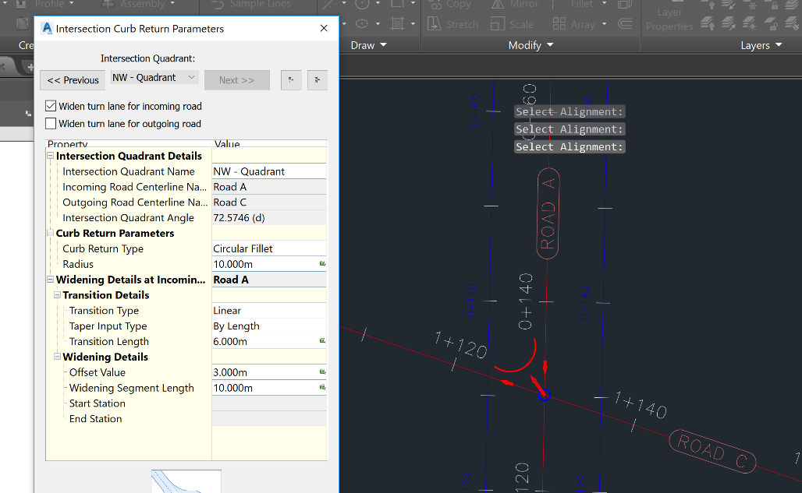
- In the Create Intersection Geometry Details, make sure that the Create Offset And Curb Return Profiles check box is selected.
Specify the vertical geometry parameters
- On the Geometry Details Offset and Curb Return Profiles, Lane Slope Parameters.
- In the Intersection Lane Slope Parameters dialog box, under Primary RoadLeft Edge Profile Definition, for Use An Existing Profile, select Yes.
- For Profile Name, click .
- In the Intersection Offset Profile Name dialog box, select Road A - -2.000%.
- Click OK.
- In the Offset and Curb Return Profiles, repeat Steps 2 through 5 to assign the offset profile that is on the right-side of the Road A alignment. Use profile Road A - -2.000% (1) as the Right Edge Profile DefinitionProfile Name.
- Click OK.
Specify the corridor parameters
- On the Corridor Regions page, specify the following options:
  - Create Corridors In The Intersection Area: Selected
  - Add To An Existing Corridor: Selected, Corridor - (1)
  - Select Surface To Daylight: Existing Ground
- Under Select Assembly Set To Import, click Browse.
- Select _Autodesk (Metric) Assembly Sets.xml. Click Open.
- Click Create Intersection.
The intersection is created, and new corridor regions are created in the intersection area.
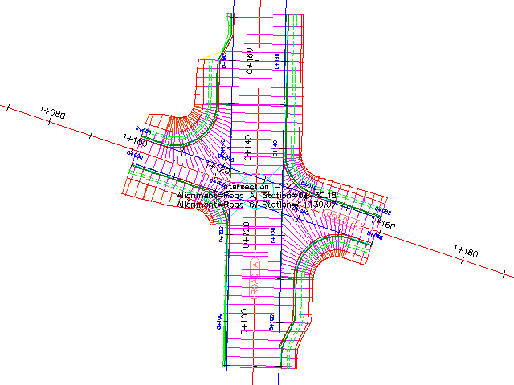

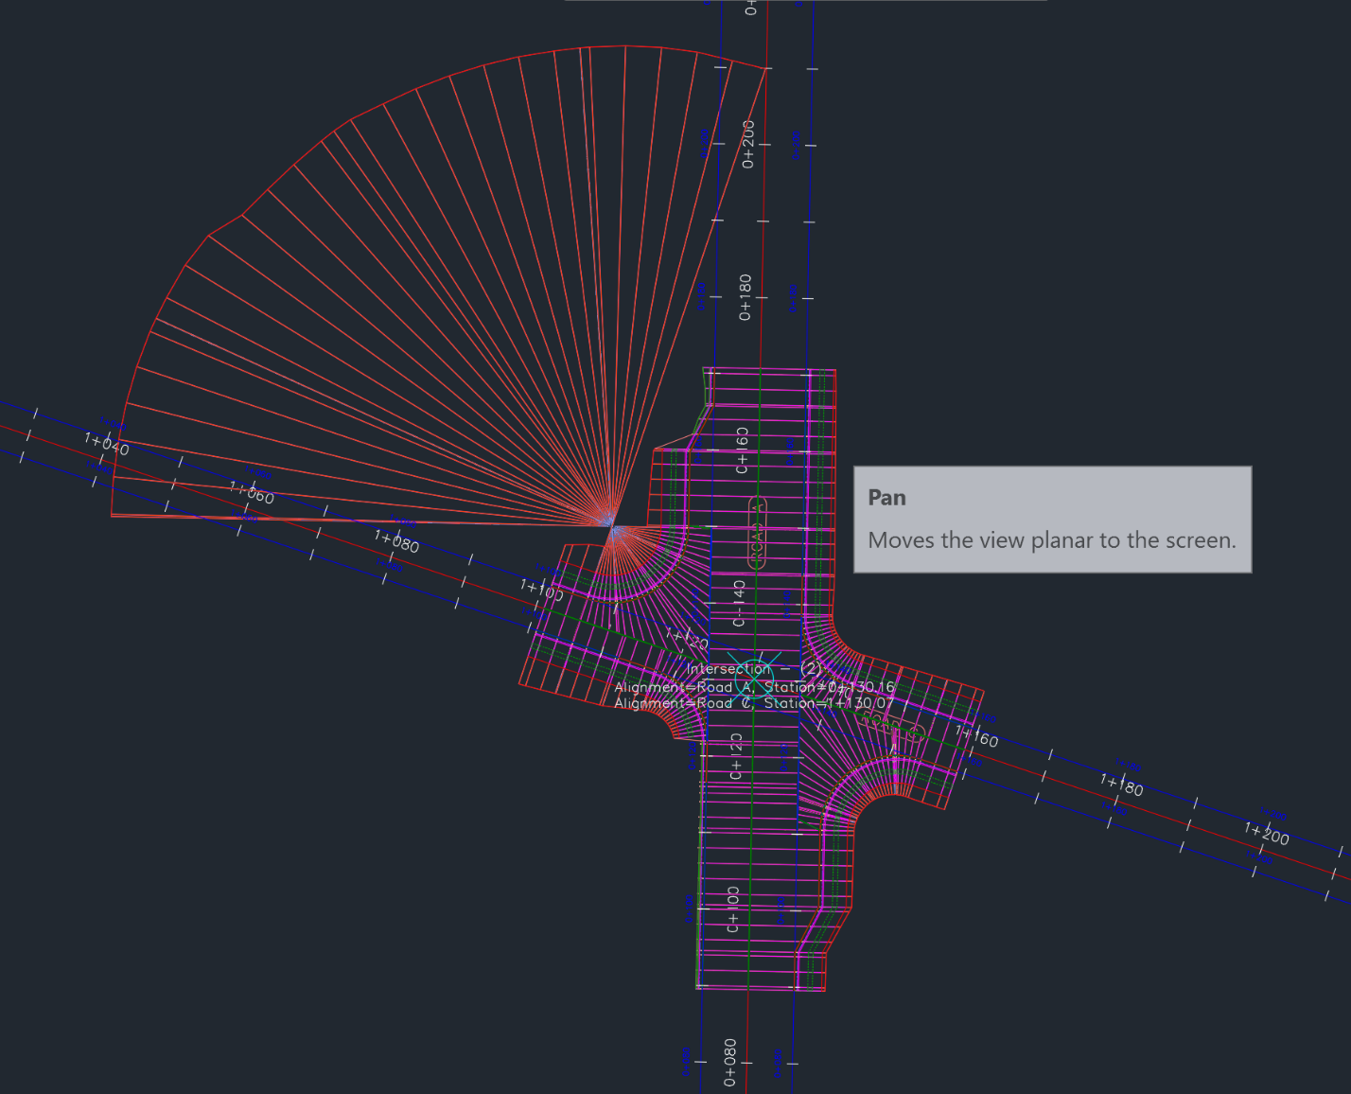

Save this file as Intersection-Create-2 Exercise 3 Lastname Firstname.dwg and submit to Canvas
Further exploration: To extend the corridor between the two intersections, add a corridor region between the two intersections.
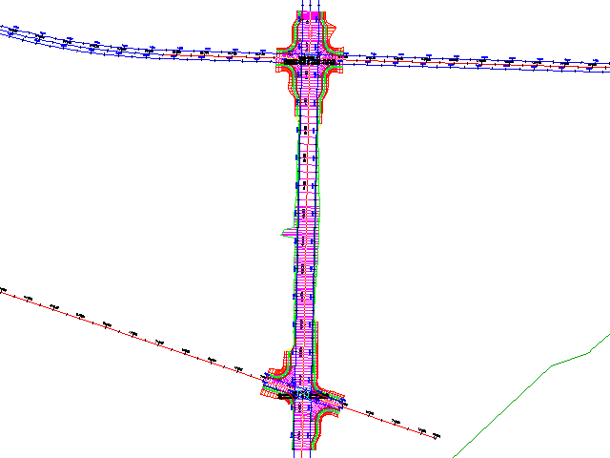
To continue to the next tutorial, go to Editing Intersections.
Parent topic: Tutorial: Creating Intersections

Tutorial: Editing Intersections
This tutorial demonstrates how to modify an existing intersection object.
When an intersection is created between two roads, one of the roads is designated as the primary road. The elevation of the other road, which is known as the secondary road, is locked to the primary road. As changes are made to the horizontal or vertical intersection geometry, the secondary road design profile is adjusted to accommodate the horizontal and vertical position of the primary road.
Topics in this section
- Exercise 4: Editing the Horizontal Geometry of an Intersection
In this exercise, you will edit the alignments that define the horizontal geometry of an intersection. You will edit the alignments graphically and parametrically, and then examine how the changes affect the intersection.
- Exercise 5: Editing the Vertical Geometry of an Intersection
In this exercise, you will edit the profiles that define the vertical geometry of an intersection object. You will edit the profiles graphically and parametrically, and examine how the changes affect the intersection.
- Exercise 6: Creating and Editing a Corridor in the Intersection Area
In this exercise, you will create a corridor using existing vertical and horizontal geometry. You will modify the corridor in the intersection area, and then experiment with the corridor region recreation tools.

Exercise 4: Editing the Horizontal Geometry of an Intersection
In this exercise, you will edit the alignments that define the horizontal geometry of an intersection. You will edit the alignments graphically and parametrically, and then examine how the changes affect the intersection.
Modify offset alignment parameters
- Open Intersection-Edit-Horizontal.dwg, which is located in the tutorials drawings folder.
This drawing contains an intersection of a primary road (Road A) and a secondary road (Road B).
  - The offset alignments for Road A extend along the full length of the centerline alignment.
  - The offset alignment for Road B does not extend beyond the intersection extents.
  - The curb returns have widening regions on all four corners of Road A.
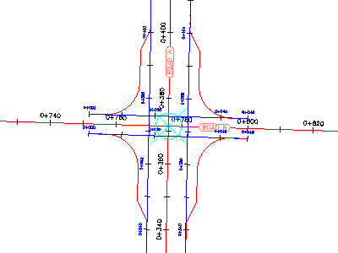

- Drawing Space Select the center point of the intersection

The Intersection tab is displayed on the ribbon. The Modify panel has tools that you can use to modify the parameters of the horizontal and vertical geometry of the intersection.
- Edit Offsets .

The offset alignment parameters are displayed in the Intersection Offset Parameters dialog box.

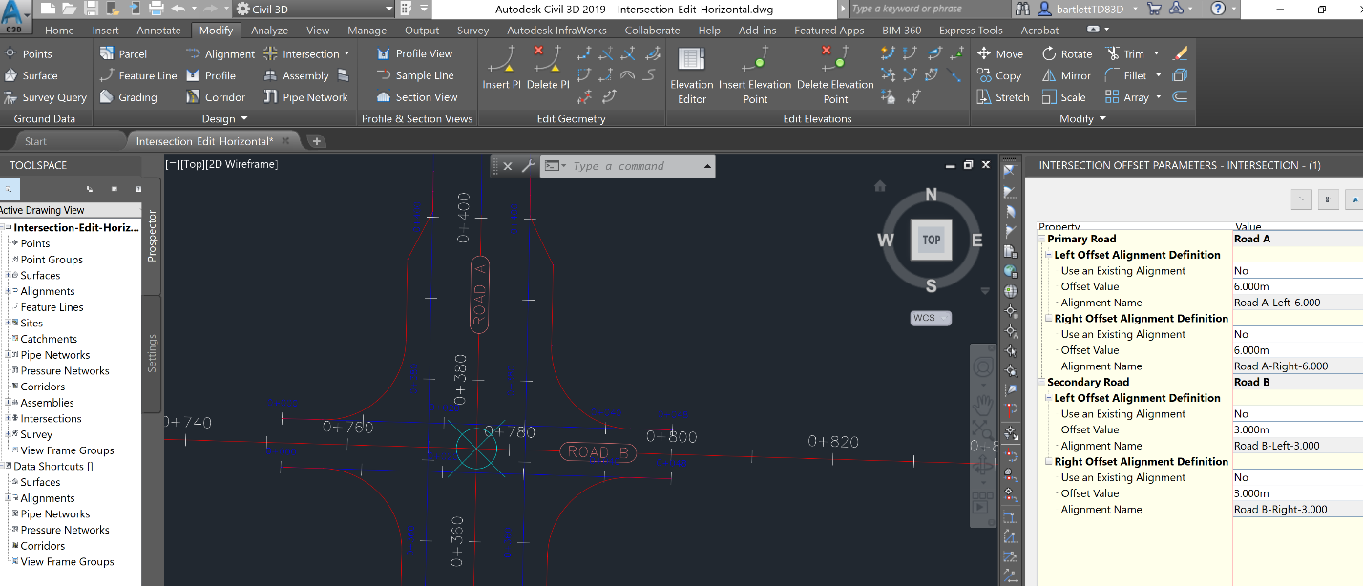

- Under Secondary Road, change the Offset Value for both offset alignments to 4.000.
Notice that as the values change, the intersection updates in the drawing.
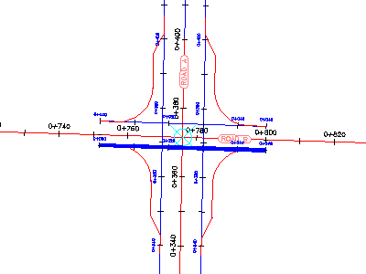
Modify the curb return parameters
- Select Edit Curb Returns .

The Intersection Curb Return Parameters dialog box displays the curb return alignment parameters for the northeast intersection quadrant. This dialog box enables you to change basic parameters, as well as specific details of the curb return at each intersection quadrant.

In the drawing, notice that the currently selected curb return is highlighted.
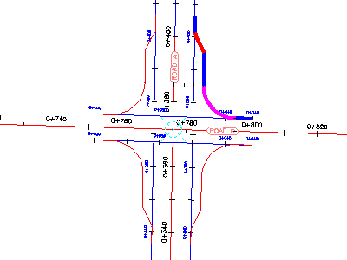
- Remove the check from the Widen Turn Lane For Outgoing Road check box.
In the drawing, the widening region for the northeast quadrant is removed.
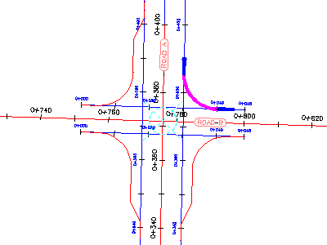
- Under Intersection Quadrant, select SW - Quadrant.
- Remove the check from the Widen Turn Lane For Outgoing Road check box.
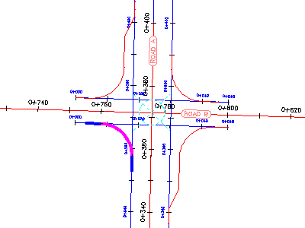
Grip edit a curb return alignment
- In the drawing space, select the SE curb return alignment.
Grips appear along the curb return alignment.
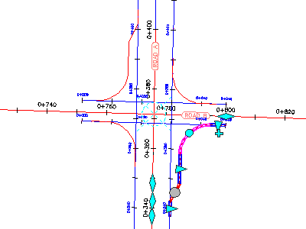
- On the Road A alignment, experiment with the grips.
When you move a grip, the curb return widening region updates, and the values update in the Intersection Curb Return Parameters dialog box.
- Press Esc.
Grip edit the centerline alignments
- Select both offset alignments along Road B.
- Click the grip on the left. Drag the grip to the left. Click near station 0+660 to place the grip.
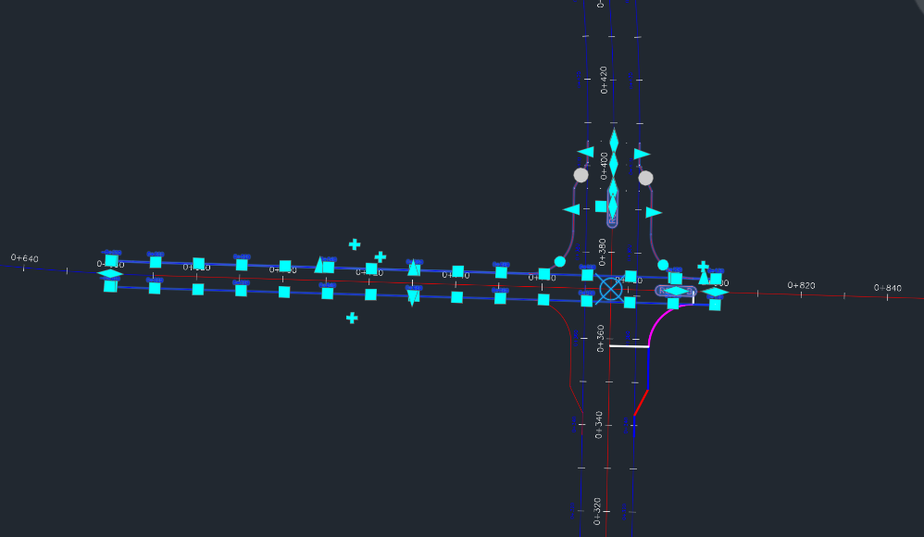
This action enables the relationship between the curb returns and the offset alignments to be maintained as you move the intersection along the centerline alignment.
- Press Esc.
- Zoom out to see the ends of both centerline alignments.
- Select the Road A centerline alignment.
- Select the grip at the southern end of the alignment. It should turn red.
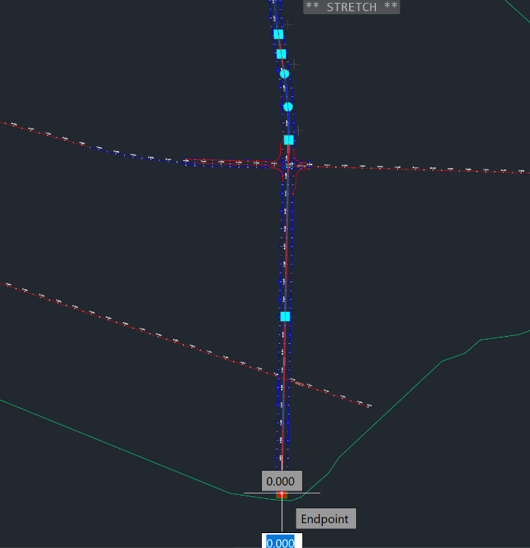
- Move this point to coordinates 6507,3663.
To do this, approximately locate the point by navigating to the coordinates shown in the bottom of the screen. If coordinates are not on, use Ctrl + I to turn on the coordinates.

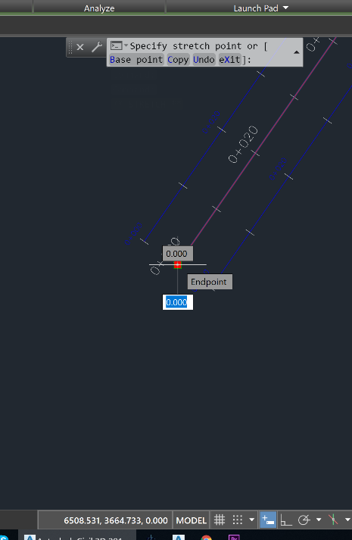

To exactly place the point, reselect the end grip and make it red. Navigate the cross-hairs to the Specify stretch point dialog box. Click in this box. Type 6507, (THE COMMA is important.) After typing the comma, the white input box at the end of the alignment disappears.

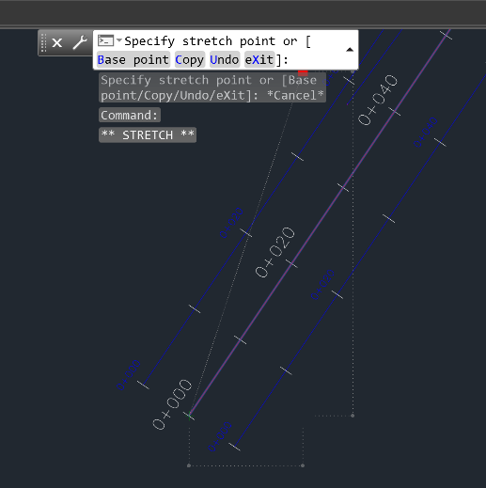
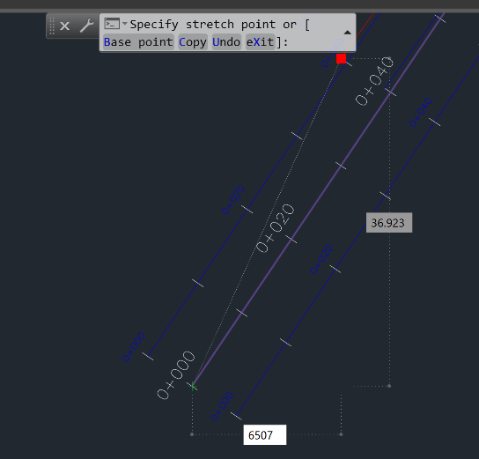

Reselect the Specify stretch point dialog box. You now will be able to enter the coordinates directly into this box. Type 6507,3663 and strike Enter.

The end point of the alignment will now move exactly to these coordinates.

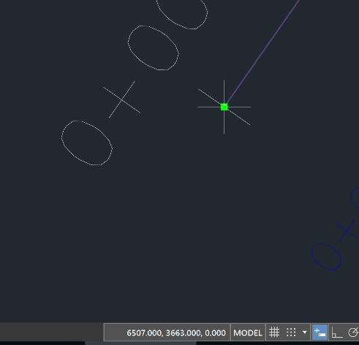

The intersection slides along the Road B centerline and offset alignment. The curb return alignments and Road A offset alignments move to accommodate the new intersection point.

The curb return and offset alignment geometry parameters are maintained.
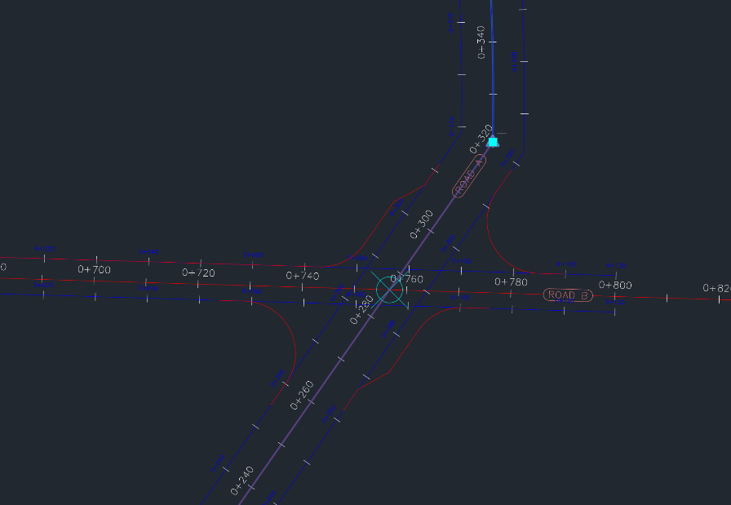
To continue this tutorial, go to Exercise 5: Editing the Vertical Geometry of an Intersection.
Parent topic: Tutorial: Editing Intersections
Save this file as Intersection-Edit-Horizontal Exercise 4 Firstname Lastname.dwg and submit to Canvas

Exercise 5: Editing the Vertical Geometry of an Intersection
In this exercise, you will edit the profiles that define the vertical geometry of an intersection object. You will edit the profiles graphically and parametrically, and examine how the changes affect the intersection.
Examine locked PVIs
- Open Intersection-Edit-Vertical.dwg, which is located in the tutorials drawings folder.
This drawing contains an intersection of a primary road (Road A) and a secondary road (Road C).
- In the lower right viewport, select the layout profile.
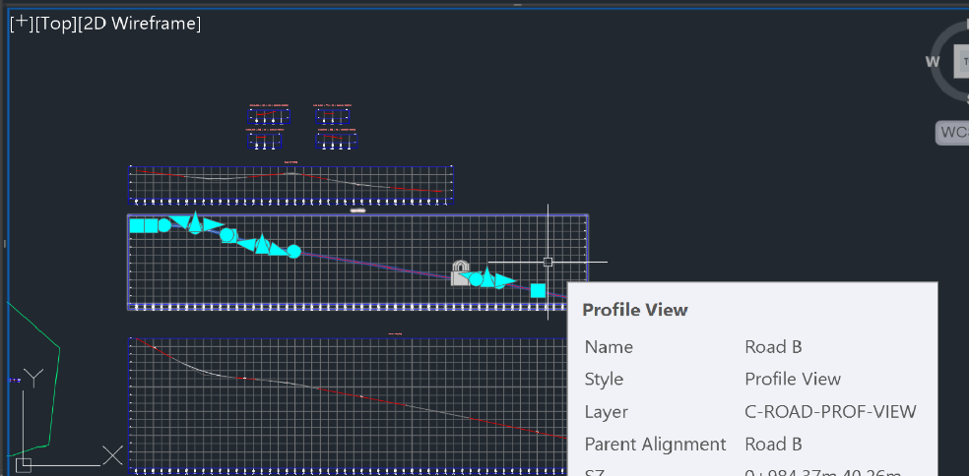
Notice that lock icons are displayed on three of the PVIs. The lock icons indicate that the PVIs are locked to another profile. When the intersection was created, the middle PVI was created at the point where the secondary road intersects with the primary road profile. The other two PVIs were created to maintain the primary road crown through the intersection, and are locked to the edges of the primary road.

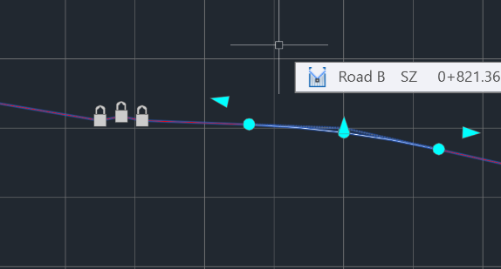
- Profile tab Modify Profile panel Geometry Editor .

- On the Profile Layout Tools toolbar, click .
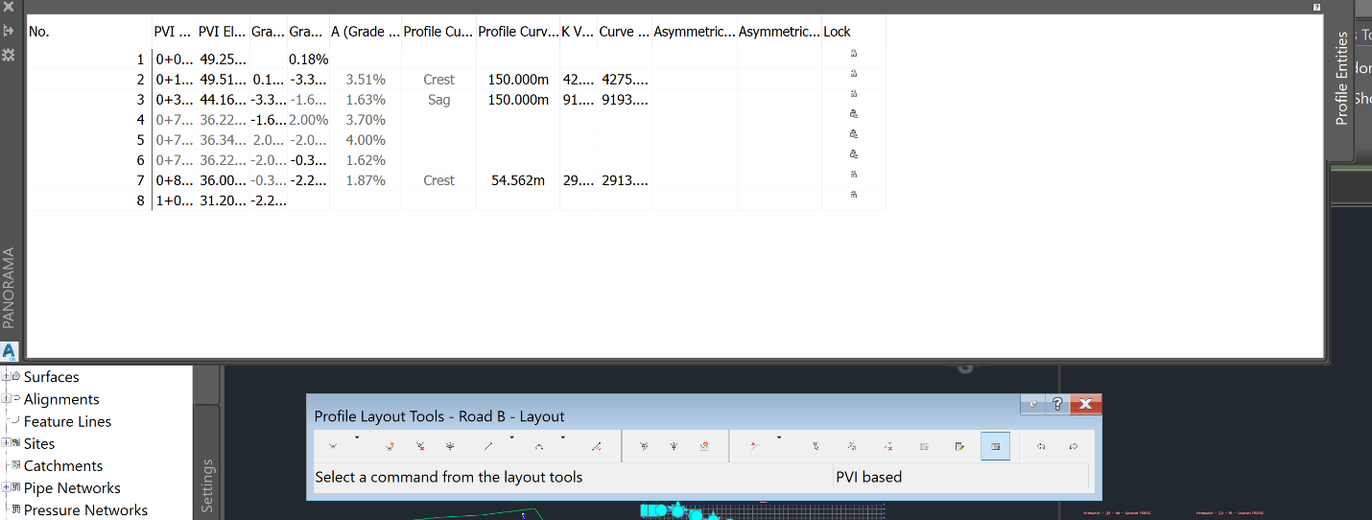
v
v

In the Profile Entities vista, notice that a is displayed in the Lock column for PVIs 5 through 7.
- Hover the cursor over the icon for PVI 6.
Information about the locked PVI, including alignment, profile, and intersection, is displayed in a tooltip. PVIs that are created as part of the intersection creation process are dynamically linked to the primary road profile.
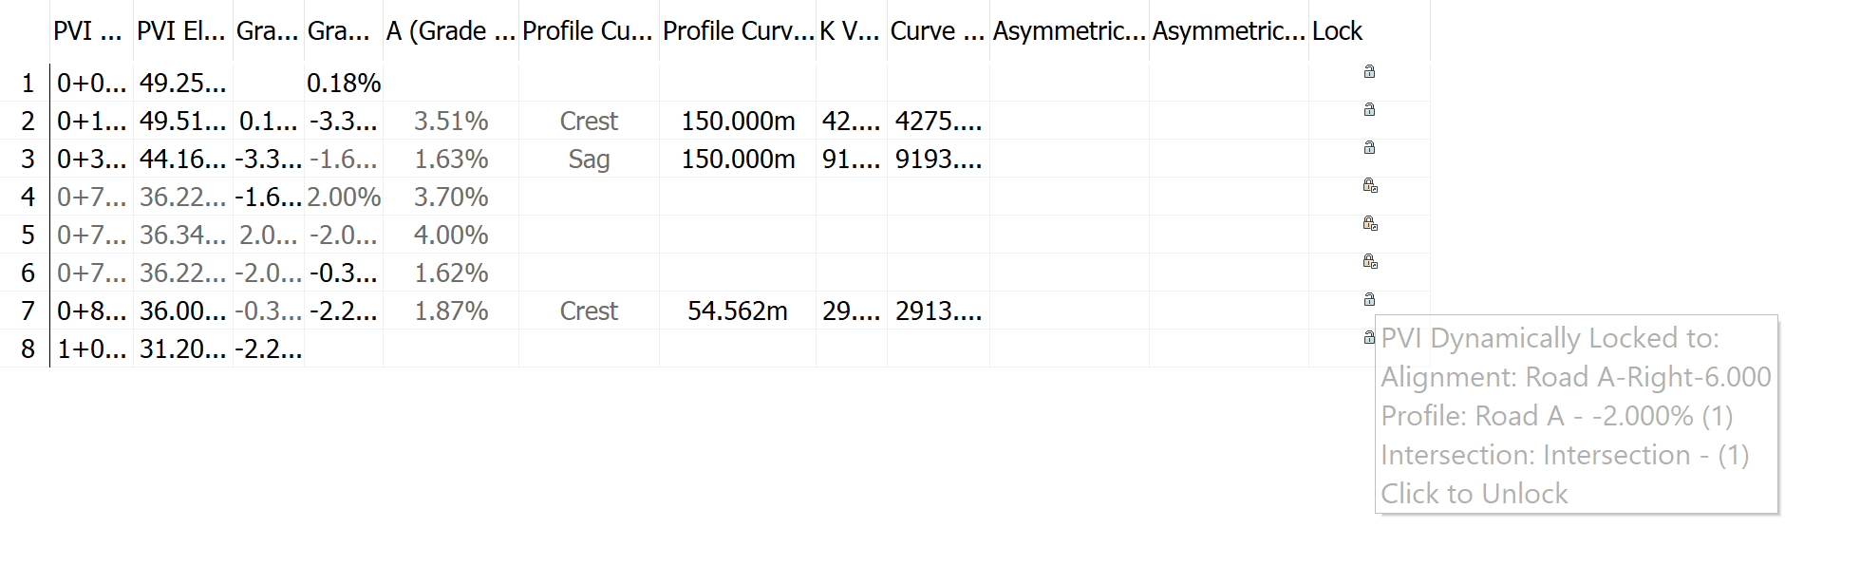
v
Note:
You can unlock a PVI by clicking the icon. If a PVI is unlocked, the profile will no longer react to changes in either the intersection or primary road profile.
- Click the icon for PVI 8.

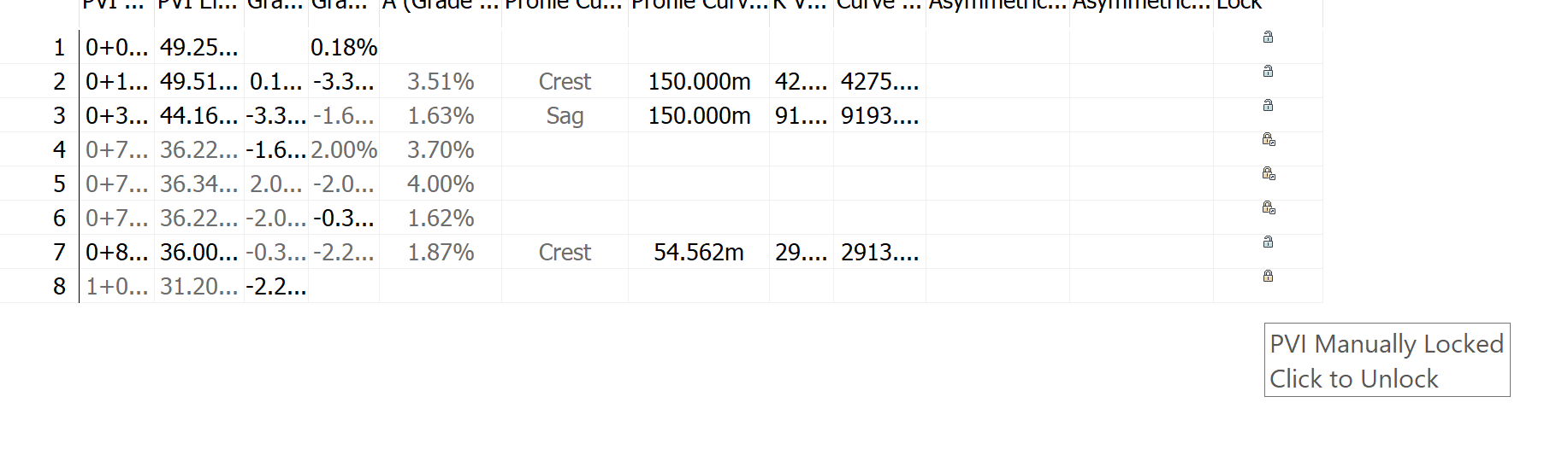
v
v
The PVI is locked at the current station and elevation. Notice that another icon is displayed on the profile, and the PVI Station and PVI Elevation values are no longer available. A PVI can be manually locked to a specified station and elevation value. Manually locked PVIs are not affected by modifications to other portions of the profile.
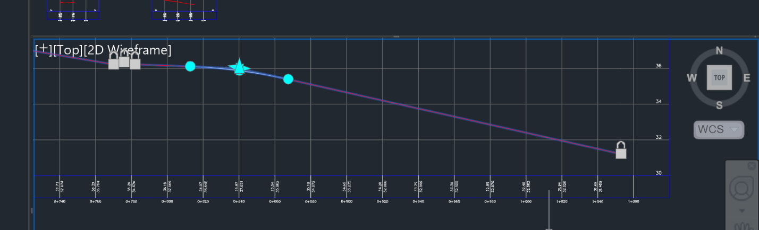
v
- Close the Profile Layout Tools toolbar.
- In the left viewport, select the intersection marker.
On the ribbon, the Intersection tab is displayed. Tools for adjusting the side road profile are displayed on the Modify panel. You can edit the primary road profile with the standard profile editing tools.
Modify the secondary road grade
- Click Intersection tab Modify panel Side Road Profile .
The Secondary Road Profile Rules dialog box is displayed. Use this dialog box to specify the secondary road grade entering and exiting the intersection.
- In the Secondary Road Profile Rules dialog box, specify the following parameters:
Note:
Enter the parameters in the following order.
  - Apply Grade Rules: Yes
  - Distance Rule To Adjust The Grade: Specify Distance
This option enables you to specify a distance from the intersection of the primary and secondary road alignments. This enables you to extend the side road grade rules outside the extents of the intersection.
  - Distance Value: 100.000m
  - Maximum Grade Change: 2.00%
In the lower right viewport, a new PVI is created 100 meters to the left of the locked PVIs. The grade entering the intersection is 0.21%, which is exactly 2.00% less than the primary road grade.
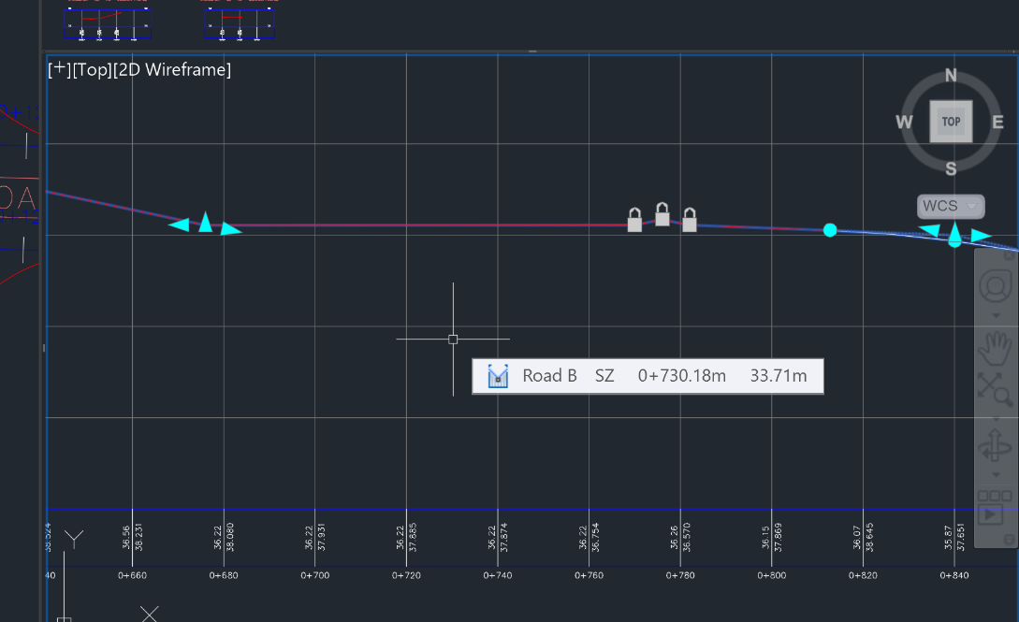
v
- In the lower right viewport, select the layout profile.
You can move the grip at the PVI to make minor changes to the profile. If you drag the grip outside the range of parameters specified in the profile grade rules, the grip snaps back to the default position that satisfies the grade rules.
- Close the Secondary Road Profile Rules dialog box.
- Press Esc.
Add a low point to a curb return profile
- In the upper right viewport, zoom in to the Intersection - 2 - (SE) Quadrant PROFILE.
- Select the profile.
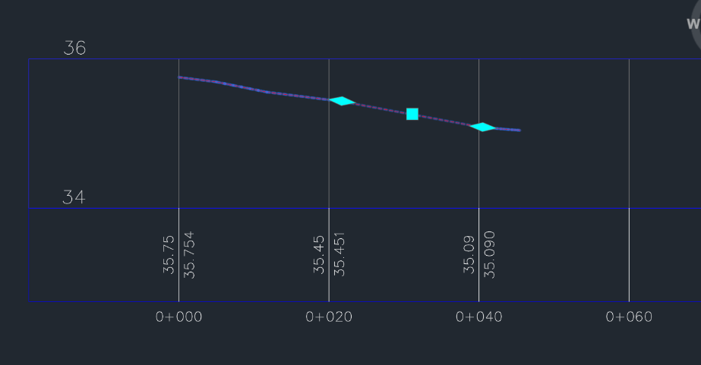
The grips indicate the extents of the curb return profile. The profile portions that are outside the extents represent the offset profiles. Changes to the offset profiles affect the curb return profiles, but changes to the curb return profile do not affect the offset profiles. You can use the grips to extend the curb return profile along either offset profile.
- Modify Profile panel Geometry Editor .
- On the Profile Layout Tools toolbar, click Insert PVI.
- Click between the two grips to place a PVI, creating a low point on the curb return.
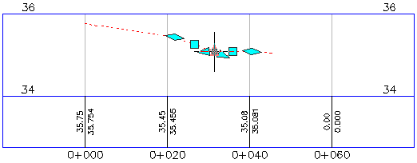
A low point facilitates drainage along a curb return. In the following procedures, you will see how the curb return reacts to changes in other objects.
- Close the Profile Layout Tools toolbar.
Move the primary road alignment
- In the left viewport, select the Road A alignment.
- Select the grip at the southern end of the Road A alignment. Drag the grip to the left. Click to place the grip.
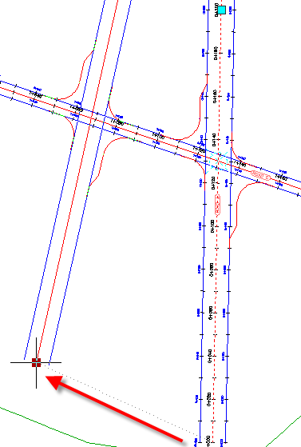
In the bottom right viewport, notice that the three dynamically locked PVIs moved to a new location. This happened because you moved the alignment to which they are locked.
In the top right viewport, examine how the changes to the intersection location affect the curb return profile that you modified.
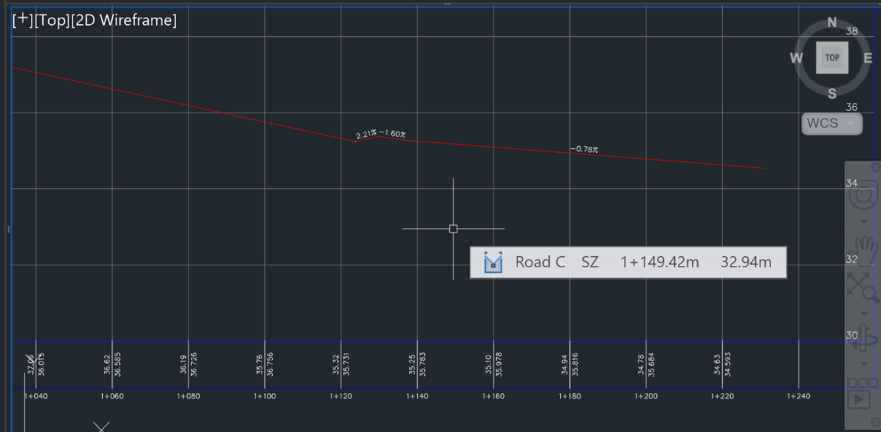
Figure 1 Before moving
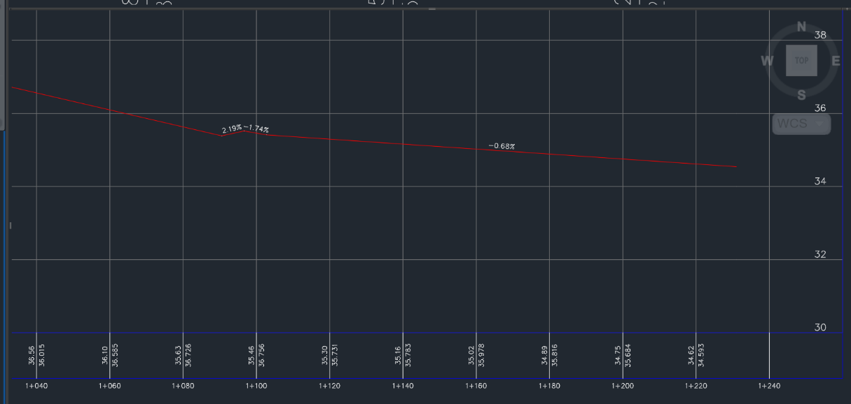
Figure 2 After moving

Change the primary road profile elevation
- In the top right viewport, pan to the Road A profile view.
- In the Road A Profile view, select the layout profile.
- Select the second PI grip from the left. Drag the grip up. Click to place the grip.
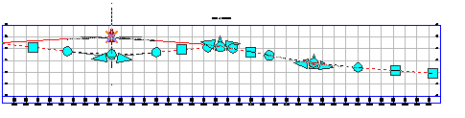
In the 2nd from bottom profile in the lower right viewport, notice that the three locked PVIs moved up to accommodate the new primary road elevation.

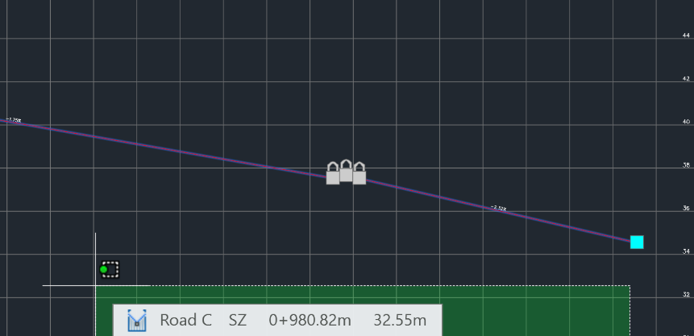

In the top right viewport, the PVI you added to the southeast curb return has stayed in the location you specified, but the ends of the profile moved up to accommodate the new elevation of the offset profiles. The ends of the curb return profile are locked to the offset profiles. You must manually update PVIs that have been placed within the profile.
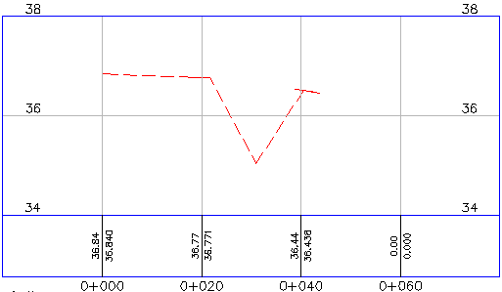
To continue this tutorial, go to Exercise 3: Creating and Editing a Corridor in the Intersection Area.
Parent topic: Tutorial: Editing Intersections
Save this file as Intersection-Edit-Vertical Exercise 5 Firstname Lastname.dwg and submit to Canvas

Exercise 6: Creating and Editing a Corridor in the Intersection Area
In this exercise, you will create a corridor using existing vertical and horizontal geometry. You will modify the corridor in the intersection area, and then experiment with the corridor region recreation tools.
Create a corridor in the intersection area
- Open Intersection-Edit-Corridor.dwg, which is located in the tutorials drawings folder.
This drawing contains an intersection of a primary road (Road A) and a secondary road (Road B). There currently are no corridors or corridor assemblies in the drawing.
- Select the intersection marker.
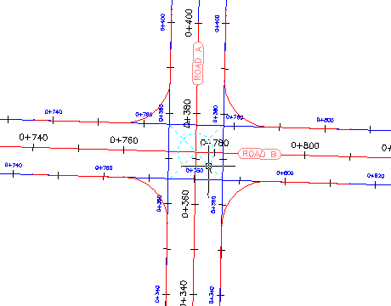
- Click Intersection tab Modify panel Recreate Corridor Regions .
The Intersection Corridor Regions dialog box is displayed.
- Under Select Surface To Daylight, select Existing Ground.
- Under Apply An Assembly Set, click Browse.
- Select _Autodesk (Metric) Assembly Sets.xml. Click Open.
- Click Recreate.
A corridor is displayed in the intersection area.
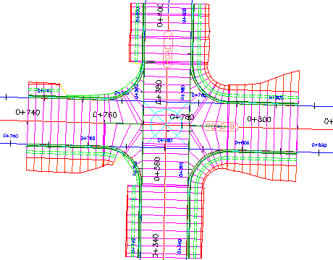
Note: If the corridor is not displayed in the intersection area, you may need to rebuild the corridor. In Toolspace, on the Prospector tab, expand the Corridors collection. Right-click Corridor - (1) and click Rebuild.
Modify the corridor properties
- In Toolspace, on the Prospector tab, expand the Corridors and Intersections collections.
If either of the objects in these collections is out of date, right-click the object and select Rebuild.
- Select the corridor that is in the intersection area.
- Select the grip that is at the bottom of the intersection. Drag the grip down. Click to place the grip further to the south.
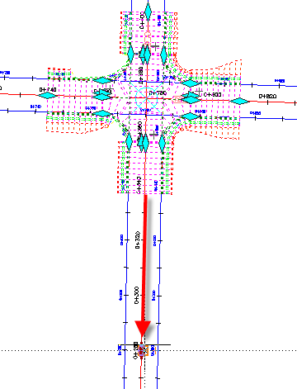
- Click Corridor tab Modify Corridor panel Corridor Properties drop-down Corridor Properties .
- In the Corridor Properties dialog box, on the Parameters tab, click Select Region From Drawing.
- In the drawing, click the bottom of the corridor.
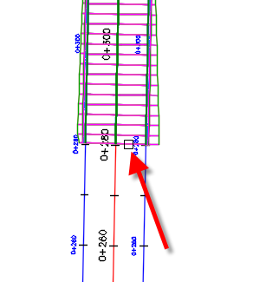
The specified region is highlighted in the Corridor Properties dialog box.
- In the highlighted row, in the Frequency column, click .
- In the Frequency To Apply Assemblies dialog box, under Apply Assembly, specify the following parameters:
  - Along Tangents: 10
  - Along Curves: At An Increment
  - Curve Increment: 5
  - Along Spirals: 5
  - Along Vertical Curves: 5
- Click OK twice.
- In the Corridor Properties - Rebuild task dialog box, click Rebuild the Corridor.
The corridor is rebuilt. The corridor extends further to the south. In the extended region, the assemblies are further apart than the intersection regions.
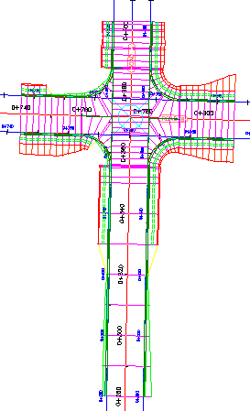
Recreate the corridor regions
- Select the intersection marker.
- Click Intersection tab Modify panel Recreate Corridor Regions .
- Under Select Surface To Daylight, select Existing Ground.
- In the Intersection Corridor Regions dialog box, under Apply An Assembly Set, click Browse.
- Select _Autodesk (Metric) Assembly Sets.xml. Click Open.
This is the assembly set that you used to create the corridor. However, Intersection Corridor Regions dialog box enables you to specify another assembly set, or individual assemblies, with which to create the corridor.
- Click Recreate.
The corridor is recreated. Notice that the modifications that you made to the Road A baseline, including the assembly frequencies and region start station, returned to their original settings. This happened because the corridor was recreated using the parameters that were originally specified during the intersection creation process. Modifications that are made to the corridor in the intersection area are not retained when you recreate the corridor from the intersection object.
Note:
Corridor regions that are outside the intersection extents are not affected by the Recreate Corridor Regions command.
To continue to the next tutorial, go to Working with Roundabouts.
Parent topic: Tutorial: Editing Intersections
Save this file as Intersection-Edit-Corridor Exercise 6 Firstname Lastname.dwg and submit to Canvas

