Lightweight Cellular Concrete (LCC) is an excellent material choice for floating and semi-floating structures due to its unique properties like low density, high strength-to-weight ratio, and durability in marine environments. Here's a detailed look at how LCC is used in these applications:

**1. Buoyancy and Weight Reduction**

Low Density: The primary advantage of LCC is its low Density compared to traditional concrete. This property is beneficial for floating structures, as it reduces the weight of the entire structure, making it easier to float.

Controlled Porosity: LCC can be made with controlled air voids (using foaming agents), further decreasing its Density and allowing for precise buoyancy control.

**2. Structural Integrity and Strength**

Compressive Strength: While LCC is lightweight, it still offers adequate compressive strength (ranging from 0.5 MPa to 10 MPa) for many floating and semi-floating applications. This ensures that the structure remains intact under the stresses of water movement and environmental conditions.

Adaptability: By adjusting the foam content, LCC can be engineered to provide varying strength levels, making it suitable for different applications like floating platforms, breakwaters, and offshore wind turbine bases.

**3. Durability in Marine Environments**

Saltwater Resistance: LCC is highly durable in saltwater environments, as its cellular structure is resistant to corrosion and deterioration, especially when combined with special admixtures or coatings.

Freeze-Thaw Resistance: Its air-entrained structure gives LCC excellent freeze-thaw resistance, making it suitable for areas with fluctuating temperatures, such as coastal zones with tidal conditions or cold climates.

**4. Environmental Impact**

Eco-Friendly: Lightweight cellular concrete is often produced using eco-friendly additives and has lower embodied energy than conventional concrete due to its reduced weight and the potential for using recycled materials like fly ash or slag.

Reduced Carbon Footprint: Because LCC uses less material to achieve buoyancy and strength, it reduces the carbon footprint of floating and semi-floating structures.

Applications of Lightweight Cellular Concrete (LCC) in Floating and Semi-Floating Structures

**1. Floating Platforms and Docks**

Lightweight Foundations: LCC is used in floating platforms and docks, where its low weight and ability to resist water absorption are key advantages. These platforms are used for boats, yachts, and even floating solar farms.

Example: Floating solar panels have been deployed on large bodies of water in places like China, where LCC is used as the base for the floating platforms. These platforms support solar panels while being resistant to water-related damage.

**2. Floating Homes and Coastal Communities**

Adaptable for Rising Sea Levels: In coastal regions experiencing rising sea levels, floating communities or homes are being constructed using LCC. The buoyancy of LCC allows for homes to remain stable as water levels change.

Example: Floating housing projects like the Floating Village in the Netherlands and Oceanix City (UN project) are looking into using LCC as a building material for structures that float on water and can withstand water fluctuations.

**3. Floating Breakwaters**

Wave Protection: LCC is used in the construction of floating breakwaters that protect coastal areas from the impact of waves and storm surges. Its lightweight nature makes it easier to deploy in the water, and its permeability allows water to pass through, reducing the force exerted on the breakwater.

Example: Breakwater systems in coastal cities like Japan and the Netherlands use LCC in some floating designs, which provide better wave attenuation while being easier to install and maintain.

**4. Floating Wind Turbines**

Offshore Wind Farms: Semi-floating platforms for offshore wind turbines have utilized LCC for their buoyant base structures. These platforms are anchored to the seabed, but the LCC helps reduce weight while ensuring the platform is stable in deep waters.

Example: The Hywind Tampen floating wind farm in Norway has used a combination of LCC and steel for its floating turbines, allowing for easier deployment in deeper waters than traditional fixed-bottom structures.

**5. Offshore Oil and Gas Platforms**

Deepwater Exploration: LCC is being explored as a material for floating oil rigs or offshore platforms, where it can reduce the load on seabed foundations while providing the required strength for supporting heavy machinery and personnel.

Example: Semi-floating TLP (Tension Leg Platform) systems use LCC in their buoyant concrete bases to minimize the load on the seabed while maintaining stability in deepwater oil extraction operations.

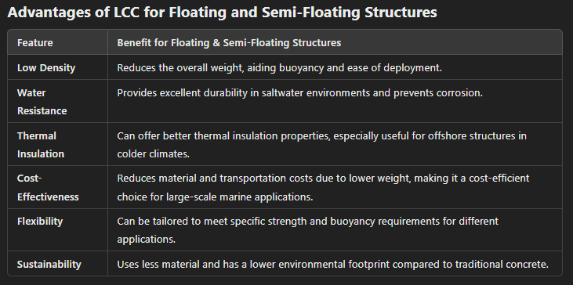

**Challenges of Using LCC in Floating and Semi-Floating Structures**

* Load-Bearing Capacity: While LCC is strong, its compressive strength is still lower than that of traditional concrete. LCC may need to be reinforced with steel or other materials for structures requiring high load-bearing capacity.
* Curing and Moisture Control: Proper curing of LCC in marine environments is essential to ensure its performance is not compromised. The curing process must be carefully managed to prevent premature degradation from saltwater or improper moisture levels.
* Long-Term Performance: Over time, the cellular structure may degrade if not correctly maintained, reducing buoyancy. Regular maintenance and monitoring are necessary to ensure structural integrity.

**Conclusion**

Lightweight Cellular Concrete (LCC) offers significant benefits for floating and semi-floating structures, particularly in marine environments. Its lightweight nature, durability, and buoyancy make it ideal for applications like floating homes, breakwaters, offshore platforms, and floating solar farms. LCC also provides a sustainable and cost-effective solution to traditional construction materials, making it a promising choice for innovative coastal and offshore projects.

**Summary of Floating Structures**

Floating and Semi-Floating Structures are innovative engineering solutions used in water-based environments, such as lakes, rivers, and coastal areas, for various purposes like housing, offshore platforms, docks, and marinas. These structures rely on the principle of buoyancy and are designed to float on the water's surface or remain partially submerged, offering several advantages in marine and coastal projects.

**Floating Structures**

A floating structure is a fully buoyant platform that remains afloat on the water's surface without being anchored to the seabed. The structure is designed to displace enough water to counteract its weight, using buoyancy to stay stable. These are commonly used in areas where land-based infrastructure is impractical.

**Applications of Floating Structures:**

1. Floating Homes and Communities:

Floating houses, apartments, and entire communities have been developed in places with rising sea levels or limited available land. The Floating Village in the Netherlands is a notable example of floating homes designed to adapt to rising water levels.

1. **Floating Solar Panels:**

Floating platforms for solar energy panels are deployed on lakes and reservoirs, reducing land use and providing clean energy. Large-scale floating solar farms have been developed in China and Singapore.

1. **Floating Docks and Marinas:**

Floating platforms that serve as docking stations for boats, yachts, and other vessels. The Floating Marina in Dubai is a luxury marina built with floating pontoons that can adapt to tidal changes.

1. **Offshore Platforms:**

Floating oil rigs and research platforms for offshore drilling, energy production, or marine research. Norway's Statoil Hywind is a floating wind turbine farm providing renewable energy.

**Benefits of Floating Structures:**

1. Adaptation to Rising Sea Levels: Floating structures adjust to changes in water levels, which is crucial in coastal areas facing rising seas due to climate change.
2. Land Availability: They provide an alternative to land-based structures in crowded or land-scarce areas, such as urban waterways.
3. Environmental Impact: Many floating structures are designed to have minimal environmental impact on water ecosystems. Floating solar panels, for example, reduce land use and can be installed without disturbing local wildlife habitats.
4. Reduced Construction Costs: In some cases, building on water can be more cost-effective than constructing on land, especially in regions with challenging soil conditions.

**Semi-Floating Structures**

A semi-floating structure is partially submerged in water, anchored to the seabed, and typically used when the water depth is too great for traditional floating structures but too shallow for conventional fixed structures. These structures are stable because they are tethered to the seabed with anchors or mooring lines.

**Applications of Semi-Floating Structures:**

1. **Floating Wind Turbines:**

Offshore wind farms with turbines mounted on semi-floating platforms that allow them to be placed in deeper waters. The Hywind Tampen in Norway is one of the world's largest floating wind farms, using semi-floating platforms to anchor turbines in deep water.

1. **Floating Ports and Harbors:**

Floating piers and ports accommodate ships and boats, where the platform is partially submerged and anchored to the seabed. The Floating Port in Rotterdam is a semi-floating harbor built in the North Sea, designed to withstand fluctuating sea levels.

1. **Offshore Oil and Gas Platforms:**

Semi-floating structures are often used in deep-sea oil and gas drilling operations, offering stability and mobility. Semi-floating platforms like SPAR or TLP (Tension Leg Platforms) are used in deepwater oil extraction.

**Benefits of Semi-Floating Structures:**

1. Stability in Deep Water: Semi-floating structures are ideal for deeper waters, offering more stability than traditional floating structures because they are anchored to the seabed.
2. Versatility: These structures can be used for various applications, including energy production, transportation, and industrial use.
3. Reduced Environmental Impact: As they are anchored to the seabed, semi-floating structures are less prone to damage from waves and tides than fully floating structures, which can be affected by currents and storms.

Key Differences Between Floating and Semi-Floating Structures:

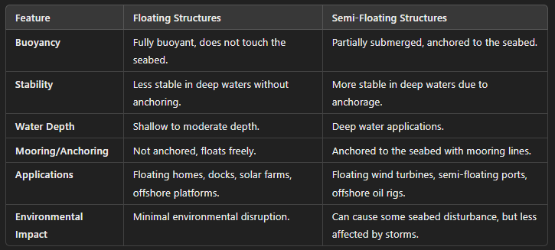

**Challenges and Considerations:**

* Wave and Weather Resistance: Floating and semi-floating structures must be designed to withstand dynamic marine environments, including high winds, large waves, and strong currents.
* Mooring and Anchoring: Proper mooring systems are essential to prevent movement and ensure the stability of semi-floating structures.
* Environmental Impact: Construction and maintenance must consider the impact on marine ecosystems, including potential effects on water quality and habitats.
* Cost: The initial cost of construction for floating and semi-floating structures can be higher compared to traditional land-based buildings due to specialized materials and technologies.

**Innovative Examples:**

1. Floating Island Projects:

In Maldives, floating islands are being developed to combat land scarcity, using advanced concrete that can withstand marine environments. These islands are planned to house tourists and local communities while adapting to rising sea levels.

1. Floating Solar Farms:

In China, floating solar farms have been implemented on large reservoirs. The structures float on water while solar panels are mounted on top, providing renewable energy while preserving land for agriculture and urban development.

1. Floating Cities:

The Oceanix City concept, supported by the UN, envisions sustainable floating cities that can adapt to rising sea levels, providing eco-friendly solutions for housing and community development.

Floating and semi-floating structures are game-changers for coastal development, offering sustainable, adaptable, and efficient solutions for various challenges faced by maritime and coastal environments. Would you like to know more about specific projects or technologies used in these structures?