**Lightweight Cellular Concrete (LCC) for Roofing**

Lightweight Cellular Concrete (LCC), also known as foamed concrete, is a low-density material made by mixing cement, water, and a foaming agent, which introduces air bubbles into the mixture. This creates a lightweight, highly insulating, and durable material that is well-suited for roofing applications.

**Advantages of LCC in Roofing**

1. **Thermal Insulation** – The air-entrained structure of LCC significantly reduces heat transfer, improving energy efficiency and reducing cooling costs.
2. **Lightweight** – LCC is much lighter than traditional concrete, reducing the structural load on buildings and allowing for cost-effective roofing designs.
3. **Fire Resistance** – Being non-combustible, LCC enhances fire safety in roofing applications.
4. **Water Resistance & Drainage** – LCC does not absorb water like other insulation materials, making it ideal for roofing, especially in areas prone to moisture and heavy rainfall.
5. **Durability & Low Maintenance** – LCC is resistant to pests, rot, and chemical damage, leading to longer-lasting roofing solutions.
6. **Easy Installation** – It can be pumped into place, allowing for fast and seamless application over large areas.

**Common Roofing Applications**

* **Sloped Roof Insulation** – LCC is often used as a lightweight fill to create sloped surfaces for water drainage.
* **Flat Roof Decking** – It serves as an insulating base layer beneath waterproof membranes.
* **Precast Roofing Panels** – Some manufacturers use LCC to produce lightweight precast roof panels for modular construction.

**Installation Methods of Lightweight Cellular Concrete (LCC) for Roofing**

1. LCC is applied in roofing systems through different techniques, depending on the design requirements and structural conditions. Below are common installation methods:
   1. Pumped Application for Roof Insulation and Sloping
   2. LCC is mixed on-site and pumped onto the roof deck.
   3. It is spread and leveled to create the desired slope for proper drainage.
   4. Once cured, a waterproofing membrane or coating is applied over it.
   5. Flat roofs requiring insulation and drainage improvements.
2. Precast Lightweight Cellular Concrete Panels
   1. LCC is cast into panel molds and cured in a controlled environment.
   2. The precast panels are transported to the site and installed on the roof structure.
   3. Seams between panels are sealed, and additional waterproofing layers can be added.
   4. Prefabricated or modular buildings needing quick installation.
3. 3. Composite Roofing Systems
   1. LCC is combined with reinforcing materials like wire mesh or fibers.
   2. It is poured over metal decks or other structural substrates.
   3. Additional layers (like waterproofing membranes, tiles, or coatings) can be applied.
   4. High-strength applications with durability and insulation requirements.
4. Case Studies of LCC Roofing Applications
   1. Case Study 1: High-Rise Building in a Hot Climate
      1. Dubai, UAE
      2. Thermal Insulation & Drainage Layer
      3. A 50mm thick LCC layer was applied to the concrete slab.
      4. It reduced the internal cooling load by 30% and prevented water accumulation.
      5. The roof remained lightweight while improving energy efficiency.
   2. Case Study 2: Industrial Warehouse in a Rain-Prone Area
      1. Location: Seattle, USA
      2. Application: Sloped Roof Deck for Water Drainage
      3. LCC was pumped and shaped to create a sloping effect on a flat concrete roof
      4. Reduced ponding issues and enhanced roof lifespan.
      5. The roof maintained high durability against moisture and temperature changes.
5. Technical Details of Lightweight Cellular Concrete (LCC) Composition

LCC provides a balance of affordability, insulation, and durability, making it a cost-effective alternative to traditional roofing methods.

LCC is a versatile material with various mix designs tailored to specific applications. The composition typically includes:

**Basic Components of LCC**

* Cement – Ordinary Portland Cement (OPC) is commonly used.
* Water – Required for hydration and workability.
* Foaming Agent – Creates air voids, reducing density and improving insulation.
* Aggregates (Optional) – Fine sand or fly ash may be added for strength and durability.
* Additives (Optional) – Pozzolans, retarders, or accelerators can enhance performance.

**Density Ranges and Properties**

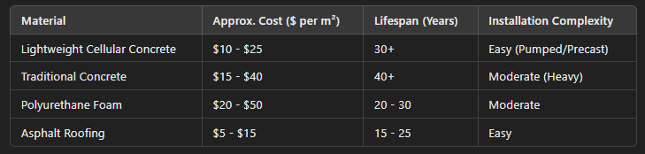

**Cost Analysis of LCC for Roofing**

* Material Costs: LCC is more cost-effective than traditional concrete due to reduced cement and aggregate use.
* Labor Costs: Since LCC can be pumped and easily shaped, installation is faster and requires less manual labor.
* Equipment Costs: Requires a foam generator and mixing/pumping equipment, but reduces heavy machinery needs.
* Maintenance Costs: LCC is highly durable, reducing long-term maintenance costs.

**Cost Comparison with Traditional Roofing Material**

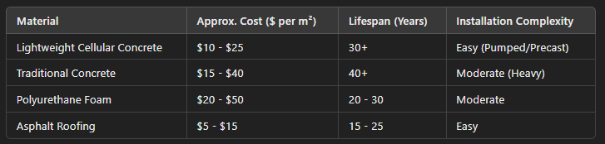

The information provided is based on a combination of industry knowledge, technical specifications from construction materials manufacturers, and general engineering principles related to lightweight cellular concrete (LCC). For further detailed references, you may consider the following sources:

**Academic and Industry Publications**

* ACI (American Concrete Institute) Report 523.1R-06 – Guide for Cast-in-Place Low-Density Cellular Concrete
* ASTM C796/C796M – Standard Test Method for Foaming Agents for Use in Producing Cellular Concrete Using Preformed Foam
* Neville, A. M. (2011). Properties of Concrete – Covers LCC properties and structural applications.

Jones, M. R., & McCarthy, A. (2005). Behavior and Performance of Foamed Concrete for Construction Applications (Cement and Concrete Research).

**Manufacturer and Construction Reports**

* Aircrete Europe – Technical documents on cellular concrete applications.
* LafargeHolcim – LCC mix designs and structural performance reports.
* Poraver – Lightweight Concrete with Expanded Glass Applications.
* National Ready Mixed Concrete Association (NRMCA) – Guidelines on Lightweight Concrete Roofing Applications.

**Case Studies & Project References**

Various high-rise and industrial projects have utilized LCC for roofing, including reports published by construction firms such as:

* Cematrix Corporation (LCC applications in North America
* Aerix Industries (Foam technologies for concrete insulation)
* Geofill (Lightweight concrete solutions)

**References and Resources**

1. ACI 523.1R-06: Guide for Cast-in-Place Low-Density Cellular Concrete

This guide provides comprehensive information on materials, properties, design, handling, and applications of cast-in-place low-density cellular concretes with oven-dry densities of 50 lb/ft³ (800 kg/m³) or less.

1. Concrete.org
2. ASTM C796/C796M-19: Standard Test Method for Foaming Agents for Use in Producing Cellular Concrete Using Preformed Foam

Contains laboratory methods to measure the performance of foaming chemicals used in producing foam (air cells) for making cellular concrete.

1. Astm.org
2. "Properties of Concrete" by A. M. Neville

This authoritative textbook covers various aspects of concrete properties, including discussions on lightweight and foamed concretes.

1. "Behavior and Performance of Foamed Concrete for Construction Applications" by M. R. Jones and A. McCarthy

This research paper, published in Cement and Concrete Research, investigates the properties and potential construction applications of foamed concrete.

1. Aircrete Europe – Technical Documents on Cellular Concrete Applications

Aircrete Europe provides technical documentation and case studies on the applications of autoclaved aerated concrete (AAC), a form of cellular concrete, in various construction scenarios.

1. LafargeHolcim – LCC Mix Designs and Structural Performance Reports

LafargeHolcim offers insights into mix designs and performance characteristics of lightweight cellular concrete through their research and development publications.

1. Poraver – Lightweight Concrete with Expanded Glass Applications

Poraver provides information on the use of expanded glass granulate in lightweight concrete applications, enhancing properties like thermal insulation and fire resistance.

National Ready Mixed Concrete Association (NRMCA) – Guidelines on Lightweight Concrete

1. The NRMCA offers guidelines and best practices for using lightweight concrete in roofing applications, focusing on structural and thermal performance.
2. Cematrix Corporation – LCC Applications in North America

Cematrix provides case studies and technical data on the use of lightweight cellular concrete in various North American construction projects.

1. Aerix Industries – Foam Technologies for Concrete Insulation

Aerix Industries specializes in foam technologies used in creating cellular concrete, offering resources on insulation and lightweight fill applications.

1. Geofill – Lightweight Concrete Solutions

Geofill provides information on various lightweight concrete solutions, including cellular concrete applications for geotechnical and roofing purposes.

These resources should provide detailed information on the composition, properties, applications, and standards related to Lightweight Cellular Concrete (LCC).