**Introduction**

Permeable Cellular Concrete (PLCC) is a lightweight, highly porous concrete material that allows water to pass through its structure. It is commonly used in stormwater management, erosion control, and lightweight fill applications. PLCC combines the advantages of traditional concrete with permeability, making it an environmentally friendly solution for managing water flow in urban and natural environments.

**Key Features of PLCC:**

* High Porosity & Permeability
* Interconnected voids that allow water to flow through.
* Reduces surface runoff and promotes groundwater recharge.

**Lightweight Composition:**

* Made with a controlled air void system, reducing its density.
* Lighter than conventional concrete, which helps in reducing load on structures.
* Durability & Strength
* Sufficient compressive strength while maintaining permeability.
* Resistant to freeze-thaw cycles due to its porous structure.
* Eco-Friendly & Sustainable
* Supports stormwater management by reducing flooding risks.
* Minimizes heat island effect by allowing water to cool surfaces.

**Applications of PLCC:**

* Stormwater Management: Used in permeable pavements, sidewalks, and drainage systems to control runoff
* Erosion Control: Helps stabilize slopes, riverbanks, and shorelines.
* Lightweight Fill Material: Used for backfilling, bridge abutments, and geotechnical applications.
* Green Infrastructure: Applied in sustainable urban drainage systems (SUDS) and low-impact development (LID) projects.

**Composition of Permeable Cellular Concrete (PLCC):**

* PLCC is designed to balance permeability, strength, and lightweight properties. Its composition typically includes:
  + Cement – Ordinary Portland Cement (OPC) or other binders for structural integrity.
  + Water – Essential for hydration and proper mixing.
  + Air-Entraining Agents or Foaming Agents – Create a cellular structure with interconnected voids.
  + Aggregates (Optional) – Fine aggregates (e.g., sand) may be used in small amounts, but coarse aggregates are typically excluded to maintain porosity.
  + Admixtures – Used to enhance workability, strength, and durability, such as polymer additives or pozzolanic materials (fly ash, silica fume).
  + Installation Process of PLCC

The application of PLCC depends on the specific project but generally follows these steps:

1. Site Preparation – The surface is cleared and graded for proper drainage. A subbase layer (e.g., crushed stone) is often placed to support water flow.
2. Mixing & Placement - The cementitious mixture is blended with a controlled amount of foam to create uniform porosity. PLCC is poured or pumped into the desired location.
3. Curing - PLCC requires careful curing to maintain strength and prevent excessive drying shrinkage. Curing time varies based on environmental conditions and mixture design.
4. Finishing & Maintenance - Surface finishing depends on its intended use (e.g., rough for erosion control, smooth for pavements).
5. Periodic inspections ensure proper functionality, especially in drainage applications.

**Case Studies**

**1. Permeable Pavements in Urban Areas**

Location: Portland, Oregon, USA

Application: PLCC was used in sidewalks and parking lots to reduce stormwater runoff and mitigate urban flooding.

Outcome: Improved water infiltration, reduced strain on drainage infrastructure, and increased groundwater recharge.

**2. Erosion Control Along Riverbanks**

Location: Netherlands

Application: PLCC blocks reinforced riverbanks while allowing water penetration to prevent soil displacement.

Outcome: Enhanced flood resilience while maintaining ecological integrity.

**3. Lightweight Fill for Road Embankments**

Location: Japan

Application: PLCC was a lightweight backfill for road embankments on soft soil.

Outcome: Reduced settlement issues and increased slope stability.

**Technical Details of Permeable Cellular Concrete (PLCC)**

PLCC is designed to balance permeability, strength, and weight, making it an efficient solution for stormwater management and geotechnical applications. Below are key technical parameters:

**1. Permeability & Porosity**

Permeability Rate: Typically ranges from 0.1 cm/s to 1.0 cm/s, depending on the pore structure and mix design.

Porosity: Generally between 15% and 35%, ensuring adequate water flow.

Void Connectivity: Essential for maintaining permeability while providing structural integrity.

**2. Strength & Density**

PLCC’s compressive strength depends on the mix ratio, air content, and curing process:

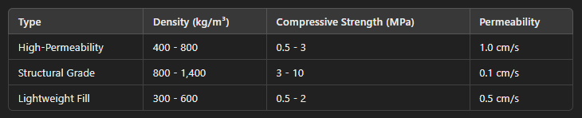

* Lower densities provide high permeability but lower strength.
* Higher densities offer better load-bearing capacity but reduced permeability.
* Strength is affected by curing time, typically reaching 70% of its full strength in 7 days and 100% in 28 days.

**3. Material Specifications & Mix Proportions**

A standard PLCC mix might include:

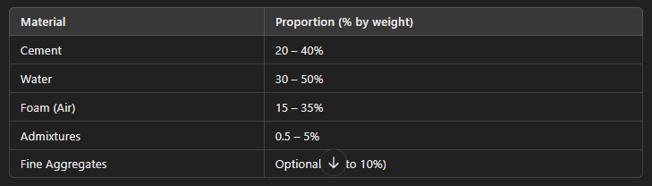

* Foaming agents (protein-based or synthetic) create the air voids.
* Polymer or pozzolanic additives (e.g., fly ash, silica fume) enhance durability.
* No coarse aggregates to maintain permeability.

**4. Structural & Load Considerations**

* Traffic Load Capacity: Can be engineered to support pedestrian and light vehicle traffic (up to 5 MPa).
* Flexural Strength: Typically 10-15% of the compressive strength.
* Shrinkage: Lower than traditional concrete due to its air content but still requires proper curing.

**5. Durability & Maintenance**

* Lifespan: 20-50 years, depending on usage and maintenance.
* Freeze-Thaw Resistance: High due to air voids preventing expansion damage.
* Clogging Prevention: Requires periodic surface cleaning (vacuuming or pressure washing) in high-sediment environments.

**Conclusion**

PLCC is a highly versatile, sustainable material for water management and lightweight fill applications. Its mix design can be tailored to meet specific permeability, strength, and durability needs.

**Comparison: Permeable Cellular Concrete (PLCC) vs. Pervious Concrete**

Permeable Cellular Concrete (PLCC) and Pervious Concrete are designed for stormwater management but differ in composition, strength, permeability, and applications. Below is a detailed comparison:

1. Composition

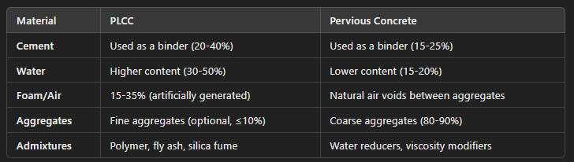

* PLCC is made using foaming agents, creating a uniform cellular structure.
* Pervious Concrete relies on coarse aggregates with minimal fine particles, allowing water to flow through gaps.

2. Strength & Load-Bearing Capacity



* Pervious Concrete is stronger and supports higher loads, making it suitable for roads and parking lots.
* PLCC is much lighter, making it ideal for applications where weight is a concern, such as embankments and green roofs.

3. Permeability & Water Infiltration

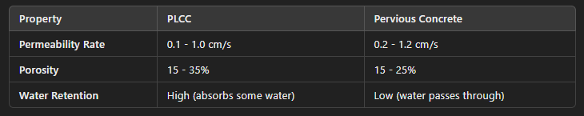

* Both materials are highly permeable, but PLCC retains more water due to its cellular structure.
* Pervious Concrete allows faster drainage, making it better for high-flow stormwater systems.

4. Weight & Density



* PLCC is significantly lighter, making it ideal for geotechnical applications where reducing soil load is essential.
* Pervious Concrete is heavier and more suited for structural applications.

5. Durability & Maintenance

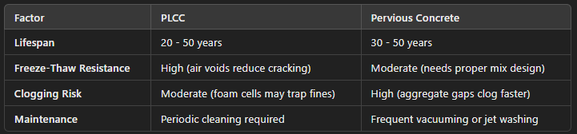

* PLCC resists freeze-thaw cycles better due to its uniform cellular structure.
* Pervious Concrete is more prone to clogging and requires more frequent cleaning.

6. Applications

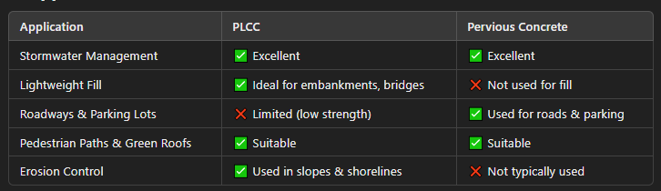

* Use PLCC when weight reduction is needed (e.g., bridge abutments, green roofs, erosion control).
* Use Pervious Concrete for higher-strength applications like roads, sidewalks, and parking lots.

**Conclusion: When to Choose PLCC vs. Pervious Concrete?**

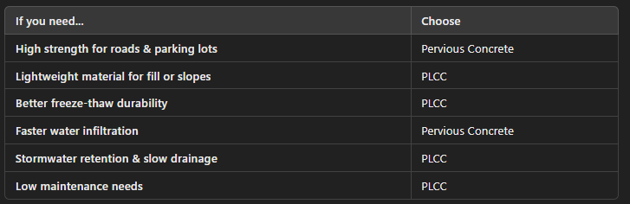

Both materials are valuable for sustainable construction, but their use depends on structural needs, load requirements, and permeability goals. Would you like assistance with a specific project or design?