The document presents the results of resilient modulus and uniaxial compressive strength tests conducted on twelve PLDCC samples grouped by batch.

**Resilient Modulus Tests**

The Resilient Modulus (RM) is the ratio of axial cyclic stress to recoverable strain, determined through cyclic stress-controlled triaxial tests. These tests apply a fixed stress for 0.1 seconds, followed by a 0.9-second rest period, under low confining pressures that simulate real-world conditions (Table 2). RM testing can also assess the effects of moisture content, density, and temperature (Bennert & Maher, 2005), though this study did not examine these factors. Instead, PLDCC samples of varying dry densities were tested using the AASHTO TP46-94 testing sequence.

The Resilient Modulus can be represented in terms of Bulk Stress, which is obtained by dividing the stress acting on the sample using the following:

|  |  |  |  |
| --- | --- | --- | --- |
|  | | $MR= K_{1}*θ^{K_{2}}$ | [Eq. 1] |
| where: | MR = Resilient Modulus (MPa) | | |
|  | Θ = Bulk Stress (kPa) = 1+  2+  3 | | |

Table

4. Resilient Modulus equation of different subbase materials.

|  |  |  |
| --- | --- | --- |
| **Subbase Material** | **Resilient Modulus Equation** | |
| **Stone dust** | MR=57.566*θ0.0911 | [Eq. 5] |
| **Fly Ash** | MR=61.011*θ0.1169 | [Eq. 6] |
| **Coarse sand** | MR=86.338*θ0.0919 | [Eq. 7] |
| **Riverbed material (RBM)** | MR=29.515*θ0.3369 | [Eq. 8] |

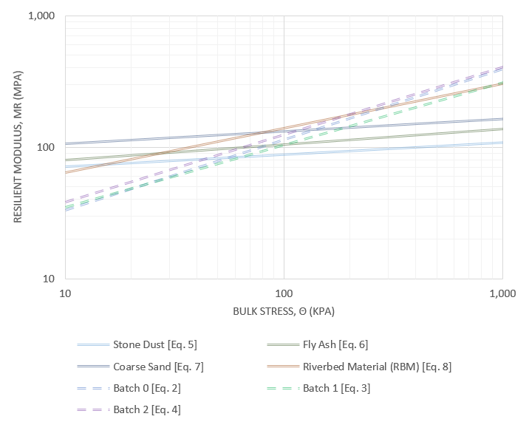

* **P** **Table**
* **5. Comparison of the resilient Modulus of different subbase materials exposed to field Bulk stresses.**

|  |  |  |  |  |
| --- | --- | --- | --- | --- |
| * Material | * Bulk Stress, θ (kPa) | * Resilient Modulus, MR (MPa) | * Bulk Stress, θ (kPa) | * Resilient Modulus, MR (MPa) |
| * DGABC, Natural Gradation | * 227 | * 158.88 | * 254 | * - |
| * DGABC, Low End | * - | * 126.53 |
| * Stone Dust | * 94.37 | * 95.32 |
| * Fly Ash | * 115.04 | * 116.53 |
| * Coarse Sand | * 142.15 | * 143.59 |
| * RBM | * 183.58 | * 190.53 |
| * Batch 0 | * 176.62 | * 187.36 |
| * Batch 1 | * 153.43 | * 161.69 |
| * Batch 2 | * 188.92 | * 199.90 |

* **LCC Resilient Modulus Tests**:
  + The results are shown in Figures 6, 7, and 8 for batches 0, 1, and 2. The resilient modulus (MR) is calculated using bulk stress and material constants (K1 and K2).
  + For batch 0, K1=9.6674K1 = 9.6674K1=9.6674, K2=0.5355K2 = 0.5355K2=0.5355, and R2=0.8014R^2 = 0.8014R2=0.8014.
  + For batch 1, K1=11.636K1 = 11.636K1=11.636, K2=0.4754K2 = 0.4754K2=0.4754, and R2=0.776R^2 = 0.776R2=0.776.
  + For batch 2, K1=11.715K1 = 11.715K1=11.715, K2=0.5125K2 = 0.5125K2=0.5125, and R2=0.8286R^2 = 0.8286R2=0.8286.
  + The R-squared values indicate a relatively strong correlation between the variables for all batches.

The results show variations in the material properties based on batch composition, with batch 0 being the strongest in both resilient modulus and compressive strength.

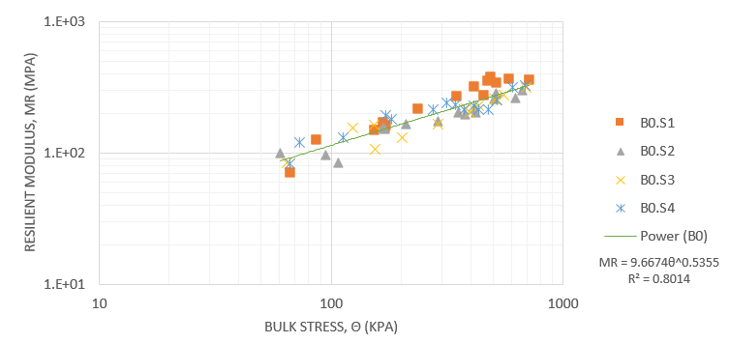

Figure 6. Graphical result of the resilient modulus test on samples of batch 0.

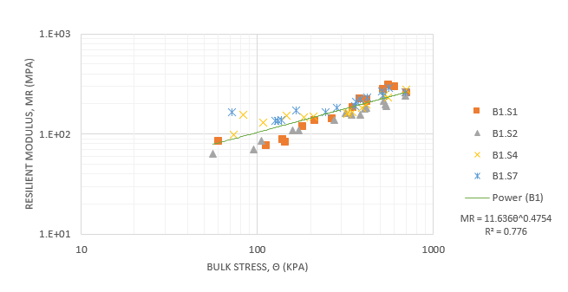

Figure 7. Graphical result of the resilient modulus test on samples of batch 1.

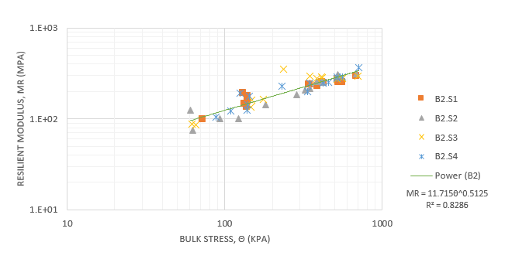

Figure 8. Graphical result of the resilient modulus test on samples of batch 2.

**Methods**

The Resilient Modulus (RM) tests were conducted following AASHTO T-307 guidelines using a calibrated GeoComp LoadTrac II load frame, a three-phase stepper motor cyclic actuator, and a Cyclic-RM Actuator Controller. The specimen was placed in a triaxial cell with a latex rubber membrane, and the confining pressure was controlled by regulated compressed air. Deviator stress was applied using the cyclic actuator, and displacement measurements were taken with two linear displacement transducers to calculate axial strain. The loading involved a haversine-shaped pulse with a 0.1-second load followed by a 0.9-second rest period. The test involved 15 sequences with varying confining pressure and deviator stress, performed in a drained condition with the sample valves vented to atmospheric pressure. The RM results were reported as the average of the moduli from the last five load pulses of each sequence.

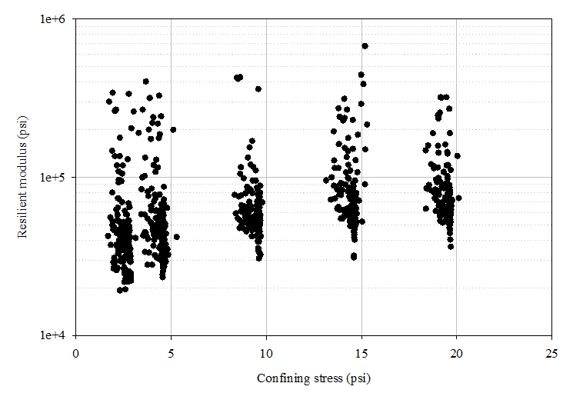

Resilient modulus of the LCC specimens as a function of confining stress.

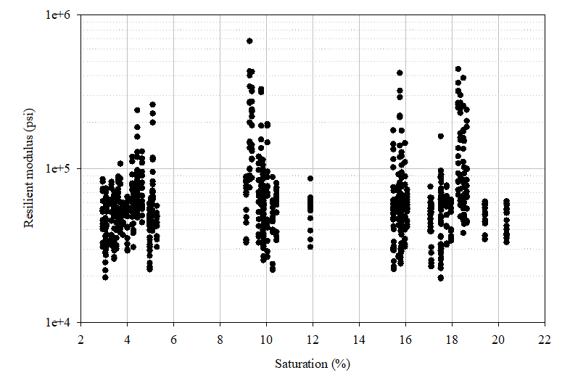

Resilient modulus of the LCC specimens as a function of saturation.

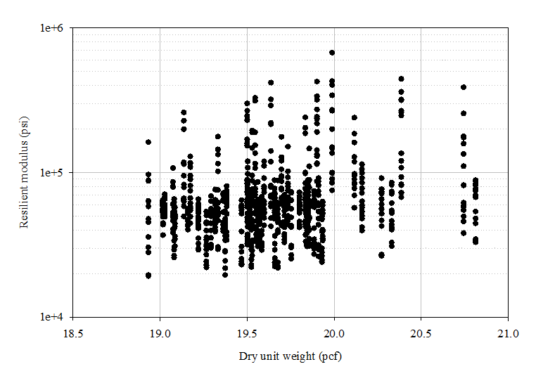

Resilient modulus of the LCC specimens as a function of the dry unit weight.

The RM tests were conducted with confinement pressures ranging from 3 to 20 psi and deviatoric stress from 3 to 40 psi, typical for base and subbase materials. The average RM was 71 ksi, comparable to compacted granular materials (Davich et al., 2004). While RM was somewhat influenced by sample confinement, increasing saturation did not significantly affect it. Based on the data, an RM regression model was developed to estimate RM as a function of confining stress, deviatoric stress, and dry unit weight. The favorable RM results indicate that LCC can be a viable base material. (Seely)