**Title: Hydraulic and Durability Properties of Lightweight Cellular Concrete for Urban Coastal Engineering Applications**

# Abstract

Seashore

# Introduction

Lightweight cellular concrete (LCC) has been used in coastal infrastructure projects due to its (1) relatively low unit weight compared to structural concrete, which reduces the vertical load on soft coastal soils, reducing consolidation settlement and improving the bearing capacity for soft soil sites and reclaimed land and their associated infrastructure (e.g., roadways, causeways, floodwalls, dikes, backfilling, bridge abutments, green roofs, etc.) (Armaghani 2011; Anderson et al., 2012; Tiwari et al., 2017; ACI 523; Sutmoller et al., 2019, Tiwari et al., 2020; Amran et al., 2022, Seely 2024), (2) favorable hydraulic properties associated with open-cell, permeable lightweight cellular concrete (PLCC) allowing for controlled water movement for drains, water retention/detention, storage, and decenteralized stormwater management systems (Bartlett et al., 2020a; 2024; Inti et al., 2021), and (3) realtively high strength-to-weight ratio and favorable durability with the potential use of additives that resist salt water, sulfate, and freeze-thaw degradation (Tikalsky, 2004; Averyanov, 2018) for constructing coastal and nearshore features (e.g., marinas, docks, partially submerged and floating systems, and artificial reefs and revetments, etc.) and (4) filtering and sequestration capabilites to remove heavy metal contaminates (Martemianov et al., 2017; Alimohammad et al., 2021), and (5) ability to reduce embodied carbon.zzz ADD REFERENCES TO SUPPORT THIS SECTION)

ACI 523.1R-06 classifies cellular concrete is classified into three types based on density and intended applications: (1) Type I Cellular Concrete with dry density from 400–800 kg/m³ (25–50 lb./ft³), (2) Type II, dry density from 800–1200 kg/m³ (50–75 lb./ft³), and (3) Type III Cellular Concrete, dry density from 1200–1900 kg/m³ (75–120 lb./ft³). This paper focuses on the properties, functions, and application of Type I Cellular Concrete, also known as low-density cellular concrete (ACI Committee 523, 2006), foamed concrete (Amran et al., 2015, 2022), lightweight foamed concrete (Kozłowski and Kadela, 2018), or aerated concrete (Narayanan and Ramamurthy, 2000). The data presented herein are LCC and PLC, consisting of Portland Cement Concrete (PCC), water, and a foaming agent. However, other binders, fine aggregates (e.g., sand), and admixtures (e.g., polymer additives or pozzolanic materials, such as fly ash and silica fume) could be considered to enhance workability, strength, and durability (Arman et al., 2022). Generally, permeability and water storage decrease with increasing density, but shear strength and durability improve. The formulation of cellular concrete strikes a balance between an ultra-low dry density (400 to 560 kg/m³) and adequate shear strength and durability properties for the intended application.

**Closed and Open Cell Lightweight Cellular Concrete**

The foaming agent of LCC produces spherical air bubbles surrounded by a low to medium permeability matrix (Fig. 1 – left). In comparison, PLCC, sometimes called Low Buoyancy Cellular Concrete (LBCC) (Masloff et al., 2022), is an open-cell, lightweight, highly porous cellular concrete with interconnected voids that allow water to flow through its structure (Fig. 1). No coarse aggregates are used in the mix to maintain higher permeability. Therefore, PLCC has lightweight applications similar to LCC but adds drainage, water storage, and heavy metal sequestration functions.

# Hydraulic Properties of LCC

The hydraulic properties of LCC and PLCC vary significantly because of aleatory variability resulting from the composition of the mix, foaming agent installation method, or specimen creation process employed. Masloff and Paladino (2012) suggest classifying cellular concrete based on material type and hydraulic conductivity (Table 1).

Fig. Comparison of the fabric of Closed-Cell Lightweight Cellular Concrete (LCC) (left) with Open-Cell Permeable Cellular Concrete (PLCC) (right).

**Table 1. Relative values of hydraulic conductivity, k, modified from Masloff and Paladino (2012)**

|  |  |  |  |
| --- | --- | --- | --- |
| **Relative Permeability** | **k (m/s)** | **Geomaterial** | **Cellular Concrete** |
| *Very permeable* | *k > 1x10-2* | *Gravel, Coarse Gravel* | *---* |
| *Medium permeability* | *1x10-5 to 1x10-3* | *Fine Sand, Sand, Coarse Sand* | *LCC, PLCC* |
| *Low permeability* | *1x10-5 to 1x10-7* | *Silty Sand, Silty-Clayey Sand* | *LCC* |
| *Very low permeability* | *1x10-7 to 1x10-9* | *Fine Sandstone, Silt* | *LCC* |
| *Impermeable* | *k < 1x10-9* | *Clay, Mudstone* | *Structural Concrete* |

Seely (2024) conducted a suite of falling head hydraulic conductivity tests on closed-cell LCC specimens using a flexible-wall permeameter (ASTM D5084-16a) (Fig. 2). Previous research has demonstrated that fluid flow bypass may occur between the specimen and the latex membrane when test specimens have a rough or porous surface on their circumference (Seely et al., 2014). Because LCC cylinders exhibit a rough, circumferential surface and have the potential to form a porous structure, depending on the degree of adhesion between the cement and the Styrofoam mold during the curing process, fluid bypass can occur. Therefore, Seely (2024) used a sidewall treatment to preclude this bypass. Each specimen sidewall was treated with a thin paste of hydrated CETCO Super Gel-X bentonite before the specimens were placed in a latex membrane and into the triaxial cell for testing. Subsequently, a minor amount of effective confining stress was maintained while the pore pressure was systematically increased to saturate the test specimen. This method of saturation, termed back-pressure saturation, ultimately allowed for saturation of the specimen (i.e., B-value equal to or greater than 0.95).

Fig. 2 Flexible wall permeameter used for falling head testing of LCC.

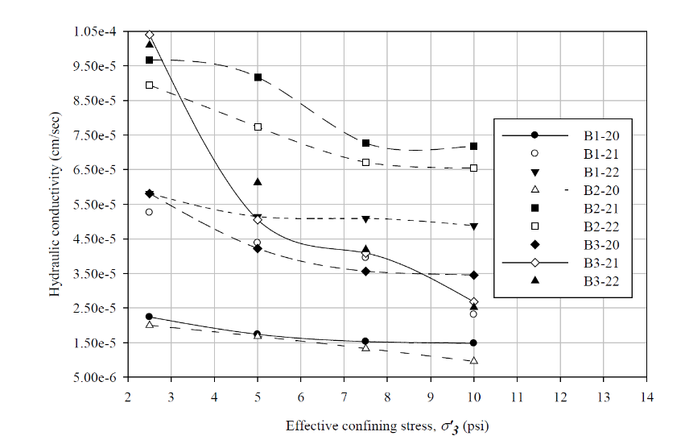The testing showed that the hydraulic conductivity of LCC is somewhat affected by the confining stress applied to the specimens (Fig. 3). On average, the test specimens exhibited a 0.04 order-of-magnitude decrease in hydraulic conductivity as the confining stress increased from 17.5 to 70 kPa (Seely, 2024). The dry unit weight for these specimens ranged from 304 to 336 kg/m3, and the confining pressure varied from 17.5 to 70 kPa. The average hydraulic conductivity for all tests was 4.9x10-7 m/s, with a maximum of 1.0x10-6 and a minimum of 9.6x10-8 m/s. These values fall in the low permeability range (Table 1).

Fig. 3 Hydraulic conductivity over a range of effective confining stresses (Seely, 2024.)

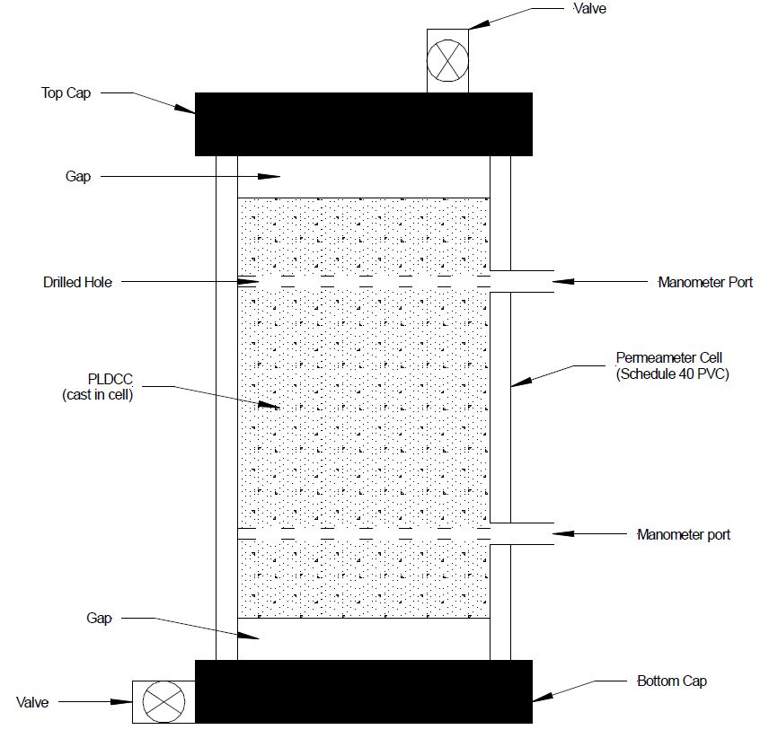In addition, Bartlett et al., 2024 performed constant head hydraulic conductivity tests on closed-cell LCC specimens using a modified testing protocol of ASTM D2434 developed by Castle Rock Consulting of Colorado using the permeameter shown in Fig. 4 (Bartlett et al., 2000b). The modifications made to the ASTM D2434 were related to sample fabrication and testing preparation. These variations were necessary because cellular concrete specimens differ significantly from permeable soils, for which the ASTM D2434 test was intended. The LCC specimens (i.e., Batches 1 and 2) were prepared by Aerix Industries using their AQUAERIX™ foaming agent (Bartlett 2024).

Fig 4. Rigid wall permeameter used for constant head testing of LCC (Bartlett et al., 2024)..

Batch 1 consisted of 14 specimens, with a dry density ranging from 330 to 367 kg/m³ with an average of 353 and a standard deviation of 13 kg/m³. The total density ranged from 734 to 823 kg/m³ with an average of 794 and a standard deviation of 25 kg/m³. The average hydraulic conductivity was 1.4×10-4 m/s, with a standard deviation of 9.3 x 10-5 m/s and an average water absorption capacity (i.e., the volume of water absorbed per unit volume of the LCC specimen) of 44.2% with a standard deviation of 3.22%. We use the nomenclature of "total density" instead of "saturated density" above because LCC specimens do not become fully saturated unless back-pressure saturation is used via a pressurized cell. Thus, the total density reported for the constant head testing represents the dry unit plus the additional weight of water gained by flowing water through the sample without back-pressure saturation, allowing the specimen to reach steady-state flow and measuring its wet density in this state.

Batch 2 consisted of 19 specimens with dry density ranging from 444 to 474 kg/m³ with an average of 457 and a standard deviation of 8.3 kg/m³. The total density ranged from 708 to 827 kg/m³ with an average of 807 and a standard deviation of 26 kg/m³. The average hydraulic conductivity was 2.2x10-5 m/s, with a standard deviation of 2.7x10-5 m/s, an average absorption capacity of 35.0%, and a standard deviation of 2.78%. The hydraulic conductivity of these batches falls within the medium to lower bound of the medium permeability range (Table 1)

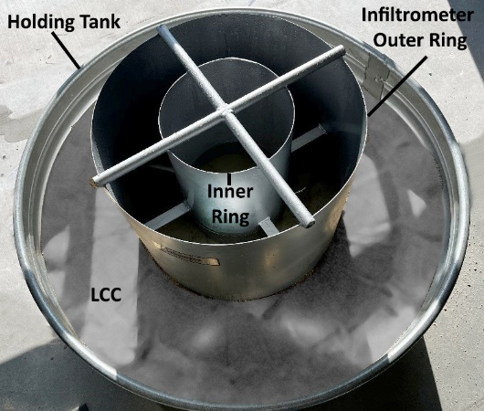Also, a green roof rehabilitation project in Salt Lake City, Utah, allowed us to test closed-cell LCC created using AQUAERIX™ foaming agent in a double-ring infiltrometer and tank setup shown in Fig. 5. This testing provided a permeability assessment at a scale similar to full-scale installations and the LCC was obtained directly from the LCC batched at the construction site into the 1.22-m aluminum holding tank (Fig 5.). Before the LCC placement, the bottom of the holding tank was filled with 0.3 m of coarse sand, and a nonwoven geotextile was placed atop the sand as a separation layer. The testing protocol followed ASTM D3385–18 using water continuously supplied to the inner ring via a constant-head mariotte tube. Before the field poring of the LCC, a 0.3-m layer of coarse sand was placed, followed by a nonwoven geotextile fabric to allow water drainage from the bottom of the tank via a port in its sidewall. Prior permeability testing has shown that the nonwoven geotextile has a minor effect on the infiltration rate of the system (Bartlett et al., 2024). The hydraulic conductivity from two infiltrometer tests was 1.1x10-6 and 2.4x10-6 m/s, falling within the range of materials with low hydraulic conductivity (Table 1).

Fig. 5 Double Ring Infiltrometer withf LCC placed in a holding tank.

Based on the testing results, we conclude that closed-cell LCC is not advantageous for applications where flow, drainage, and water storage are needed. Some literature suggests that the LCC void ratio can be as low as 10 percent air voids (Panesar, 2013), resulting in low hydraulic conductivity and water absorption levels ranging from 3% to 7% (Amran et al., 2022). We found that hydraulic conductivity significantly decreased from an average of 1.4x10-4 to 2.2x10-5 m/s as the average dry density increased from 353 to 457 kg/m3.

In addition, our laboratory tests on LCC specimens that vary from 708 to 827 kg/m³ resulted in an average buoyant uplift force of 2.9 to 1.7 kN/m³, respectively. This result suggests that closed-cell LCC may have a moderate buoyancy force when placed below groundwater or where temporary flooding or submersion is possible. This uplift force may be sufficient to cause damage or cracking if the LCC is not sufficiently covered, buried, or anchored. However, due to its relatively low permeability and low water storage capacity, LCC might be desirable for cases where limited water flow is desired in or through the geosystem (e.g., dikes, roadways, pavements, embankments, docks, revetments, etc.) if adequate countermeasures against buoyancy uplift are taken.

# Hydraulic Properties of PLCC

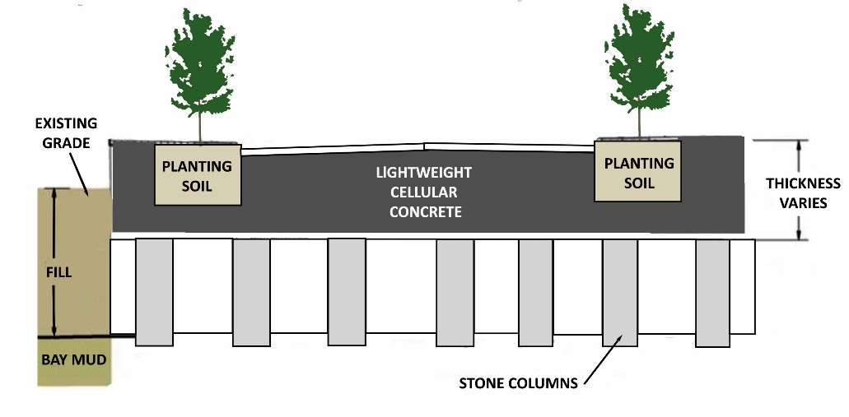In contrast to LCC, the foaming agent used to produce PLCC (Masloff et al., 2022) creates a significantly higher hydraulic conductivity and water storage capacity (Bartlett et al., 2024). Notable case studies of PLCC construction include the Mission Rock Project (MRP) in the Port of San Francisco (Bartlett et al., 2020a) and a soft soil remediation project at the Louis Armstrong International Airport (LAIA) in New Orleans, Louisiana (Sutmoller and Gomez, 2022). For the latter project, a concrete vault was to be built on a saturated, weak, compressible black clay. The lightweight fill material around the vault's pavement was needed to facilitate significant stormwater drainage and stabilize the soft soil. A silt fabric was placed to mitigate silt infiltration before PLCC, with a 450 kg/m3 density, was installed to a depth of 1.2 m for a total PLCC volume of 2300 m3

Fig. 6 Cross-sectional view of typical street for Mission Rock Project (Bartlett et al., 2000a).

The extensive MRP project site (6.5 hectares) comprises mixed commercial and residential development constructed atop potentially liquefiable uncompacted fill material, which overlies the Young and Old Bay Muds of San Francisco Bay. To protect the site against a projected sea level rise of up to 1.67 m by 2100, the development team proposed increasing the ground elevation by 1.5 to 1.8 m across most of the site (Bartlett et al., 2020a). The foundations for the planned buildings are pile-supported. The potential for liquefaction of the uncompacted fill was mitigated by installing stone columns (Fig. 6). However, if earthen fill were used to raise the ground, the additional weight placed in non-building areas would cause significant primary consolidation settlement (about 0.56 m) of the Young Bay Mud. This consolidation and subsequent creep settlement would cause considerable damage to planned roadways, sidewalks, landscaped areas, and buried utilities. Therefore, it was decided that a "zero net load" could be created by sub-excavating the existing ground and paved areas to a depth equivalent to the expected weight of the LCC fill, roadway base (where applicable) overlying flexible pavement section (Fig. 6).

In addition, MRP performance requirements specified that the PLCC should be sufficiently permeable to prevent the buildup of excessive hydrostatic uplift pressure during fluctuations in the groundwater table and tides in the San Francisco Bay. Based on subsurface flow calculations, the advisory panel specified a minimum hydraulic conductivity of 5x10-5 m/s (i.e., medium permeability - Table 1) for the LCC or PLCC layer to prevent excessive hydrostatic uplift pressure during tidal fluctuations. Red Rock Consultants performed constant head permeability testing (ASTM D2434) for the MRP on ten 76.2 x 152.4 mm specimens obtained while constructing a PLCC test pad to verify in-place permeability. The average batched and total density were 437 and 867 kg/m³, respectively. The average hydraulic conductivity was 5.34x10-4 m/s, with a standard deviation of 4.69x10-4 m/s. This hydraulic conductivity falls within the medium permeability range (Table 1).

In addition, the MRP installed a full-scale mockup or Pilot of a typical street section using PLCC as part of the approval process (Bartlett et al., 2020a). The LCC Pilot consisted of an 8.8-m wide (approximately half the full street width) x 7.6-m long PLCC fill that incorporated typical utilities, street paving, sidewalk, curb and gutter, and planter strip. The goals of the Pilot were to demonstrate construction methods and materials related to PLCC placement and its ability to support a typical heavy vehicle load (standard SF Fire Department Fire Truck) and a typical water line leak and repair. Also, hydrostatic uplift tests were performed to demonstrate LCC performance under simulated current and future groundwater conditions during construction and in its finished condition. The hydrostatic uplift test was done by flooding the PLCC fill to raise the groundwater level to the future design level, including sea level rise. No evidence of uplift was measured in the pressure cell instrumentation and ground surface surveying.

Experience gained from the MRP advanced the concept of using PLCC as a base and subbase material to support the pavement and sidewalk systems while accommodating detention and infiltration. Subsequently, the University of Utah and the Land and Housing Corporation of Korea (LH-Korea) initiated research in developing a Decentralized Stormwater Management System (DCMS) that used PLCC as the primary storage and infiltration medium (Fig. 7) (Bartlett et al., 2024). In such a system, the PLCC would not be the wearing surface for the roadway and sidewalks; instead, these areas would be capped by rigid or flexible pavement and paver blocks, respectively. These capping layers are required to guard against overstressing and localized damage of the PLCC.

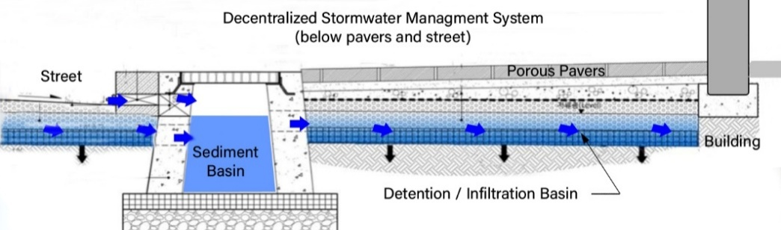In addition to storage and infiltration, the PLCC medium would act as a filter to adsorb and sequester toxic heavy metals and other microparticles that might be present in the surface stormwater runoff. For example, Martemianov et al. (2017) have shown that aerated concrete (i.e., aerocrete) has an adsorption capacity exceeding activated carbon and vermiculite-based adsorbents concerning heavy metal cations. Arsenic anions are adsorbed in amounts comparable to the ones of activated carbon-supported adsorbents.

To better understand the flow, absorption capacity, and durability of LCC and PLCC, the University of Utah has conducted additional constant head testing of PLCC specimens to define further design properties, including infiltration rates, hydraulic conductivity, storage capacity, infiltration rates, and strength and stiffness properties of LCC and PLCC (i.e., shear strength and resilient modulus) (Bartlett et al., 2024; Seely, 2024).

Fig. 7 Conceptual schematic of PLCC base (blue) as primary component in a decentralized Stormwater Management System

Constant head permeability testing was performed on sixteen 76.2 x 152.4 mm specimens created using AQUAERIX-LB™ foaming agent (Masloff et al., 2022) having a dry density ranging from 375 to 419 kg/m³ with an average of 408 and a standard deviation of 17.5 kg/m³. The total density ranged from 806 to 1005 kg/m³ with an average of 921 and a standard deviation of 84 kg/m³. The average hydraulic conductivity was 1.48-3 m/s, with a standard deviation of 1.37x10-3 m/s, an average absorption capacity of 51.3%, and a standard deviation of 7.37%. The buoyant uplift force varied from 1.90 to -0.047, averaging 0.771 kN /m³ with a standard deviation of 0.220 kN/m³. Additional constant head testing of seven larger specimens (152.4 x 304.8 mm) produced an average hydraulic conductivity of 1.23x10-3 m/s with a standard deviation of 4.91x10-4 m/s. The hydraulic conductivity for both series of tests falls within the medium permeability range (Table 1).

In some applications and systems, a nonwoven geotextile can be used as a separation layer between the cellular concrete and the basal or covered soil. Because nonwoven geotextiles are often needle-punched, this gives them a 3D structure more resistant to clogging woven alternatives, especially in applications with high fines content or biological activity. Geotextiles allow water to pass through while trapping fine particles when it is placed between fine and coarse materials (like soil and aggregate). Besides filtration, nonwoven geotextiles keep dissimilar materials separate, preventing fines from a subgrade layer from migrating upward into an LCC or PLCC base layer, helping maintain the system's structural integrity.

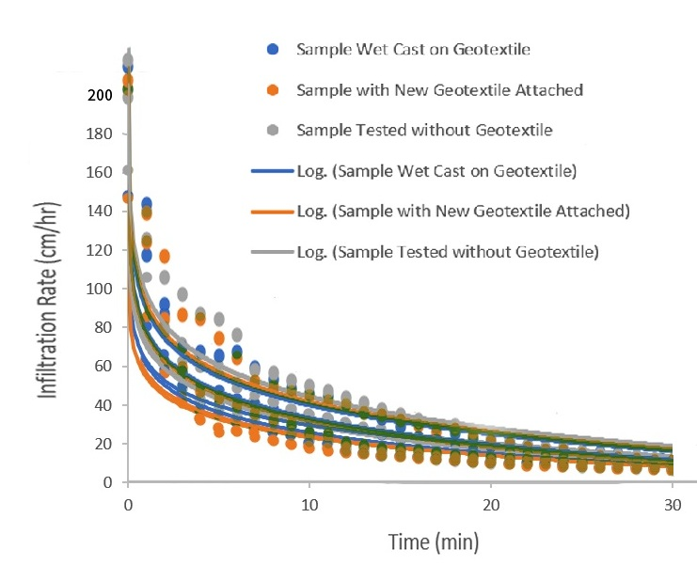However, when a wet, cement-based LCC or PLCC mixture is applied to a nonwoven geotextile fabric, there is the possibility of obstructing the fabric's pores at this interface and reducing the system's overall infiltration or drainage rate. To explore this, we prepared four 152.4 x 304.8 mm specimens and consecutively tested these using three variations of that included (1) wet casting of PLCC on the basal geotextile and infiltration testing after curing, (2) removing and replacing the original geotextile of the first variation with a new geotextile attached to the base of the cured PLCC sample and infiltration retesting, and (3) retesting samples with the geotextile of variation 2 removed (Bartlett et al., 2024). Four aired-specimens were prepared These air-dried specimens were subject to constant head gravity flow (i.e., vertical hydraulic gradient = 1) for 1 hour. Steady state flow was achieved after about 30 minutes. The average infiltration rates at t = 10 min. are 32.1, 30.2 and 34.6 and are 12.6, 11.0 and 13.7 at t = 30 min. for variations 1, 2, and 3, respectively. Therefore, the wet casting on and dry placement of the geotextile reduced the infiltration rates by 7.2 and 12.7 percent, respectively for t = 10 min and by 8.0 and 19.7 percent for t = 30 min, respectively.

Fig 8 Results of infiltration testing of PLCC for specimens prepared with and without a non-woven geotextile.

We also observed the wet casting of the PLCC on the geotextile produced a strong adhesion bond at this interface when cured. This bonding occurred because the PLCC mix had infiltrated the nonwoven geotextile during the casting of the specimens. Therefore, we conclude that the PLCC interface with a nonwoven geotextile may experience long-term plugging from biofouling or accumulation of fine-grained particle at this interface. However, additional studies regarding long-term plugging potential are warranted, including the use of different geosynthetic or natural materials.

# Durability

## Unconfined Compressive Strength (UCS)

We believe that the source of the unconfined compressive strength (UCS) is complex and primarily results from a combination of chemical bonding of the cement achieved during cement hydration and curing and a minor component from matric and osmotic suction. Notwithstanding, we recognized that the UCS cannot be guaranteed during the system's design life due to the potential for degradation from environmental factors and other loading conditions; hence, a resistance factor of less than 1.0 is required for LRFD design for long-term conditions.

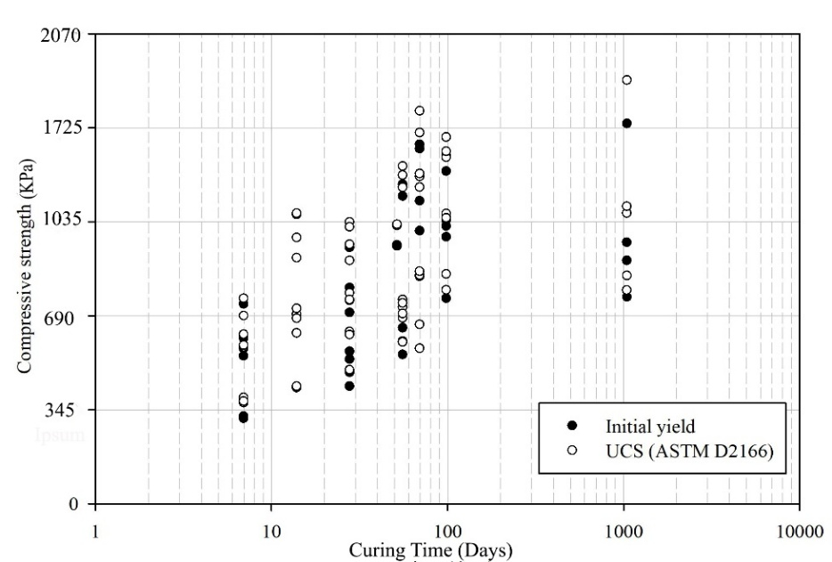However, the UCS test is relatively quick, inexpensive, and requires no specialized equipment beyond what is found in a typical material testing laboratory. Because of this, engineering practice primarily utilizes the UCS as an indicator of the quality of the LCC mix. Seely (2024) performed UCS testing on air-dried specimens throughout the curing process to understand LCC's strength gain with time. The test program included 57 UCS tests with curing ages ranging from seven to 99 days (Seely, 2024). The air-dried density ranged from 308 to 324 kg/m3. The series testing was subsequently terminated at 1,050 days of curing. We note that most specimens exhibited an initial reduction in strength before reaching the ultimate unconfined strength or a substantial deviation from the initial straight-line portion of the stress-strain curve. This strength loss (i.e., deviation from Young's modulus line) was recorded and identified as the initial yield. The peak strength and initial yield values for the test specimens as a function of time are shown in Fig. 7.

Fig. 7 Initial yield and the peak UCS of the air-dried LCC specimens as a function of time

These data were fitted with an exponential decay model (Eq. 1) where all regression coefficients are significant at p < 0.0001 (the probability that any coefficient is not significant, i.e., equals zero, is 1x10-4, or less). However, there is no significant strength gain after about t=70 days for practical purposes.

*UCS (psi)=143.6342(1-e (-0.1043·t))* (Eq. 1)

The specimens in the test program were also subjected to various times of submergence. The UCS test results suggest that the unconfined strength and its modulus are reduced by increasing the degree of saturation, but the effects are relatively minor (Seely, 2024).

## Triaxial Compression Strength (CIDTx)

Advantages of triaxial strength testing over UCS testing include allowance for back-pressure saturation, consolidation and confinement of the test specimen, and shearing under drained and undrained conditions. Therefore, the consolidation and loading of the specimens can more closely replicate field conditions. The equipment required to perform the tests is much less ubiquitous than the UCS test equipment but is relatively common in specialized geotechnical testing laboratories. Proper test performance requires more advanced training and time than the UCS test and, therefore, is more costly.

Tiwari et al. (2017) have suggested a conservative value for the effective friction angle of 35° be used for saturated design purposes. The authors have also reported that the partially saturated friction angle of 40° was obtained through direct shear testing, but the degree of saturation for this test is unknown. The authors suggest that the effective friction angle for design may be increased to 40° for Class-II or Class-IV LCC when subjected to normal stresses less than 1,000 kPa.

## Resilient Modulus

## Freeze-Thaw

Compressive strength, depth of initial penetration, absorption, and absorption rate are the important variables in producing cellular concrete that is resistant to cycles of freezing and thawing.

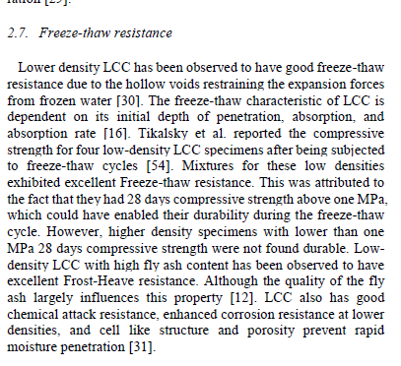

From Ni

Fatigue

6. Applications

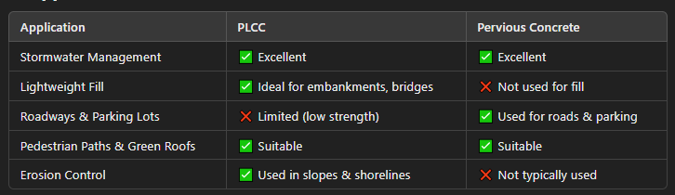

* Use PLCC when weight reduction is needed (e.g., bridge abutments, green roofs, erosion 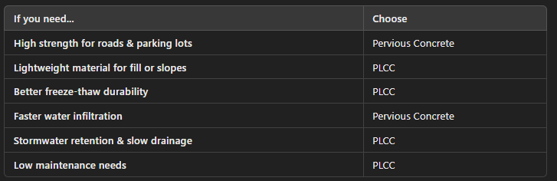

Both materials are valuable for sustainable construction, but their use depends on structural needs, load requirements, and permeability goals. Would you like assistance with a specific project or design?

# References

Alimohammadi V., Maghfour M., Nourmohammadi D., Azarsa P. Gupta R., Saberian M. 2021. Stormwater Runoff Treatment Using Pervious Concrete Modified with Various Nanomaterials: A Comprehensive Review, Sustainability 2021, 13(15), 8552; https://doi.org/10.3390/su13158552.

American Concrete Institute (ACI), Guide for Cast-in-Place Low-Density Cellular Concrete, 2006. ACI 523.1R-06.

Amran M., Onaizi A. M., Fediuk R., Danish A., Vatin N. I., Murali G., Abdelgader H.S., Mosaberpanah M.A., Cecchin D., Azevedo A. 2022. An Ultra-Lightweight Cellular Concrete for Geotechnical Applications - A Review, Case Studies in Construction Materials, Volume 16.

Amran, Y. H. M., N. Farzadnia, and A. A. Abang Ali. 2015. "Properties and applications of foamed concrete; a review." Construction and Building Materials, 101: 990–1005. https://doi.org/10.1016/j.conbuildmat.2015.10.112.

Anderson J., Bartlett, S. F., Dickerson N., and Poepsel P., 2012, Development of Seismic Design Approach for Freestanding Freight Railroad Embankment Comprised of Lightweight Cellular Concrete, ASCE GeoCongress 2012: State of the Art and Practice in Geotechnical Engineering <https://doi.org/10.1061/9780784412121.177>.

Armaghani, J.,2011. Structural Evaluation of Pervious Concrete on Cellular Lightweight Concrete (CLPC) Base, Global Sustainable Solutions, 27 p.

ASTM D3385-18 Standard Test Method for Infiltration Rate of Soils in Field Using Double-Ring Infiltrometer. ASTM International.

ASTM D2434-19. Standard Test Method for Permeability of Granular Soils (Constant Head). ASTM International.

ASTM D18 Committee. 2016. D5084-16a Test Methods for Measurement of Hydraulic Conductivity of Saturated Porous Materials Using a Flexible Wall Permeameter. ASTM International.

Averyanov S. 2018. Analysis of construction experience of using lightweight cellular concrete as a subbase material. Thesis. University of Waterloo, 94 p.

Bartlett, S. F., Peters, S. Arulmoli, A., 2020a. Mission Rock Lightweight Cellular Concrete Technical Advisory Panel (TAP) Technical Review Report (Addendum) Vol. 1 – Main TAP Report, 120 p.

Bartlett, S. F., Peters, S. Arulmoli, A., 2020b. Response to Comments and Questions Memo, dated June 25, 2020, on the Mission Rock LCC Technical Advisory Panel Review Report. Attachment 1.

Bartlett, S. F., Camargo-Gontscharow, T., Huang Y., 2024. Development of a Stormwater Detention/Infiltration System for Urban Highways Using Permeable Lightweight Cellular Concrete, Phase I, Technical Report for Project ID: 2021-UU-01, National Center for Transportation Infrastructure Durability & Life-Extension, 175 p.

Inti, S., Evans, T. W., Flores, M., Solanki, J.S., Chandramouli, C. V., 2021. Permeable Low-Density Cellular Concrete (PLDCC) as a Replacement for Aggregate Layers in Permeable Parking Lots, Development in the Built Environment, 2021.

Kozłowski, M., and M. Kadela. 2018. "Mechanical characterization of lightweight foamed concrete." Advances in Materials Science and Engineering, 2018: 1–8. <https://doi.org/10.1155/2018/6801258>.

Martemianov D., Xie B.-B., Yurmazova T., Khaskelberg M., Wang F., We C.-H. i, Preis S. 2017. Cellular concrete-supported cost-effective adsorbents for aqueous arsenic and heavy metals abatement, Journal of Environmental Chemical Engineering, Volume 5, Issue 4, 2017, Pages 3930-3941, ISSN 2213-3437, <https://doi.org/10.1016/j.jece.2017.07.063>.

Masloff B. and Palladino R. 2012. Lightweight Drainable Cellular Concrete. Patent No. US 8,172,937 B2.

Masloff, B., Feller, J. and Gomez, M., 2022. Low Buoyancy Cellular Concrete, U.S. Patent Application Publication US2022/0048817. Feb. 17, 2022.

Narayanan, N., and K. Ramamurthy. 2000. Structure and properties of aerated concrete: a review. Cement and Concrete Composites, 22 (5): 321–329. <https://doi.org/10.1016/S0958-9465(00)00016-0>.

Panesar, D. K. 2013. Cellular concrete properties and the effect of synthetic and protein foaming agents, Constr. Build. Mater. <https://doi.org/10.1016/j>. conbuildmat.2013.03.024.

Seely, D.D.B., 2024. Engineering Behavior of Type I Lightweight Cellular Concrete and the Effects of Partial Saturation and Confinement, Dissertation, Dept. of Civil and Environmental Engineering, University of Utah, 201 p.

Sutmoller N., Gomez M., and Kevern J. 2019. Soft Soil Remediation with Permeable Low-Density Cellular Concrete (PLDCC), MATEC Web of Conferences 271, 02002 (2019), Tran-SET 2019, <https://doi.org/10.1051/matecconf/201927102002>.

Sutmoller N., and Gomez M. 2022. An Introduction to Low-Density Cellular Concrete and Advanced Engineered Foam Technology - NAT2022. Society for Mining, Metallurgy & Exploration, 2022.

Taylor S., and Halsted G., Guide to Lightweight Cellular Concrete for Geotechnical Applications, 2021. PCA Special Report SR1008P, National Concrete Pavement Technology Center, 58 p.

Tikalsky P.J., Pospisil J., MacDonald W. 2004. A method for assessment of the freeze–thaw resistance of preformed foam cellular concrete. Cement and Concrete Research 34 (2004) 889–893

Tiwari B., Ajmera B., Maw R., Cole R., Villegas, D. and Palmerson, P., 2017. Mechanical Properties of Lightweight Cellular Concrete for Geotechnical Applications, J. of Mater. Civ. Eng. 2017, 29(7); 06017007.

Tiwari, B., Wykoff, J., and Villegas, D., 2020. Review of State of Practice – Use of Lightweight Cellular Concrete (LCC) Materials in Geotechnical Applications, California Nevada Cement Association, 68 p.

U.S. Environmental Protection Agency. 2012. "Cool Pavements." In: Reducing Urban Heat Islands: Compendium of Strategies. Draft. https://w—ww.epa.gov/heat-islands/heat-island-compendium.