The shear strength behavior of LCC varies depending on its density, confinement, water content and mode of shearing (direct simple shear versus triaxial shear). At higher dry densities (about 600 kg/m³ or higher), LCC behaves similar to a conventional cementitious material, with significant cohesion and tensile strength. However, at very low densities (about 500 kg/m³ or less), LCC exhibits characteristics similar to weakly bonded friable granular material, especially if the LCC is highly porous and has limited cementitious bonding. For the friable behavior,

While previous research suggests LCC behaves as a cohesionless material with a friction angle of up to 40° under normal stresses up to 100 MPa (Tiwari et al., 2017), this Seely (2024) indicates zero cohesion and a 65° friction angle for partially saturated conditions below 83 kPa confinement.

An initial curing period of approximately 70 days is needed for LCC to reach its peak strength Unconfined compressive strength (UCS) (Figure zzz). Therefore, normalizing the strength data to the 70-day strength enables accurate comparisons, prevents misinterpretations, and provides a reliable long-term strength value for design.

The UCS results ranged from 80 to 200 psi after the 70-day cure period, showing high variability across different saturation levels and cure times. The strength is primarily influenced by cement hydration and curing, with minor effects from matric and osmotic suction. While increasing saturation slightly reduces the UCS and modulus, the impact is minimal. Predictive models were developed to estimate peak UCS, initial yield stress, and unconfined Young’s modulus based on dry unit weight and saturation level.

Lightweight cellular concrete (LCC) behaves more like a cohesive material rather than a granular material. This is because LCC consists of a cementitious matrix with uniformly distributed air voids, which gives it a continuous, bonded structure. Unlike granular materials (such as sand or gravel), which rely on friction and interparticle interactions, LCC maintains its integrity due to cement hydration and bonding between particles.

g.

The degree of saturation impacts the shear strength and modulus in CIDTx compression more than confinement.

With a mean Poisson’s ratio of 0.231 equivalent to an at-rest lateral earth pressure coefficient of 0.3, is recommended for all saturation levels.

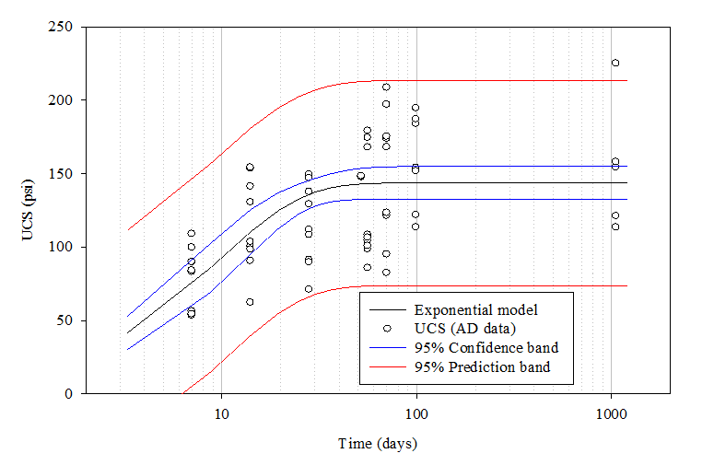

Figure zzz Initial yield and the UCS of the air-dried LCC specimens as a function of time.

**PLCC Uniaxial Compressive Strength Tests**:

* Figures 9 to 14 display the results of the uniaxial compression tests for batches 0, 1, and 2.
* Batch 0 has an average uniaxial compressive stress of 0.85 MPa with a fresh density of 29.6 pcf (4.65 kN/m³).
* Batch 1 has a lower average compressive stress of 0.40 MPa and a fresh density of 24 pcf (3.77 kN/m³).
* Batch 2 has an average compressive stress of 0.73 MPa with a fresh density of 25.27 pcf (3.97 kN/m³).

A study submitted to Aerix Industries analyzed Permeable Low-Density Cellular Concrete (PLDCC) and found that dry samples with fresh densities of 25 and 30 pcf (400 and 480 kg/m³) experienced compressive strength reductions of 30% and 23%, respectively, when saturated. However, samples with a fresh density of 35 pcf (560 kg/m³) showed no strength reduction upon saturation (Kevern, 2018). The PLDCC in that study was made with AQUAERiX-LB foaming agent, mixed in a 1:50 ratio with water to produce foam with a density of 2 to 2.1 pcf (32 to 33.6 kg/m³), which was combined with a water-cement slurry at a 0.50 ratio.

A comparison of Kevern’s results with the current study (Figure 16) shows that his samples had higher compressive strength than those from batches 0, 1, and 2. This discrepancy may be due to minor fractures in the current samples from the resilient modulus test or differences in foam density. Additionally, all tested PLDCC specimens in this study exhibited a similar failure pattern: rupture began at the bottom and propagated upward. This failure behavior may be linked to the production process, where lighter fresh PLDCC tended to concentrate at the top of the container and was used as the first layer in all molds.

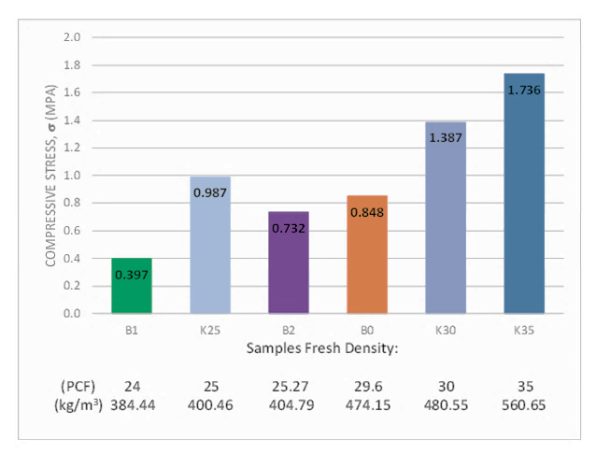

Unconfined Compressive Strength of dry PLDCC versus fresh densities.

References

Tiwari, B., B. Ajmera, R. Maw, R. Cole, D. Villegas, and P. Palmerson. 2017. “Mechanical properties of lightweight cellular concrete for geotechnical applications.” Journal of Materials in Civil Engineering, 29 (7): 06017007. https://doi.org/10.1061/(ASCE)MT.1943-5533.0001885.