Recommendations for instrumentation and testing program to monitor long-term performance and properties of lightweight cellular concrete

Objectives
The overall objectives of the monitoring and testing program are to evaluate the long-term performance and potential changes in the properties of lightweight cellular concrete (LCC) for an extended period for the Mission Rock Project. We recommend these objectives be evaluated data and information obtained via sampling, laboratory testing, field instrumentation, in situ monitoring, surveying, photogrammetry, and visual observations.

Array Locations
We recommend that the project team establish at least two array locations to be used for instrumentation and repeated in situ samplings of undisturbed specimens the LCC. It that one array is located in an LCC treated area that is near the northern extent of the project where tidal fluctuation is expected to be relatively large. The second array should be positioned further inland, where tidal influence is expected to be less. We recommend that an area approximately 15’ by 15’ be used for the array locations to accommodate the recommended LCC sampling and in situ monitoring instrumentation. Perhaps, the best places for the arrays would be in LCC landscaped areas where geotechnical drilling operations can be carried out.

Sampling

Frequency
We recommend that annual sampling be carried out for the first 4-year post-construction period, followed by biennial sampling for subsequent years up to a minimum of 10 years.

Method of Drilling and Sampling
Intact, undamaged, or uncracked specimens of LCC must be obtained for laboratory testing. Unfortunately, the LCC specimens may be damaged by routine geotechnical drilling and sampling methods. To minimize this potential, we recommend that triple tube coring and sampling be performed at the array locations. We recommend that the full depth of the LCC be sampled at each array and specimens visually inspected for any signs of disturbance or damage from the core drilling and handling. Specimens should be obtained above and below the water table for subsequent laboratory testing. In areas where daily water table fluctuation is significant, data from the array piezometer should be used to help determine the sampling depths.

Laboratory Testing
Specimens obtained from the coring operations should be tested for the following properties: (1) unconfined compressive strength, (2) permeability, (3) degree of saturation, (4) in situ unit weight, (5) dry unit weight. We recommend this suite of testing for specimens retrieve above the water table (i.e., partially saturated, i.e., moist) and specimens below the water table (saturated or nearly saturated, i.e., wet density). The depth and location of the specimens from the coring operations should also be documented. Photographs of the specimens should be taken before and after testing.
Unconfined compressive strength testing shall be done following ASTM C495. Permeability testing should be done following ASTM D2434, as modified by Castle Rock Consulting (see Attachment 1 of this letter). Degree of saturation, in situ, and dry unit weights, can be determined using ASTM D7263, or modifications to that.

Field Instrumentation and In Situ Monitoring

Piezometers
We recommend that one piezometer be installed at each array to monitor short-term and long-term fluctuations of the water table. The US Bureau of Reclamation (USBR 6515) can be used as a guide for the selection of the type and installation of the piezometer. Also, the geotechnical engineer of record (GEOR) should be consulted in selecting and installing the piezometers. The project team should determine the reading schedule of the piezometer in conjunction with the City Engineer. We also recommend an increase in the frequency of monitoring one week before any coring operations at the arrays to establish the maximum and minimum water levels during the field coring and sampling events.

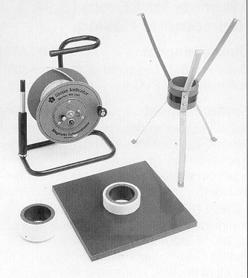
Magnet Extensometers and Settlement Plates
The magnet extensometer (also known as a borehole or magnet reed extensometer) is used to measure settlement in foundations and embankments (Fig. 1). Data gathered from the extensometer indicates the depths at which settlement has occurred as well as the total amount of settlement. This type of extensometer is especially useful for identifying the overall compression or settlement within targeted layers.
The position of the magnets must be pre-planned to capture settlement within specific layers of interest. Generally, a magnet is placed at the top and bottom of a compressible layer to measure the compression of that interval with time. Geotechnical subsurface explorations (e.g., CPT soundings) are a valuable tool for identifying compressible soil layers underlying the LCC and positioning of the spider magnets.
Figure 1 Magnet extensometer equipment. Tape reel (left). Spider magnet (right) and base plate magnet (center middle)
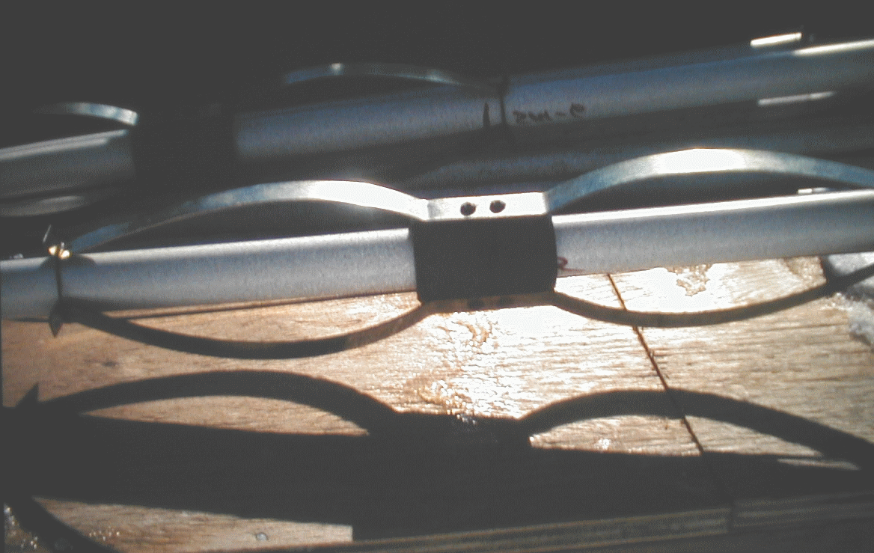
The first step in the installation of a borehole magnet extensometer is to drill a borehole to the desired final depth. We recommend that the borehole be completed to the bottom of the Young Bay Mud and a spider magnet installed at this depth. We also recommend a spider magnet be installed at a depth corresponding to the top of the Young Bay mud. Spider magnets are positioned in a retracted position along the access pipe at the appropriate depths (Figure 2). A locking cable is wrapped around the spider legs, and an anchor pull pin holds the locking cable in place. An anchor pull cable is attached to the anchor pull pin. The locking cable not only keeps the spider legs in the retracted position but also secures the spider magnet at the appropriate depth during installation. When the setup is complete, the access pipe sections are connected and placed down the borehole. The anchor pull cables are pulled, releasing the locking cables, and allowing the spider legs to spring into place. The borehole is grouted through a tremie pipe using a soft bentonite grout that will not impede the settlement of the ground.
Figure 2 Spider magnet in retracted position
We also recommend that a separate standpipe be used to measure any compression of the LCC using base plates positioned during construction at the base of the LCC and the top of the LCC.
For all installations, a protective secondary casing is placed around the top of the magnet extensometer. This casing keeps the access pipe free from debris and serves as a protective cushion. Also, because the magnet extensometer must be read from the top, reading access and safety must be taken into consideration in determining the instrument location.
Care should be taken in selecting the reference point for collecting and reducing the magnet extensometer data. Three possible reference points can be used: (1) bottom of the access tube casing, (2) depth to the bottom magnet, (3) top of the casing of the access tube.
If the extensometer is installed to a depth that is greater than the compressible layers (i.e., Young Bay Mud), then reference point (1) is often used. The selection of this reference point essentially assumes that the bottom of the casing will not settle significantly. If settlement does occur below this depth, it will not be possible to measure or estimate its magnitude. However, the results may still be used to calculate the relative movement and compression of specific layers between the magnets. The use of reference point (1) can also give erroneous readings if soil, obstructions, or other items are present or can enter and settle to the bottom of the casing. For this reason, it is often preferable to use reference point (2), where the bottom magnet is usually placed below the depth of the compressible zone. However, selecting reference point (2) also suffers from the same limitation of that of (1) because one is not able to measure the amount of settlement occurring below the reference point.
Reference point (3) can be used for installations where it is desirable or necessary to measure settlement occurring below the bottom of the casing or the bottom magnet. Using the reference point requires a corresponding optical level survey to be done at the top of the casing for each set of extensometer readings. With this information, it is possible to establish elevations for the top of the casing and each magnet position versus time. The settlement that has occurred below the bottom of the casing is simply the elevation of the bottom of the casing at the time of interest, minus the elevation for the same point established during the baseline reading. However, a slight caution is warranted for cases where rigid casing has been installed and where small settlement measurements are being attempted (e.g., creep settlements for geofoam). In this case, it is possible to have minor thermal expansion and contraction of the casing, which introduce a few millimeters of error into the calculations. We have found that even a few millimeters of thermal effects can partially obscure the small amount of creep settlement that occurs for geofoam installations. For this case, it may be better to select reference point (1) or (2) to interpret the data and neglect the settlement that is occurring below the LCC.
The project team should determine the reading schedule of the magnet extensometers in conjunction with the City Engineer. As a minimum, we recommend that the magnet extensometers be read quarterly for the first three years, followed by an annual reading in subsequent years. Also, the magnet extensometers should be read just before any coring of specimens submitted for laboratory testing.

Surface Survey Settlement Points
Surface settlement points are used to monitor the settlements of embankments, zones, and structures, MSE walls, buildings, etc. These measurements are used in conjunction with other data to provide a more comprehensive picture of the amount and settlement pattern throughout the project. The project team, in conjunction with the City Engineer, should determine locations for settlement points. Settlement points will also be required at each array location. Also, if surface effects of differential settlement appear with time (i.e., cracking of pavement, concrete, etc.), additional survey points should be installed at these locales.
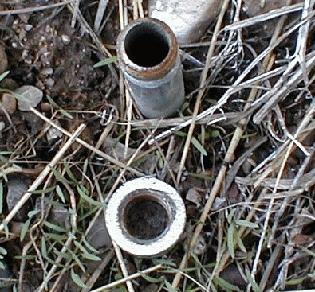
Settlement points are surface monuments that have been established by optical surveying and are monitored periodically to measure settlement by changes in elevation. These points consist of two basic types: those placed within the soil and those within concrete or pavement. Settlement points placed within earth include a cased piece of rebar that has been driven into the ground (Figure 3). The rebar is a 24-inch (610 mm) length of 3/8-inch diameter reinforcing bar (i.e., rebar), and the casing is an 18-inch (457 mm) long, ½-inch (12.7 mm) diameter capped galvanized steel pipe (i.e., thread-pipe riser). The length of rebar should be of sufficient length to penetrate below the frost heave depth. Settlement points placed within concrete are either a ¼-inch (6.4 mm) diameter lead plug that is placed in a pre-drilled hole or a PK nail driven directly into the pavement of a roadway or building foundation.
Figure 3 Settlement point with casing. Rebar has been driven or set into ground and cased.
To place a settlement point within a concrete surface (e.g., building foundation or concrete pavement), a ¼-inch (6.4 mm) diameter hole is drilled into the concrete. A hammer drill works best for drilling holes in high strength concrete. For settlement points placed directly in the concrete road surface, a lead plug that is slightly longer than the depth of the hole is inserted into the hole. The exposed portion of the plug is hammered flat until the top of the plug is nearly flush with the road surface. This type of settlement point is intended to be safe from snowplows. For settlement points not directly in the roadway surface, a PK nail is hammered into the hole. These nails have a fluting that is designed to lock tightly within the concrete sides of the pre-drilled hole.

Surveying of Settlement Points
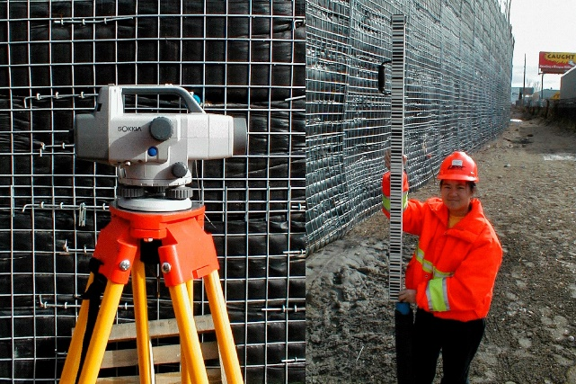
Experience has shown that great care must be taken to obtain accurate elevation information from surveying techniques. Generally, GPS or total station surveying will not provide sufficient accuracy to see relatively small movements expected for the Mission Rock Project. We recommend that digital differential level surveying be done using a Sokkia SDL30 Digital Level (or equivalent) and the corresponding RAB-Code (Random Bi-directional Code) staff, also known as the rod (Figure 4). The Sokkia SDL30 Digital Level is extremely operator-friendly. The technician need only aim the digital level at the rod, adjust the focus, and with a touch of a key, measure the height and distance. Readings can be taken at a distance of 5.3 to 328 ft (1.6 to 100 m). One side of the RAB-Code staff consists of a bar code, which is automatically read by the digital level. The digital level can interpret the unique code pattern on the rod and give height measurements to the nearest 0.004-inch (0.1 mm). Typically, the rod has a maximum height of 16.4 ft (5 m) and has a portable handheld level that is placed on the rod to ensure that the rod is vertical.
Figure 4 Self-reading digital level and rod
The selected benchmarks should be positioned on stable objects that can be relocated and reused on subsequent surveys. It also should be located so that a permanent point can be preserved without disturbance for an extended period (approximately ten years). The relative elevation of each of the survey points is then established by completing a level circuit. This circuit should be closed on the initial benchmark and adjusted, as necessary, to determine the baseline elevations of all survey points. Once the baseline survey is established, the amount of settlement is then measured by subsequent surveys by calculating the difference between the current reading and the initial baseline reading.
For the locations of the arrays, more than one benchmark should be established. In general, secondary benchmarks are placed at the array in the event something destroys the primary benchmark. In most cases, each survey can be performed solely by using the primary benchmark. However, periodically the elevations between the primary benchmark and the secondary benchmark(s) should be checked to verify that the primary benchmark has not been disturbed. If there is reason to suspect that the primary benchmark has moved, or the survey results appear to be suspect, the elevation of the primary benchmark should be checked against all secondary benchmark(s).
To ensure that survey error is kept to a minimum, each survey should be closed. This means that the survey should begin and end at the same benchmark. It is recommended that each survey should close with less than 3 mm of error. If a survey is completed and the total error is greater than 3 mm, then the survey should be repeated until the error is less than the required tolerance of 3 mm.
The project team should determine the reading schedule of the survey points in conjunction with the City Engineer. As a minimum, we recommend that the surveys be completed in conjunction with reading the magnet extensometers, i.e., read quarterly for the first three years, followed by an annual reading in subsequent years. Also, the survey points should be read just before any coring of specimens submitted for laboratory testing.

Photogrammetry and Visual Observations
These techniques offer a cost-effective and rapid way to inspect the overall performance of the infrastructure in the LCC treated areas. We recommend that Unmanned Aerial Vehicles (UAV) be used to perform an annual assessment of the infrastructure (primarily of the streets) by developing 2D Orthomosaic map(s). Also, if cracks develop in pavements or other concrete flat works, the location, size, and width of the cracks should be GPS located and photographed.
We recommend that the UAV survey be completed annually. Crack documentation and mapping should be done on an “as-needed” basis.
The TAP has some experience performing UAV reconnaissance using a DJI Phantom 4 version 2 UAV in conjunction with DJI Terra software. These are recommended for use.

Post-Earthquake Assessment
The TAP recommends that reading of field instrumentation, in situ monitoring arrays, surveying, photogrammetry, and visual observations, be repeated following earthquakes that produce 0.1 g peak horizontal ground acceleration in the Port of San Francisco area.
UAVs and field visual inspections should be done quickly to note any areas of potential damage or concern. Locations of buried utilities should also be inspected for any new cracking or damage to the LCC or associated utilities.

