FIELD-SCALE AND LABORATORY ASSESSMENT OF PERMEABLE AND NON-PERMEABLE LIGHTWEIGHT CELLULAR CONCRETE
by
Jun Ha Kim
A thesis submitted to the faculty of
The University of Utah
in partial fulfillment of the requirements for the degree of
Master of Science
Department of Civil and Environmental Engineering
The University of Utah
May 2025
Copyright © Jun Ha Kim 2025
All Rights Reserved

The University of Utah Graduate School

STATEMENT OF THESIS APPROVAL

The thesis of |  | Jun Ha Kim
has been approved by the following supervisory committee members:
Steven F. Bartlett |  |  |  | , Chair
 |  |  |  |  |  | ^{Date Approved}
Chris Pantelides |  |  |  | , Member
 |  |  |  |  |  | ^{Date Approved}
Pedro Romero Zambrana |  |  |  | , Member
 |  |  |  |  |  | ^{Date Approved}
and by | Tong Qiu |  |  |  | , Chair of
the Department of |  |  | Civil and Environmental Engineering
and by Darryl P. Butt, Dean of The Graduate School.

ABSTRACT
This study investigated the permeability characteristics and hydraulic performance of Lightweight Cellular Concrete (LCC) and Permeable Lightweight Cellular Concrete (PLCC) through laboratory-scale and field-scale testing. While both LCC and PLCC share a low-density structure created by introducing foam into a cement-water mixture, their hydraulic behaviors differ significantly, depending on the foaming agent and the resultant pore structures. Laboratory tests using constant-head permeability methods demonstrated that PLCC samples produced with AQUAERIX-LB foam exhibited a high permeability of 1.16 × 10⁻³ m/s, suitable for drainage and infiltration applications. In contrast, field-scale double-ring infiltrometer tests on LCC samples produced with AQUAERIX foam demonstrated significantly lower permeability (2.43 × 10⁻⁶ m/s untreated and 1.15 × 10⁻⁶ m/s after surface treatment), highlighting the impact of the foaming agent and surface conditions on performance.
The research identified critical factors influencing permeability, including foam selection, density, and surface treatments. Unexpectedly, surface removal intended to enhance permeability in LCC resulted in a decreased infiltration rate, suggesting that surface modifications of LCC should be evaluated on a case-by-case basis. Practical implications suggest that PLCC is suitable for sustainable infrastructure involving drainage and lightweight fills in flooded areas. In contrast, LCC is more suitable for applications requiring moisture resistance and structural stability, such as roadway and barrier infrastructure. Future research should address long-term durability under varying environmental conditions, advanced pore structure characterization, and broader comparisons with traditional permeable materials to enhance design predictability and optimize application strategies.

TABLE OF CONTENTS

ABSTRACT iii
LIST OF FIGURES vi
LIST OF TABLES vii
PREFACE OR ACKNOWLEDGMENTS viii
1 INTRODUCTION 1
Lightweight Cellular Concrete 2
Permeable Lightweight Cellular Concrete 6
Summary 9
2 METHODS 13
Cylinder Sample Production 14
Constant Head Permeability Test 15
Double Ring Infiltrometer Test 16
3 RESULTS 20
Constant-Head Permeability Test on Cylindrical PLCC Specimens 20
Modified Double-Ring Infiltrometer Test 20
4 DISCUSSION 25
Interpretation of Cylinder Test Results 25
Evaluation of the Double-Ring Infiltrometer Test 26
Comparison Between PLCC and LCC 27
Broader Context and Future Potential 29
5 CONCLUSION 30
REFERENCES 34

LIST OF FIGURES
Figures
1. Different Textures between LCC (A) and PLCC (B). 11
2. Cylinder PLCC Samples for Constant Head Test. 18
3. Gravel Base of Double Ring Infiltrometer Test. 18
4. Geotextile Fabric Placed Between Gravel and PLCC. 18
5. LCC in the 4ft tank with double-ring infiltrometer set 19
6. Relationship between Permeability and Density 23
7. Non-porous (L) and Porous (R) Texture of LCC 24
8. Summary of Hydraulic Conductivity 24

LIST OF TABLES
Tables
1. Summary of LCC Applications Based on Density [14]. 11
2. Cellular concrete material strength and density [1] 12
3. Permeability of PLCC 23
4. Permeability of Sand from Double-Ring Infiltrometer Test 23
5. Permeability of LCC from Double-Ring Infiltrometer Test 24

ACKNOWLEDGMENTS
I want to thank the TriDurLE Transportation Center for its partial funding of this research. In addition, the University of Utah Department of Environmental Engineering helps sponsor me through funded teaching assistantships. Without this funding, this research would not have been possible.

CHAPTER

1
INTRODUCTION
Lightweight Cellular Concrete (LCC), produced by mixing cement, water, and foam, is widely used in civil engineering for applications where reduced weight and ease of placement are beneficial. Its low unit weight and good workability make it a practical choice for backfill, insulation, and load reduction in geotechnical and structural applications. In recent years, a permeable variant of this material, known as Permeable Lightweight Cellular Concrete (PLCC), has emerged. PLCC retains the lightweight characteristics of LCC but incorporates an interconnected pore structure that allows water to pass through, making it suitable for applications requiring both drainage and load reduction.
LCC and PLCC differ significantly in their hydraulic behavior, foam composition, and optimal density ranges. While LCC has been widely adopted for use in soft ground improvement and structural support, PLCC is still under investigation, particularly regarding its long-term field performance and durability. Understanding their material properties, application contexts, and performance limitations is crucial for practical use, particularly since field-scale studies of PLCC remain relatively limited.

Lightweight Cellular Concrete
Lightweight Cellular Concrete (LCC) is a type of concrete made by mixing Portland cement, water, and preformed (or in situ) foams. According to the American Institute of Concrete [1], LCC is a type of concrete with an oven-dried unit weight of 50 PCF (800 kg/m³) or less. When the concrete mixture dries, the foam creates air bubbles in the concrete, giving its unique low density and porous properties. LCC has been applied in various fields of civil engineering, such as construction, structural, and geotechnical applications. Depending on the density of the LCC, it can be utilized as a soundproof or fireproof material with insulation properties, as a flooring filler, lightweight mortar, and as slabs, according to [2] and [3]. In the geotechnical field, based on its mechanical properties, it can be used as a backfill for Mechanically Stabilized Earth (MSE) Walls [4] or as a backfill for reinforced retaining walls [5]. MSE is often a low-cost but effective solution in sites with high estimated settlement. LCC can be a component of MSE to lower the total load applied on the foundation. When applying LCC in MSE, LCC's low density, angle of internal friction, buoyancy of LCC, and required reinforcement length must be considered in the design. The significant factors that designers should consider are material properties, construction loads, buoyancy, cracking of LCC, inspection, design parameters of MSE structures, and communication between stakeholders.
Other geotechnical applications include utilizing LCC as a coating and stabilizing tunnels to reduce vault settlement by 61 percent [6]. In structural applications, it is used as thin walls with reinforcements. LCC also has several advantages over traditional Portland cement concrete. The use of foam in the mixture enables a reduction in the weight of LCC by up to 80 percent compared to conventional concrete. Additionally, the cost of raw materials is lower than that of traditional concrete, and it has a more straightforward application process than mixing aggregates. The ease of application is primarily because LCC does not require compaction or vibration. Like conventional concrete, fibers or reinforcements can be used to increase their compressive strength [6]
Although LCC is used in many fields for various purposes, utilizing it in real applications based on the properties of LCC, as defined by previous studies, needs careful design. This limitation is because the studies were primarily laboratory experiments with few field-scale tests. In addition, the properties of LCC depend on factors that are difficult to control, such as the foaming agent, mixing method (including mixing speed), and mixture design. Therefore, methods are required to standardize the properties of LCC for consistent application.
The three main constituents of LCC are cement, foam, and water [1]. The foaming agents are the most critical material in LCC because they significantly affect its properties, such as density, strength, pore size, and distribution [7]. Therefore, it is crucial to have consistency in foam quality. When preparing the foam, the dilution ratio of the foaming agent to water ranges from 1:30 to 1:50 [2]. Compared to wet foam, dry foam is produced in a mixing unit using compressed air. They are more stable and easier to mix with concrete slurry. Various foaming agents, such as detergents and saponins, are used to produce cellular concrete. However, two commonly used foaming agents are synthetic and protein-based. Synthetic agents are hydrophilic, creating air bubbles as they dissolve in water. In the process, this lowers the surface tension, leading to expansion and a decrease in the density of the concrete. On the other hand, protein-based agents break down into small hydrophobic molecules, which produce bubbles by reducing surface tension [8]. This process also forms smaller closed-air bubbles, resulting in higher compressive strength [2].
When making the slurry for mixing LCC, the W/C ratio ranges from 0.4 to 1.25. W/C ratios outside this range make mixing the foam with the concrete more difficult. Lowering the ratio will increase strength if the W/C ratio remains within this range. However, in most studies, a W/C ratio of about 0.5 is used [6]. Another mixing criterion to consider is the use of purified water without organic matter, which is recommended as its presence can affect the foam structure [1].
Unlike traditional concrete, cellular concrete often does not require aggregates, making it more cost-effective and easier to construct [9]. Instead of aggregates, fillers are typically used to reduce the amount of cement needed. Adding fly ash reduces the required cement and the hydration temperature. However, the presence of fly ash can reduce the bubble, increasing compressive strength [10]. Additional admixtures or additives are considered supplements in the mixture to enhance its properties. Blast furnace slags also help reduce the required cement by 30 percent [11].
Additionally, the introduction of superplasticizers enhances both compressive strength and workability. Micro-silica helps form round pores in LCC, resulting in higher strength and insulation effect. It also reduces the density of LCC [6]. Other materials, such as plastic waste from polymers like PVC or polystyrene, can enhance its soundproofing or insulation effect. However, they can negatively affect the compressive strength of LCC [6]. Much like traditional concrete, admixtures are a viable option for enhancing the desired properties of LCC, allowing for its use in various applications.
When preparing the concrete mix, the cement slurry, with the desired water-to-cement (W/C) ratio, and the diluted foam are produced simultaneously. When mixing, the foam is gradually added to the slurry until the target density is reached [12]. This mixing method may cause inconsistency in the ratio between foam and slurry depending on the total volume of the mixture. Further studies may be needed to homogenize the mix ratio of foam and slurry and reduce density separation within the mix.
Due to the variability of properties among different LDCCs, these are classified based on their density. The compressive strength of LCC increases with density. In a study by Tiwari [13], the mechanical properties of Class II and Class IV LCC were explored. Class II has a unit weight of 30-35 pounds per cubic foot (pcf), and Class IV has a unit weight of 43-49 pcf. Based on their experimental data, Tiwari [13] established an empirical relationship between the unconfined compressive strength and the unit weight of LCC. The anisotropically consolidated (i.e., K₀ consolidation) earth pressure coefficient for Class II ranged from 0.4 to 0.5. For Class IV, the K₀ value ranged from 0.2 to 0.3. The value of Poisson's ratios of both classes ranged from 0.20 to 0.30. Tiwari [13] recommended an effective friction angle of 35 degrees for saturated LCC, with cohesion of 11 psi obtained from triaxial tests.
LCC is utilized in various geotechnical and civil engineering applications because of its unique mechanical properties. These include lightweight, workability, low cost, insulating effect, and more. Due to its wide range of densities, its application can be classified according to density ranges. Table 1 summarizes the application of LCC based on density [14]. LDCCs with higher densities ranging from 60 to 90 PCF are applied as cast-in-place walls, house applications, or load-bearing elements. LDCCs with densities of 20 to 40 PCF are used to stabilize soil and sublayers in roadway construction. The permeability of LCC is strengthened to allow water retention when applied underground. This cellular concrete, which focuses on its permeability properties, is known as permeable low-density cellular concrete (PLCC).

Permeable Lightweight Cellular Concrete
Permeable Lightweight Cellular Concrete (PLCC) is made using synthetic foam with microscopic pores. These foams create a porous texture, which increases the permeability of the concrete. Figure 1 shows the difference in texture between LCC and PLCC. LCC (A) exhibits a dense structure with little to no visible voids, whereas PLCC (B) has a noticeably porous structure with a significant number of interconnected voids. Because permeability is an essential property of PLCC, the target density must be met to get the desired texture. The primary difference between PLCC and LCC, where LCC is a relatively low permeability mix, lies in differences regarding hydraulic conductivity and water absorption. However, PLCC offers other advantages, such as freeze-thaw resistance, workability, and insulating properties [15]. Unlike LCC, PLCC utilizes coalescing bubbles to produce larger, connected voids, resulting in higher retention and transmission of water [16]. Due to these unique properties, PLCC can be used as a subbase drainage layer, replacing traditional fill materials, such as aggregates, in various types of construction. (However, if limited drainage is described, the use of LCC as a subbase layer significantly decreases the infiltration rate compared to using aggregates.) However, the infiltration rate found by [15] was within the expected permeability range (8.33⁻¹²–5.00x10⁻¹ cm/s) [15]. However, these authors concluded that PLCCs mixes with densities less than 25 PCF were too weak and crumbled when handled, which would generally disqualify PLCC as a roadway material. However, PLCC densities between 25 and 32 PCF had smooth and non-porous surfaces. Thus, PLCC with this density range may be more desirable. These authors measured the permeability of PLCC and the infiltration rate of the paving system (with and without PLCC). A falling head permeability test showed that higher PLCC density and higher fly ash ratio resulted in lower permeability.
The case study of the remediation of West Lake Eloise Drive shows the use of PLCC as drain material for roadways. The study demonstrated that PLCC can remediate settlement and serve as a solution for roadway elevation applications in areas with a high water table and localized flooding. The placement of PLCC, with a density of 30 PCF, has been proven effective in reducing hydrostatic pressure and providing increased roadway elevation with significantly less load on the roadway foundation soils [16]. However, since the dry density of conventional fill material is about 4 to 5 times heavier than that of PLCC, and PLCC's density is lower than that of water, it should be used only as a sub-layer with sufficient cover to prevent hydrostatic uplift [18].
Although PLCC received attention in the 2000s, its properties, especially the hydraulic properties, are less well-defined compared to LCC, as determined by experimental and field-scale measurements. Hwang [19] studied the hydraulic properties of PLCC on a laboratory scale. In addition, Gontscharow [17] studied the mechanical properties of PLCC. However, due to its variability and potential inconsistency resulting from the foam structure and its placement, field measurements are recommended to define the macro-scale and long-term properties of PLCC.

Various tests were done to measure the permeability of PLCC. One type of laboratory test is the falling head permeability test. The bottom-up falling head test can be suitable for PLCC as it can measure small pressure heads, which PLCC will usually be exposed to in field conditions. Another test that can be used in calculating the permeability of PLCC is the constant head permeability test. Huang [19] used a Mariotte bottle to maintain a steady water level, allowing for a constant pressure level. The study was conducted following ASTM D2434-68 [20]. The permeability rates obtained from testing 25 PCF PLCC were 1.4 × 10⁻² cm/s (50.4 cm/hour) and 32.6 PCF as 2.2 × 10⁻³ cm/s (7.92 cm/hour) [19]. This range is comparable to that of traditional fill materials.
For many applications, the mechanical properties of LCC and PLCC are essential. Although not a focus of this study, Table 2 [1] provides the compressive strength and the modulus of elasticity of LCC based on the density of cellular concrete. At a desired density of 25 to 35 pcf, cellular concrete has a 28-day compressive strength of 125 to 350 psi. Sutmoller [18] suggests that PLCC, with a density of 30 PCF, has a compressive strength of 225 psi. This result is comparable to a study by [17], which found that PLCC, with a density of 29.6 PCF, has a uniaxial compressive strength of 123 psi.
However, it is worth noting that the compressive strength of permeable materials is often influenced by saturation and should be taken into account in system design. However, Sutmoller [18], based on limited testing, suggests that PLCC was able to maintain its compressive strength when it was saturated or partially saturated. Later, more extensive testing of Gontscharow [17] explored the uniaxial compressive strength of PLCC when it was dry and saturated. PLCC, with a density of 25 PCF, exhibited a 30 percent reduction in compressive strength, a 30 PCF reduction, and a 23 percent reduction when saturated. The same testing showed that 35 PCF density PLCC had no reduction of compressive strength. Thus, it was concluded that the compressive strength of PLCC at lower densities can be affected by saturation. Nonetheless, these results suggest that PLCC can be utilized as a subbase material for roadways, replacing traditional subbase materials such as aggregates, provided that its lower strengths are accounted for in the pavement design. However, PLCC is not recommended as a base material. Also, the variability and differences between the findings of these studies need further investigation.

Summary
Lightweight Cellular Concrete (LCC) and Permeable Lightweight Cellular Concrete (PLCC) represent related yet distinct variants of Cellular Concrete, each offering specialized benefits tailored to specific application design requirements. The principal distinctions between LCC and PLCC involve foam selection, pore connectivity, and permeability characteristics. Both materials, however, share common advantages such as reduced unit weight, cost-effectiveness, and ease of installation. Choosing between LCC and PLCC ultimately depends on specific project requirements, including desired permeability, structural needs, environmental conditions, and long-term durability considerations.
LCC has long been utilized for reducing structural loads, providing insulation, and stabilizing soft soils. Its suitability for general fill applications and structural backfills is well-documented and extensively proven in practice. In contrast, PLCC introduces engineered permeability, addressing the growing need for effective water management and sustainable drainage solutions in infrastructure projects. PLCC's carefully controlled pore structure enables it to serve as a viable alternative to traditional permeable materials, particularly in applications that emphasize drainage and water infiltration.
Further research, particularly involving field-scale performance evaluations and pore-structure characterization, is necessary to refine design guidelines and enhance the predictive capability of both LCC and PLCC applications. Despite differences in development maturity, both materials have clear roles in modern civil engineering practice, particularly as sustainability and resilience become increasingly important in infrastructure design.
This research aims to compare the hydraulic properties of Permeable Lightweight Cellular Concrete (PLCC) and conventional Lightweight Cellular Concrete (LCC) through both laboratory-scale and field-scale testing to evaluate their suitability for various geotechnical applications. By examining permeability, water absorption, and related hydraulic behaviors, the study identifies differences between the two materials and assesses how these differences affect performance in field conditions. Based on this comparison, recommendations are made for the appropriate applications of PLCC and LCC, particularly in contexts where drainage, load reduction, and material stability are crucial.

Table 1. Summary of LCC Applications Based on Density [14]
Density (PCF) | Application
20-40 | For soil material replacement, stabilization, and raft foundation
30-40 | Used to stabilize a redundant, geotechnical rehabilitation and soil settlement, pavement construction.
40-50 | Used in void filling as an alternative to granular fill. Some applications include the filling of old sewerage pipes, walls, basements, and subways.
50-55 | Used in the production of blocks and other non-load bearing building elements such as balcony railing, partitions, parapets, etc.
70-90 | Used in prefabrication and cast-in-place walls, either load-bearing or non-load bearing and floor screeds.
90-95 | Housing applications.
100-110 | Recommended for slabs and other load-bearing building elements where higher strength is required.

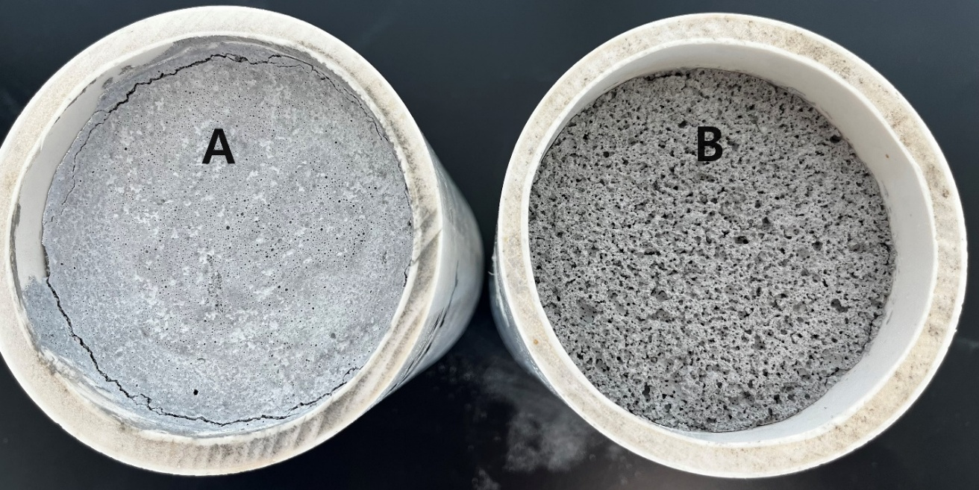
Figure 1. Different Textures between LCC (A) and PLCC (B)

Table 2. Cellular concrete material strength and density [1]
Oven-Dry Density |  | Usual Range of Compressive Strength at 28 Days |  | Modulus of Elasticity
lb/ft³ | kg/m³ | psi | MPa | 10³ psi | GPa
20 to 25 | 320 to 400 | 70 to 125 | 0.48 to 0.86 | 30 to 52 | 0.21 to 0.36
25 to 30 | 400 to 480 | 125 to 225 | 0.86 to 1.55 | 52 to 89 | 0.36 to 0.61
30 to 35 | 480 to 560 | 225 to 350 | 1.55 to 2.41 | 89 to 135 | 0.61 to 0.93
35 to 40 | 560 to 640 | 350 to 450 | 2.41 to 3.10 | 135 to 183 | 0.93 to 1.26
40 to 50 | 640 to 800 | 450 to 750 | 3.10 to 5.17 | 183 to 320 | 1.26 to 2.21

CHAPTER

2
METHODS
The primary objective of this research was to investigate the permeability characteristics of Permeable Lightweight Cellular Concrete (PLCC) and, unintentionally, Lightweight Cellular Concrete (LCC) under field-scale conditions. While the original intention was to evaluate PLCC, specifically designed to allow water infiltration, the field-scale concrete provided by Aerix Industries was later identified as standard LCC made with AQUAERIX foam, which lacks engineered permeability compared to PLCC. Despite this distinction, both materials were examined to compare their hydraulic behavior and to highlight the critical role of mix design and foam agents. Understanding the permeability performance of PLCC and LCC is essential for their respective applications in infrastructure projects.
This research involved a three-phase experimental program, progressing from laboratory-scale validation to field-scale evaluation.The first phase involved preparing cylindrical PLCC samples with target densities ranging from 24 to 32 PCF. These samples were produced using AQUAERIX-LB, a foaming agent provided by AERIX INDUSTRIES. The specimens were tested to validate and compare their permeability with results previously documented by Huang [19] and other related studies. In the second phase, a 4 ft diameter cylindrical tank was used to conduct double-ring infiltrometer tests on concrete sand. These tests served as validation trials to ensure the accuracy and operational reliability of the large-scale testing setup. In the final phase, the permeability of LCC was evaluated using the same double-ring infiltrometer test setup. This phase aims to obtain field-scale permeability data that reflect actual performance conditions. Notably, the LCC tested in this phase was produced using AQUAERIX, a different foaming agent from the AQUAERIX-LB used in the earlier PLCC samples.

Cylinder Sample Production
Cylindrical PLCC specimens were produced using AQUAERIX-LB foam, provided by AERIX INDUSTRIES, diluted with water with a 1:50 ratio. To achieve specific target densities, foam density was strictly regulated at 2.5pcf, following previous research. Throughout the entire production process, a constant water-to-cement ratio of 0.55 was maintained to ensure consistent quality and reproducibility of the samples. This water-to-cement ratio is extensively used in industry practices for PLCC to ensure optimal balance between workability, structural integrity, and permeability.
The initial foam-to-slurry volume ratio was calculated to be approximately 2.84:1, based on assumed foam and slurry densities of 2.5pcf and 108pcf, respectively. Through iterative mixing and adjustments, the desired wet density of approximately 30 PCF was achieved by incrementally increasing the foam content. As the mixing process progressed, it was observed that the amount of foam required to achieve the target density varied between trials, making a trial-and-error approach necessary during the initial stages of specimen preparation. The initial focus of the experimental process was solely on achieving the target density with consistency.
The density of each cylinder was calculated by dividing its mass by its total volume. The first four samples had the same volume, while the remaining five samples varied in volume. After achieving the target density, the permeability of PLCC was tested on larger cylinder samples, where PLCC was poured only to one-third of the cylinder height, and the rest of the cylinder was filled with water.

Constant Head Permeability Test
The constant head permeability testing was conducted using 6-inch-diameter and 12-inch-tall cylindrical plastic concrete molds specifically prepared for this experiment. Each cylinder mold had its bottom section removed, enabling water drainage. The molds were deliberately filled partially to provide adequate space for conducting permeability measurements effectively. Additionally, an opening was placed near the top of the cylinder to establish and maintain a consistent hydraulic head without water overflow. Figure 2 presents a representative sample of the PLCC used in the experiment.
Permeability (k) was calculated using the Darcy's law,
$$q=k∙i∙A$$
where i is defined as the hydraulic gradient, q represents the measured flow rate, and A is the cross-sectional area. Initially, two PLCC samples exceeded the target density and were therefore excluded from permeability measurements. Consequently, comprehensive permeability data was obtained from nine selected samples.

Double Ring Infiltrometer Test
The double-ring infiltrometer test provides an assessment of LCC's permeability at scales closer to actual construction projects. Testing of PLCC at a similar scale would have been desirable, but the project was not deploying this mix.
The LCC testing procedure was based on ASTM D3385–18, with appropriate modifications for laboratory implementation. The test involved the installation of concentric metal rings on the LCC surface, where the inner ring was continuously filled with water to maintain a constant head. A Mariotte bottle was used to supply a constant head of water to the inner ring while the outer ring's water level was manually maintained. The Mariotte bottle also made it possible to measure the amount of water supplied, which was used to calculate the infiltration rate for permeability evaluation.
To closely simulate realistic construction conditions, the experimental setup consisted of a cylindrical tank with a diameter of 4 ft, filled with a 6 in. compacted gravel layer, over which a 1 ft thick LCC layer was cast. Figure 3 shows the gravel base. A geotextile fabric was placed between the gravel and the overlying material to prevent particle migration and maintain the integrity of the layered system (Figure 4). Before conducting the actual tests using LCC, preliminary trials were performed using concrete sand. A 1-foot-thick sand layer over a 6-inch gravel base was initially tested. The results obtained were compared with known permeability values of standard sand, ensuring the validation of test accuracy and reliability.
Following verification of the test setup, LCC was produced with technical assistance and materials provided by AERIX INDUSTRIES, using the AQUAERIX foam. The LCC slurry was poured into the tank and leveled. During the initial setting period, the double-ring apparatus was carefully suspended so that the inner and outer rings were embedded to depths of 1 inch and 2 inches, respectively. This process ensured minimal disturbance to the PLCC structure while enabling accurate vertical infiltration measurements. Figure 5 shows the dried LCC in the 4ft tank with a double-ring infiltrometer set.
The permeability test was conducted after a 24-hour saturation period to ensure that the LCC's pore structure had fully absorbed water. The permeability test was conducted after a 24-hour saturation period to ensure that the LCC's pore structure had fully absorbed water. Additionally, before saturation, the samples were allowed to cure for 7 days to ensure sufficient cement hydration, a crucial step in developing representative permeability characteristics. Initially, the surface of the LCC appeared non-porous, which was assumed to have restricted infiltration. To expose the pores on the surface, approximately ¼ inch of the surface layer was removed. The permeability test was then repeated on the treated surface to explore whether the exposed porous texture could improve the accuracy of infiltration capacity assessment.

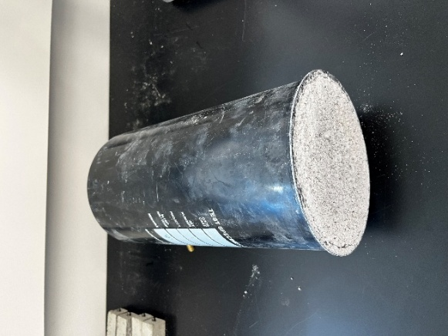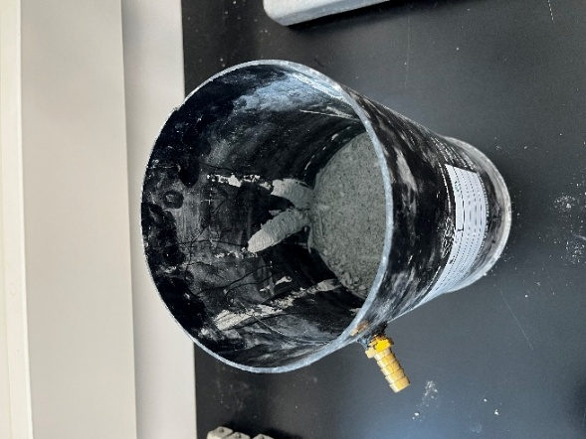
Figure 2. Cylinder PLCC Samples for Constant Head Test
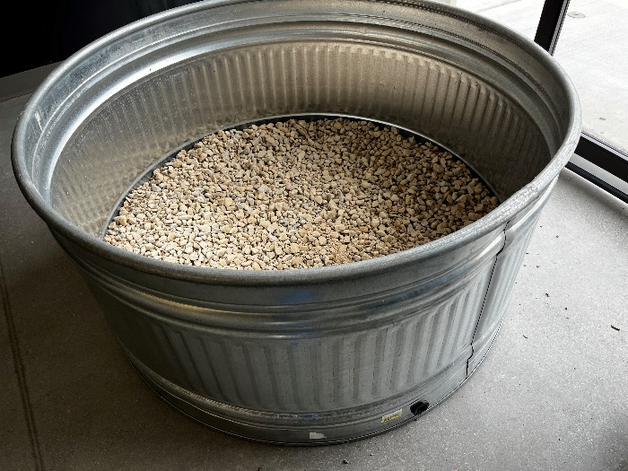
Figure 3. Gravel Base of Double Ring Infiltrometer Test
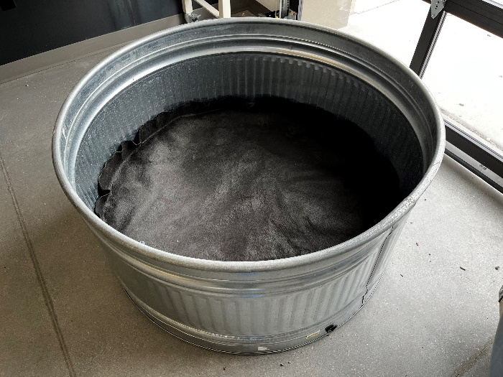
Figure 4. Geotextile Fabric Placed Between Gravel and PLCC
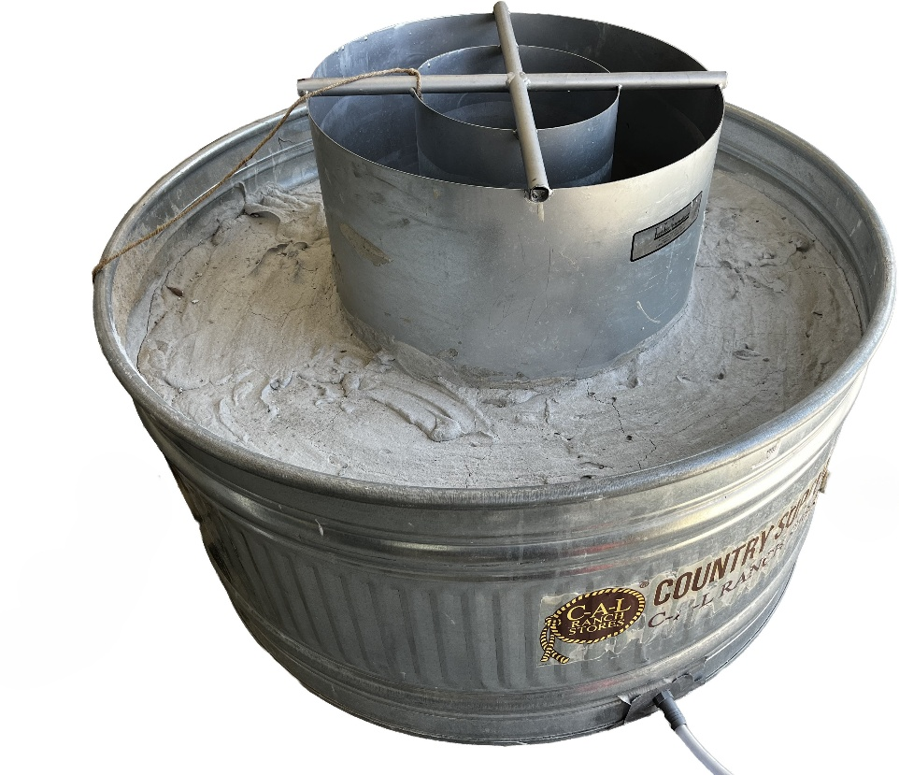
Figure 5. LCC in the 4ft tank with double-ring infiltrometer set

CHAPTER

3
RESULTS

Constant-Head Permeability Test on PLCC Cylinder Specimens
Permeability tests conducted on cylindrical PLCC specimens using the constant-head method revealed measurable differences in hydraulic conductivity based on the achieved density of each sample. Two initial specimens with densities around 40 PCF, which were significantly higher than the intended maximum of 32 PCF, were excluded from further analysis as they did not represent the target material properties. The remaining specimens, which fell within the designated density range of 24 to 32 pounds per cubic foot (PCF), exhibited consistent permeability behavior suitable for comparative evaluation.
The saturated permeability values, calculated using Darcy's law, are summarized in Table 3. A general trend of decreasing permeability with increasing density was observed, consistent with the expected inverse relationship between void ratio and flow capacity (Figure 6). Minor variability among samples was attributed to small inconsistencies in the dispersion of foam during mixing with the cement grout.

Modified Double-Ring Infiltrometer Test
To validate the reliability of the large-scale testing apparatus, a preliminary infiltration test was conducted using concrete sand. The measured infiltration rates closely aligned with standard values reported for uniformly graded clear sands, typically ranging from approximately 10⁻⁴ to 10⁻⁶ m/s. The average permeability obtained from the sand test was approximately 6.65 × 10⁻⁵ m/s, further confirming the accuracy and consistency of the experimental setup. The permeability values obtained from the sand infiltration test are summarized in Table 4.
Following validation, LCC samples with a target dry density of 28 PCF were tested. However, the average density obtained from the measurements was 31.4 PCF, exceeding the intended target density. The significant reduction in permeability, from 1.16 × 10^ (- 3) m/s to 2.43 × 10^ (- 6) m/s, is primarily attributed to the difference in foam agents used. Unlike the PLCC samples produced with AQUAERIX-LB, the LCC was made using AQUAERIX, which resulted in a denser and less permeable matrix.
After the LCC specimen was thoroughly dried, the surface appeared dense and non-porous, with no visible voids or infiltration pathways. It was hypothesized that this surface was created by a minor separation of the cement at the surface, creating a non-porous paste. Once a thin surface layer was carefully scraped away using a thin, sharp blade, an underlying porous structure became apparent, revealing a previously unexposed network of voids. This visual observation is illustrated in Figure 7, which contrasts the as-cast surface condition with the exposed porous texture following light surface removal.
To further examine the influence of surface texture, approximately ¼ inch of the surface was manually removed to reveal the underlying porous texture. However, contrary to initial expectations that the infiltration rate would improve, the retested infiltration rate decreased to 1.15 × 10⁻⁶ m/s after surface removal. This result suggests that surface disturbance and damage may cause localized heterogeneity and significantly influence water movement through the material. Figure 8 summarizes the hydraulic conductivities of PLCC, concrete sand, and LCC.
Unfortunately, these results indicate that LCC exhibits relatively low permeability and that surface preparation alone may not uniformly enhance hydraulic performance. Comprehensive infiltration data for both non-porous and porous conditions are presented in Table 5. The test results demonstrated a clear difference in permeability between PLCC and LCC. While PLCC samples allowed measurable infiltration, LCC samples exhibited much lower permeability. This contrast is primarily attributed to the different foam agents used in the production of the PLCC and LCC.
Table 3. Permeability of PLCC
Sample | Density (pcf) | k (m/s)
1 | 39.68 | NA
2 | 40.36 | NA
3 | 31.14 | 7.93E-04
4 | 32.03 | 7.49E-04
5 | 24.69 | 1.67E-03
6 | 24.71 | 1.73E-03
7 | 26.06 | 1.71E-03
8 | 31.90 | 1.34E-03
9 | 37.60 | 1.44E-04
10 | 29.25 | 1.69E-03
11 | 32.37 | 6.28E-04
Average | 29.97 | 1.16E-03
Standard Deviation | 4.01 | 5.59E-04
COV | 13.38 | 48.12

Figure 6. Relationship between Permeability and Density
Table 4. Permeability of Sand from Double-Ring Infiltrometer Test
K (m/s)
Trial 1 | Trial 2 | Trial 3 | Trial 4 | Trial 5 | Trial 6
7.07E-05 | 7.09E-05 | 5.71E-05 | 6.57E-05 | 7.01E-05 | 6.46E-05

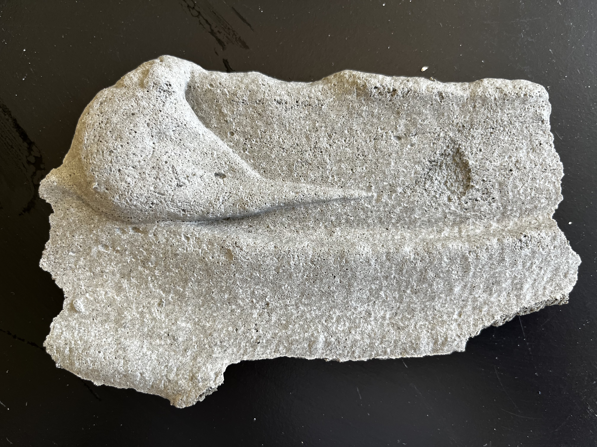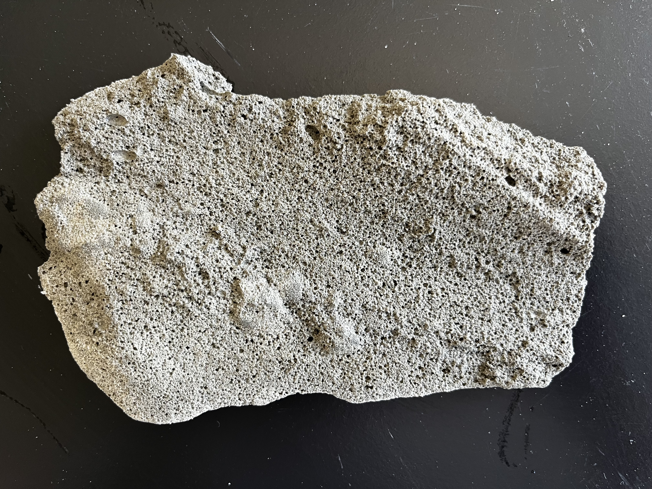
Figure 7. Non-porous (L) and Porous (R) Texture of LCC
Table 5. Permeability of LCC from Double-Ring Infiltrometer Test
 | Non-porous Texture | Porous Texture | Porous texture (2nd Trial)
K (m/s) | 2.43E-06 | 1.12E-06 | 1.15E-06

Figure 8. Summary of Hydraulic Conductivity

CHAPTER

4
DISCUSSION

Interpretation of Cylinder Test Results
The constant-head permeability test across all PLCC samples yielded a mean permeability of 1.16 × 10⁻³ m/s, with a coefficient of variation (COV) of 48.1%, indicating notable variability in hydraulic performance. In contrast, density measurements showed better consistency (COV = 13.4%). These results suggest that while the foam-based production process can produce structurally uniform specimens in terms of density, achieving hydraulic uniformity remains sensitive to variations in foam content and mixing conditions. The exclusion of two samples with excessive density (approximately 40 PCF) further emphasizes the sensitivity of hydraulic behavior to deviations in mix proportions, highlighting the importance of strict quality control during production.
A general trend of decreasing permeability with increasing density was observed, consistent with the expected inverse relationship between void ratio and flow capacity. Minor variability in density among samples may be attributed to potential inconsistencies in foam distribution and pore connectivity within the PLCC matrix. These findings suggest that while bulk density is a primary factor, microstructural characteristics, such as pore continuity and irregularity, also influence the hydraulic performance of PLCC. The average permeability measured in the laboratory-scale PLCC specimens was approximately 1.16 × 10⁻³ m/s, which reflects a relatively high level of permeability suitable for drainage and water conveyance applications.

Evaluation of the Double-Ring Infiltrometer Test
The double-ring infiltrometer test provided a field-scale assessment of LCC permeability, which was compared with laboratory-scale PLCC results obtained from constant-head tests. The measured average infiltration rate of 6.65 × 10⁻⁵ m/s is closely aligned with literature values for similar sand types, thereby supporting the reliability of the test setup.
In the field-scale LCC test, the surface exhibited a smooth, dense texture, allowing for measurable but limited infiltration. The initial (untreated) LCC surface yielded a permeability of 2.43 × 10⁻⁶ m/s. To examine the influence of surface texture on hydraulic behavior, approximately ¼ inch of the upper layer was manually removed using a scraper while simultaneously removing debris with a vacuum. Contrary to expectations, this treatment resulted in a further reduction in infiltration, with the post-treatment permeability decreasing to 1.15 × 10⁻⁶ m/s. This result contradicts the assumption that exposing the internal structure would necessarily enhance water flow. One possible explanation is that surface removal may disrupt existing preferential flow paths or reveal regions with less interconnected pore structures. Regardless of the mechanism, the results suggest that surface removal does not enhance permeability in LCC.
Furthermore, the laboratory setup using a Mariotte bottle proved effective in maintaining a constant hydraulic head, eliminating transient fluctuations that could otherwise introduce measurement error. This device enabled the accurate application of Darcy's law in calculating saturated hydraulic conductivity and provided a clear understanding of the role of air-void distribution and matrix continuity in influencing fluid flow.

Comparison Between PLCC and LCC
A key finding from this study is the difference in permeability between PLCC and LCC, which is primarily attributed to the use of different foam agents. The PLCC samples were produced using AQUAERIX-LB, a foaming agent specifically engineered to create an open-pore structure that facilitates water infiltration. In contrast, the LCC sample was made using AQUAERIX, which results in a denser, more closed-cell matrix. The permeability values show this difference. PLCC exhibited average values on the order of 10⁻³ m/s, while LCC values were closer to 10⁻⁶ m/s even after surface modification.
These results suggest that the selection of foam agents is crucial in designing cellular concrete for hydraulic applications where enhanced drainage and permeability is required. While PLCC, with AQUAERIX-LB, demonstrates permeability suitable for use in subbase drainage layers and pervious fill materials, LCC produced with AQUAERIX is more appropriate for applications requiring low permeability. In drainage applications, using a foaming agent designed to yield an open-pore structure (such as AQUAERIX-LB) is essential for ensuring adequate infiltration. On the other hand, if water resistance is desired, the use of a denser foam agent such as AQUAERIX may be advantageous.
Regardless of the intended function, overlooking these variables may result in hydraulic behavior that deviates significantly from design expectations. The contrast between PLCC and LCC highlights that the designation "lightweight cellular concrete" encompasses a wide range of material behaviors depending on formulation and production method. This study also highlights the complex role of surface texture in influencing infiltration. Surface preparation was expected to improve permeability by exposing the more porous surface. However, in the LCC test, surface removal resulted in a decline in hydraulic conductivity, suggesting that it may have disrupted existing preferential flow channels or allowed debris to enter and clog the pore structure.
Therefore, designers must avoid assuming hydraulic performance based solely on density or appearance and must instead consider the specific foam product used and the intended permeability profile. Project-specific laboratory permeability tests, such as the constant-head or falling-head test, are vital for verifying performance prior to field application. Additionally, field-scale testing using the double-ring infiltrometer is recommended.
Additionally, the findings in this study suggest that assumptions about the benefits of surface roughening or removal may not hold true in all cases. Surface treatment may lead to reduced performance unless the internal pore structure is well-connected and continuous. The result highlights the importance of conducting pre-installation trials and site-specific tests before adopting surface preparation as a design strategy to enhance permeability.
These findings carry important implications for the practical use of PLCC and LCC. The sensitivity of permeability to foam type, density, and surface condition highlights the need for a comprehensive and integrated approach to material selection and specification. Designers must evaluate not only mix proportions and curing conditions but also the role of the foaming agent and any post-placement surface modifications.

Broader Context and Applications
Closed-cell LCC exhibited low to very low hydraulic conductivity, classifying it as a low-permeability material. This classification renders LCC unsuitable for applications that require substantial flow, drainage, or water storage. However, its limited permeability may offer advantages in cases where restricted water movement is desired, such as in embankments, levees, roadways, and reclaimed ground, provided buoyancy forces are adequately counteracted. The laboratory results confirmed that the hydraulic conductivity of LCC decreases with increasing dry density, while modest confining pressures also slightly reduce flow rates.
While LCC may serve niche applications requiring low permeability and hydraulic isolation, PLCC offers a more versatile and high-performing solution for drains, decentralized stormwater management, and geotechnical stabilization, meriting further research into long-term filtration performance and compatibility with geosynthetics. Case studies, including the Mission Rock Project and Louis Armstrong International Airport, demonstrate PLCC's effectiveness in managing hydrostatic uplift pressures and accommodating subsurface flow, particularly in areas vulnerable to sea level rise or with compressible subgrades.

CHAPTER

5
CONCLUSION
This study aimed to evaluate the permeability characteristics of Permeable Lightweight Cellular Concrete (PLCC) and Lightweight Cellular Concrete (LCC) through both laboratory-scale and field-scale testing. The research was motivated by the need to better understand how design variables, particularly foam agent type, density, and surface condition, affect the hydraulic performance of these materials in infrastructure applications. The findings contribute to a growing body of knowledge that supports the tailored design and implementation of cellular concrete in drainage and water-sensitive environments.
In the laboratory phase, PLCC specimens produced with AQUAERIX-LB exhibited consistent and repeatable permeability results under constant-head conditions. A general trend of decreasing permeability with increasing density was observed, highlighting the importance of quality control during mixing and placement. The laboratory tests also confirmed the effectiveness of using a constant-head setup, which enabled accurate application of Darcy's law and minimized errors. The average permeability of these PLCC specimens was approximately 1.16 × 10⁻³ m/s, suggesting that with the right foam agent and density control, PLCC can be engineered to meet the needs of permeable applications.
The field-scale component of the study utilized a double-ring infiltrometer to assess the permeability of LCC produced with AQUAERIX. Before testing, a concrete sand infiltration trial confirmed the accuracy of the test setup, validating the reliability of the results. LCC samples initially assumed to be PLCC demonstrated significantly lower permeability values: 2.43 × 10^-6 m/s for untreated surfaces and 1.15 × 10^-⁶ m/s after surface removal. These findings highlight the impact of foam agents on hydraulic performance. The lower permeability of LCC indicates that not all lightweight cellular concretes are suitable for infiltration-based applications, and the selection of the foaming agent is a key design decision.
A critical outcome of this study is the clear distinction in permeability behavior between PLCC and LCC, despite both having similar densities and falling under the general category of lightweight cellular concrete. This variation was primarily attributed to the properties of the foam agents used. AQUAERIX-LB resulted in an open-pore structure, while AQUAERIX yielded a denser, more closed-cell matrix. As a result, material classification alone is insufficient to predict hydraulic behavior. Designers must adopt a performance-based approach grounded in material testing, to ensure that the selected material aligns with the project's intended functional requirements.
Surface condition was another key factor explored in this study, particularly its influence on permeability. Surface layers were manually removed from selected samples to expose the internal pore structure, allowing for an assessment of how surface texture affects hydraulic behavior. Contrary to initial assumptions, removing the top layer of the LCC sample reduced rather than enhanced infiltration. This result suggests that the surface may have contained flow-favorable features that were disrupted during treatment or that the exposed internal structure lacked sufficient pore connectivity to promote infiltration. The findings reinforce that surface preparation must be evaluated on a case-by-case basis and that standard assumptions about improving permeability through roughening or exposure may not hold across different formulations.
Collectively, the study shows that achieving the desired permeability performance in cellular concrete systems depends on a combination of factors. The formulation of the foaming agent plays a primary role, influencing not only the pore structure but also the effectiveness of surface treatment strategies. Density control and curing conditions also contribute to the overall hydraulic behavior, underscoring the need for integrated design practices that consider both material selection and construction considerations.
In practical terms, these findings suggest that PLCC, when produced with an appropriate foam agent and carefully managed density, can serve as an effective permeable material in infrastructure applications. Conversely, LCC may be better suited for scenarios where low permeability is desired. These different properties reflect the diversity of functions that cellular concrete can offer when its properties are well-understood and intentionally controlled.
Moving forward, material selection for permeable systems should prioritize performance metrics over material classification. Foam agents should be evaluated not only based on their mechanical contributions to mix stability but also on their ability to support hydraulic continuity. Post-placement treatments, such as minor surface removal or preparation, should be tested under site-specific or project-specific conditions before being implemented on a larger scale.
This research offers valuable insights into the hydraulic behavior of PLCC and LCC, highlighting critical parameters for consideration during the design process. However, the findings also point to the need for further investigation. Environmental influences, long-term permeability performance, and direct pore structure characterization remain areas for future exploration. The results presented here offer a strong foundation for understanding and applying lightweight cellular concrete in contexts where hydraulic performance is a key design priority.

REFERENCES
[1] ACI Committee 523, "523.1R-06: Guide for Cast-in-Place Low-Density Cellular Concrete," Tech. Doc., Aug. 2006.
[2] M. Amran et al., "An ultra-lightweight cellular concrete for geotechnical applications – A review," Case Stud. Constr. Mater., vol. 16, p. e01096, Jun. 2022, doi: 10.1016/j.cscm.2022.e01096.
[3] K. Ramamurthy, E. K. Kunhanandan Nambiar, and G. Indu Siva Ranjani, "A classification of studies on properties of foam concrete," Cem. Concr. Compos., vol. 31, no. 6, pp. 388–396, Jul. 2009, doi: 10.1016/j.cemconcomp.2009.04.006.
[4] N. Deni and R. A. Gladstone, "Low-Density Cellular Concrete in MSE Structures with Steel Strip Reinforcements—Design and Construction Considerations and Case Histories," in Geo-Congress 2019, Philadelphia, Pennsylvania: American Society of Civil Engineers, Mar. 2019, pp. 127–139. doi: 10.1061/9780784482087.012.
[5] R. J. Wilkinson, "Behavior of Unreinforced Lightweight Cellular Concrete Backfill for Reinforced Concrete Retaining Walls".
[6] L. Chica and A. Alzate, "Cellular concrete review: New trends for application in construction," Constr. Build. Mater., vol. 200, pp. 637–647, Mar. 2019, doi: 10.1016/j.conbuildmat.2018.12.136.
[7] E. Kuzielová, L. Pach, and M. Palou, "Effect of activated foaming agent on the foam concrete properties," Constr. Build. Mater., vol. 125, pp. 998–1004, Oct. 2016, doi: 10.1016/j.conbuildmat.2016.08.122.
[8] D. K. Panesar, "Cellular concrete properties and the effect of synthetic and protein foaming agents," Constr. Build. Mater., vol. 44, pp. 575–584, Jul. 2013, doi: 10.1016/j.conbuildmat.2013.03.024.
[9] S. Averyanov, "Analysis of construction experience of using lightweight cellular concrete as a subbase material".
[10] M. R. Jones and A. McCarthy, "Heat of hydration in foamed concrete: Effect of mix constituents and plastic density," Cem. Concr. Res., vol. 36, no. 6, pp. 1032–1041, Jun. 2006, doi: 10.1016/j.cemconres.2006.01.011.
[11] H. Awang, Z. S. Aljoumaily, N. Noordin, and M. Z. Al-Mulali, "The Mechanical Properties of Foamed Concrete containing Un-processed Blast Furnace Slag," MATEC Web Conf., vol. 15, p. 01034, 2014, doi: 10.1051/matecconf/20141501034.
[12] W. Yu, X. Liang, F. M.-W. Ni, A. G. Oyeyi, and S. Tighe, "Characteristics of Lightweight Cellular Concrete and Effects on Mechanical Properties," Materials, vol. 13, no. 12, p. 2678, Jun. 2020, doi: 10.3390/ma13122678.
[13] B. Tiwari, B. Ajmera, R. Maw, R. Cole, D. Villegas, and P. Palmerson, "Mechanical Properties of Lightweight Cellular Concrete for Geotechnical Applications," J. Mater. Civ. Eng., vol. 29, no. 7, p. 06017007, Jul. 2017, doi: 10.1061/(ASCE)MT.1943-5533.0001885.
[14] F. M.-W. Ni, A. G. Oyeyi, and S. Tighe, "The potential use of lightweight cellular concrete in pavement application: a review," Int. J. Pavement Res. Technol., vol. 13, no. 6, pp. 686–696, Nov. 2020, doi: 10.1007/s42947-020-6003-8.
[15] S. Inti, T. W. Evans, M. Flores, J. S. Solanki, and C. V. Chandramouli, "Permeable low-density cellular concrete (PLDCC) as a replacement for aggregate layers in permeable parking lots," Dev. Built Environ., vol. 8, p. 100060, Sep. 2021, doi: 10.1016/j.dibe.2021.100060.
[16] J. Eskew, K. Hill, L. Madrid, N. Sutmoller, and L. "Connor" Updike, "Soft Soil Settlement Remediation and Roadway Elevation Increase with Permeable Low-Density Cellular Concrete (PLDCC)," in Geo-Extreme 2021, Savannah, Georgia: American Society of Civil Engineers, Nov. 2021, pp. 90–100. doi: 10.1061/9780784483688.009.
[17] T. de C. Gontscharow, "THE EVALUATION OF PERMEABLE LOW-DENSITY CELLULAR CONCRETE AS A POTENTIAL SUBBASE MATERIAL IN ROADWAY SYSTEMS."
[18] N. Sutmoller, M. Gomez, and J. Kevern, “Soft Soil Remediation with Permeable Low-Density Cellular Concrete (PLDCC),” MATEC Web Conf., vol. 271, p. 02002, 2019, doi: 10.1051/matecconf/201927102002.
[19] Y. Huang, "LABORATORY INVESTIGATION OF THE HYDRAULIC PROPERTIES OF PERMEABLE LOW-DENSITY CELLULAR CONCRETE".
[20] D18 Committee, "Test Method for Permeability of Granular Soils (Constant Head)," ASTM International. doi: 10.1520/D2434-68R06.
Appendix I
Hydraulic and Durability Properties of Lightweight Cellular Concrete for Coastal Engineering
Title: Hydraulic and Durability Properties of Lightweight Cellular Concrete for Coastal Engineering

Abstract
Lightweight cellular concrete (LCC) is used in coastal infrastructure due to its low unit weight, which reduces the load on soft soils, improving bearing capacity and reducing settlement (Armaghani, 2011; Anderson et al., 2012). Its hydraulic properties, especially in open-cell forms (PLCC), allow controlled water movement for stormwater management. LCC is also durable, resistant to saltwater, sulfate, and freeze-thaw degradation, and offers filtering capabilities for heavy metal sequestration. There are three types of cellular concrete: Type I, II, and III. This paper focuses on Type I, or LCC, which, for this paper, is a combination of Portland cement, water, and foaming agents. Because permeability decreases with increased density, LCC balances its ultra-low density (400–560 kg/m³) to maintain its favorable hydraulic properties while providing adequate strength and durability. Closed-cell LCC shows low hydraulic conductivity and is suitable for applications needing low water flow, like dikes and roadways. Open-cell PLCC has higher hydraulic conductivity and water storage, making stormwater management and filtration preferable.
In addition, this paper presents the durability and mechanical properties of Lightweight Cellular Concrete (LCC) and Permeable Lightweight Cellular Concrete (PLCC) with a focus on their compressive strength, resilient modulus, and freeze-thaw resistance. Unconfined compressive strength (UCS) testing of LCC specimens revealed that strength gain continued up to 70 days of curing, followed by a plateau. Initial strength reductions observed in some specimens before achieving peak strength were attributed to yield strength, which is recommended for allowable stress design. Additionally, triaxial compression strength testing indicated that LCC's friction angle varies with saturation levels, with zero cohesion and a 65° friction angle for partially saturated specimens. Resilient modulus (RM) testing of LCC showed favorable stiffness, with an average RM of 489 MPa, indicating minimal impact from water saturation. Conversely, RM values for PLCC were about 50% lower than those of LCC, with an average of 240 MPa. Freeze-thaw testing demonstrated that LCC and PLCC exhibited good resistance under specific conditions. These findings suggest that LCC and PLCC are viable materials for use in applications subjected to freeze-thaw and varying saturation conditions, such as pavement systems.

Introduction
Lightweight cellular concrete (LCC) has been used in coastal infrastructure projects due to its (1) relatively low unit weight compared to structural concrete, which reduces the vertical load on soft coastal soils, reducing consolidation settlement and improving the bearing capacity for soft or peaty soil sites and reclaimed land and their associated infrastructure (e.g., roadways, causeways, floodwalls, dikes, backfilling, bridge abutments, green roofs, etc.) (Armaghani 2011; Anderson et al., 2012; Tiwari et al., 2017; ACI 523; Sutmoller et al., 2019, Tiwari et al., 2020; Amran et al., 2022, Seely 2024), (2) favorable hydraulic properties associated with open-cell, permeable lightweight cellular concrete (PLCC) allowing for controlled water movement for drains, water retention/detention, storage, and decentralized stormwater management systems (Bartlett et al., 2020a; 2024; Inti et al., 2021), and (3) relatively high strength-to-weight ratio and favorable durability with the potential use of additives that resist salt water, sulfate, and freeze-thaw degradation (Tikalsky, 2004; Averyanov, 2018) for constructing coastal and nearshore features (e.g., marinas, docks, partially submerged and floating systems, and artificial reefs and revetments, etc.) and (4) filtering and sequestration capabilities to remove heavy metal contaminates (Martemianov et al., 2017; Alimohammad et al., 2021), and (5) ability to reduce embodied carbon.zzz ADD REFERENCES TO SUPPORT THIS SECTION)
ACI 523.1R-06 classifies cellular concrete is classified into three types based on density and intended applications: (1) Type I Cellular Concrete with dry density from 400–800 kg/m³ (25–50 lb./ft³), (2) Type II, dry density from 800–1200 kg/m³ (50–75 lb./ft³), and (3) Type III Cellular Concrete, dry density from 1200–1900 kg/m³ (75–120 lb./ft³). This paper focuses on the properties, functions, and application of Type I Cellular Concrete, also known as low-density cellular concrete (ACI Committee 523, 2006), foamed concrete (Amran et al., 2015, 2022), lightweight foamed concrete (Kozłowski and Kadela, 2018), or aerated concrete (Narayanan and Ramamurthy, 2000). The data presented herein are LCC and PLC, consisting of Portland Cement Concrete (PCC), water, and a foaming agent. However, other binders, fine aggregates (e.g., sand), and admixtures (e.g., polymer additives or pozzolanic materials, such as fly ash and silica fume) could be considered to enhance workability, strength, and durability (Arman et al., 2022). Generally, permeability and water storage decrease with increasing density, but shear strength and durability improve. The formulation of cellular concrete strikes a balance between an ultra-low dry density (400 to 560 kg/m³) and adequate shear strength and durability properties for the intended application.
Closed and Open Cell Lightweight Cellular Concrete
The foaming agent of LCC produces spherical air bubbles surrounded by a low to medium permeability matrix (Fig. 1 – left). In comparison, PLCC, sometimes called Low Buoyancy Cellular Concrete (LBCC) (Masloff et al., 2022), is an open-cell, lightweight, highly porous cellular concrete with interconnected voids that allow water to flow through its structure (Fig. 1). No coarse aggregates are used in the mix to maintain higher permeability. Therefore, PLCC has lightweight applications similar to LCC but adds drainage, water storage, and heavy metal sequestration functions.

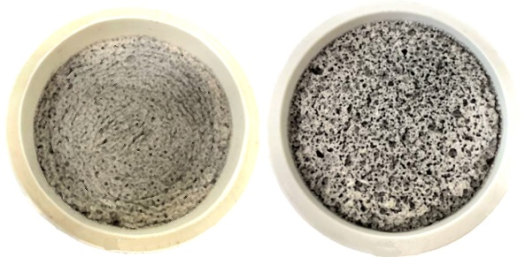
Hydraulic Properties of LCC
The hydraulic properties of LCC and PLCC vary significantly because of aleatory variability resulting from the composition of the mix, foaming agent installation method, or specimen creation process employed. Masloff and Paladino (2012) suggest classifying cellular concrete based on material type and hydraulic conductivity (Table 1).
Fig. 1 Comparison of the fabric of Closed-Cell Lightweight Cellular Concrete (LCC) (left) with Open-Cell Permeable Cellular Concrete (PLCC) (right).

Table 1. Relative values of hydraulic conductivity, k, modified from Masloff and Paladino (2012)
Relative Permeability | k (m/s) | Geomaterial | Cellular Concrete
Very permeable | k > 1x10⁻² | Gravel, Coarse Gravel | ---
Medium permeability | 1x10⁻⁵ to 1x10⁻³ | Fine Sand, Sand, Coarse Sand | LCC, PLCC
Low permeability | 1x10⁻⁵ to 1x10⁻⁷ | Silty Sand, Silty-Clayey Sand | LCC
Very low permeability | 1x10⁻⁷ to 1x10⁻⁹ | Fine Sandstone, Silt | LCC
Impermeable | k < 1x10⁻⁹ | Clay, Mudstone | Structural Concrete

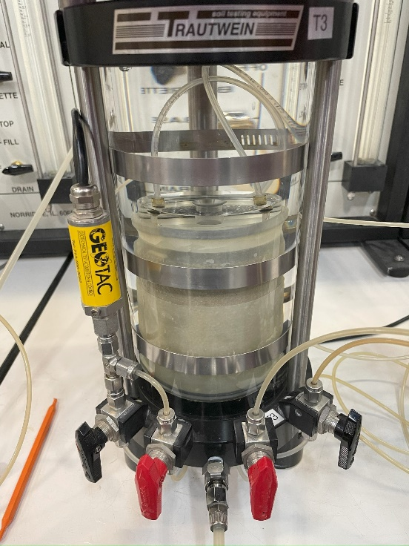
Seely (2024) conducted a suite of falling head hydraulic conductivity tests on closed-cell LCC specimens using a flexible-wall permeameter (ASTM D5084-16a) (Fig. 2). Previous research has demonstrated that fluid flow bypass may occur between the specimen and the latex membrane when test specimens have a rough or porous surface on their circumference (Seely et al., 2014). Because LCC cylinders exhibit a rough, circumferential surface and have the potential to form a porous structure, depending on the degree of adhesion between the cement and the Styrofoam mold during the curing process, fluid bypass can occur. Therefore, Seely (2024) used a sidewall treatment to preclude this bypass. Each specimen sidewall was treated with a thin paste of hydrated CETCO Super Gel-X bentonite before the specimens were placed in a latex membrane and into the triaxial cell for testing. Subsequently, a minor amount of effective confining stress was maintained while the pore pressure was systematically increased to saturate the test specimen. This method of saturation, termed back-pressure saturation, ultimately allowed for saturation of the specimen (i.e., B-value equal to or greater than 0.95).
Fig. 2 Flexible wall permeameter used for falling head testing of LCC.
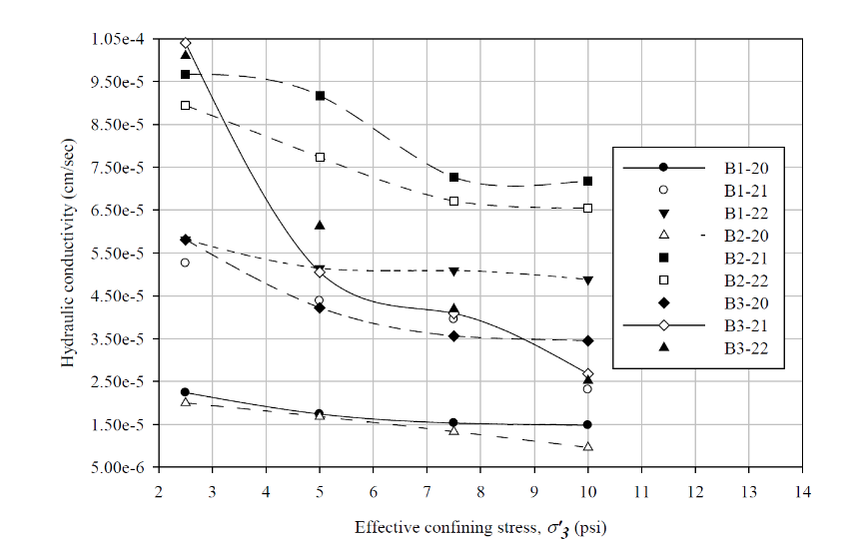
The testing showed that the hydraulic conductivity of LCC is somewhat affected by the confining stress applied to the specimens (Fig. 3). On average, the test specimens exhibited a 0.04 order-of-magnitude decrease in hydraulic conductivity as the confining stress increased from 17.5 to 70 kPa (Seely, 2024). The dry unit weight for these specimens ranged from 304 to 336 kg/m³, and the confining pressure varied from 17.5 to 70 kPa. The average hydraulic conductivity for all tests was 4.9x10⁻⁷ m/s, with a maximum of 1.0x10⁻⁶ and a minimum of 9.6x10⁻⁸ m/s. These values fall in the low permeability range (Table 1).
Fig. 3 Hydraulic conductivity over a range of effective confining stresses (Seely, 2024.)
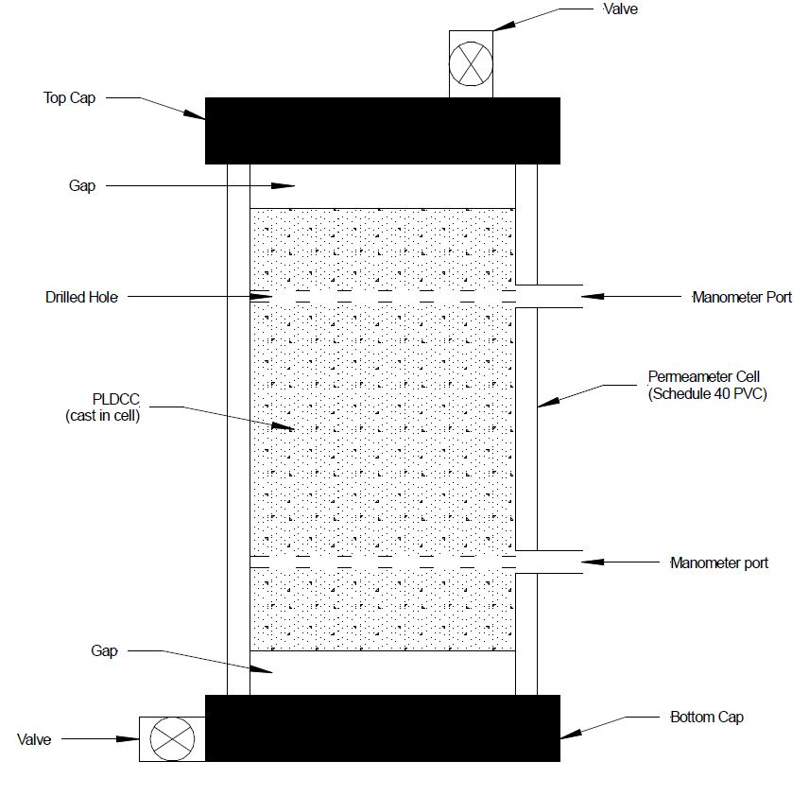
In addition, Bartlett et al., 2024 performed constant head hydraulic conductivity tests on closed-cell LCC specimens using a modified testing protocol of ASTM D2434 developed by Castle Rock Consulting of Colorado using the permeameter shown in Fig. 4 (Bartlett et al., 2000b). The modifications made to the ASTM D2434 were related to sample fabrication and testing preparation. These variations were necessary because cellular concrete specimens differ significantly from permeable soils, for which the ASTM D2434 test was intended. The LCC specimens (i.e., Batches 1 and 2) were prepared by Aerix Industries using their AQUAERIX™ foaming agent (Bartlett 2024).
Fig 4. Rigid wall permeameter used for constant head testing of LCC (Bartlett et al., 2024)..
Batch 1 consisted of 14 specimens, with a dry density ranging from 330 to 367 kg/m³ with an average of 353 and a standard deviation of 13 kg/m³. The total density ranged from 734 to 823 kg/m³ with an average of 794 and a standard deviation of 25 kg/m³. The average hydraulic conductivity was 1.4×10⁻⁴ m/s, with a standard deviation of 9.3 x 10⁻⁵ m/s and an average water absorption capacity (i.e., the volume of water absorbed per unit volume of the LCC specimen) of 44.2% with a standard deviation of 3.22%. We use the nomenclature of "total density" instead of "saturated density" above because LCC specimens do not become fully saturated unless back-pressure saturation is used via a pressurized cell. Thus, the total density reported for the constant head testing represents the dry unit plus the additional weight of water gained by flowing water through the sample without back-pressure saturation, allowing the specimen to reach steady-state flow and measuring its wet density in this state.
Batch 2 consisted of 19 specimens with dry density ranging from 444 to 474 kg/m³ with an average of 457 and a standard deviation of 8.3 kg/m³. The total density ranged from 708 to 827 kg/m³ with an average of 807 and a standard deviation of 26 kg/m³. The average hydraulic conductivity was 2.2x10⁻⁵ m/s, with a standard deviation of 2.7x10⁻⁵ m/s, an average absorption capacity of 35.0%, and a standard deviation of 2.78%. The hydraulic conductivity of these batches falls within the medium to lower bound of the medium permeability range (Table 1)
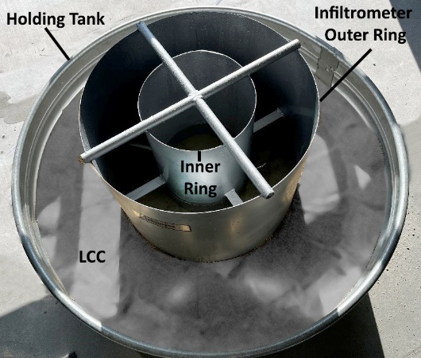
Also, a green roof rehabilitation project in Salt Lake City, Utah, allowed us to test closed-cell LCC created using AQUAERIX™ foaming agent in a double-ring infiltrometer and tank setup shown in Fig. 5. This testing provided a permeability assessment at a scale similar to full-scale installations and the LCC was obtained directly from the LCC batched at the construction site into the 1.22-m aluminum holding tank (Fig 5.). Before the LCC placement, the bottom of the holding tank was filled with 0.3 m of coarse sand, and a nonwoven geotextile was placed atop the sand as a separation layer. The testing protocol followed ASTM D3385–18 using water continuously supplied to the inner ring via a constant-head mariotte tube. Before the field poring of the LCC, a 0.3-m layer of coarse sand was placed, followed by a nonwoven geotextile fabric to allow water drainage from the bottom of the tank via a port in its sidewall. Prior permeability testing has shown that the nonwoven geotextile has a minor effect on the infiltration rate of the system (Bartlett et al., 2024). The hydraulic conductivity from two infiltrometer tests was 1.1x10⁻⁶ and 2.4x10⁻⁶ m/s, falling within the range of materials with low hydraulic conductivity (Table 1).
Fig. 5 Double Ring Infiltrometer with LCC placed in a holding tank.
Based on the testing results, we conclude that closed-cell LCC is not advantageous for applications where flow, drainage, and water storage are needed. Some literature suggests that the LCC void ratio can be as low as 10 percent air voids (Panesar, 2013), resulting in low hydraulic conductivity and water absorption levels ranging from 3% to 7% (Amran et al., 2022). We found that hydraulic conductivity significantly decreased from an average of 1.4x10⁻⁴ to 2.2x10⁻⁵ m/s as the average dry density increased from 353 to 457 kg/m³.
In addition, our laboratory tests on LCC specimens with a dry density from 708 to 827 kg/m³ resulted in an average buoyant uplift force of 2.9 to 1.7 kN/m³, respectively. This result suggests that closed-cell LCC may have a moderate buoyancy force when placed below groundwater or where temporary flooding or submersion is possible. This uplift force may be sufficient to cause damage or cracking if the LCC is not sufficiently covered, buried, or anchored. However, due to its relatively low permeability and low water storage capacity, LCC might be desirable for cases where limited water flow is desired in or through the geosystem (e.g., dikes, levees, roadways, pavements, embankments, revetments, etc.) if adequate countermeasures against buoyancy uplift are taken.

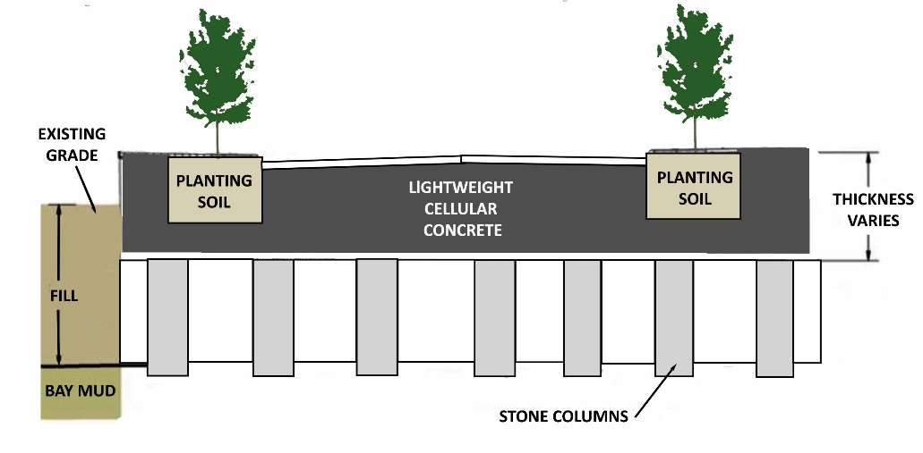
Hydraulic Properties of PLCC
In contrast to LCC, the foaming agent used to produce PLCC (Masloff et al., 2022) creates a significantly higher hydraulic conductivity and water storage capacity (Bartlett et al., 2024). Notable case studies of PLCC construction include the Mission Rock Project (MRP) in the Port of San Francisco (Bartlett et al., 2020a) and a soft soil remediation project at the Louis Armstrong International Airport (LAIA) in New Orleans, Louisiana (Sutmoller and Gomez, 2022). For the latter project, a concrete vault was to be built on a saturated, weak, compressible black clay. The lightweight fill material around the vault's pavement was needed to facilitate significant stormwater drainage and stabilize the soft soil. A silt fabric was placed to mitigate silt infiltration before PLCC, with a 450 kg/m3 density, was installed to a depth of 1.2 m for a total PLCC volume of 2300 m³
Fig. 6 Cross-sectional view of typical street for Mission Rock Project (Bartlett et al., 2000a).

The extensive MRP project site (6.5 hectares) comprises mixed commercial and residential development constructed atop potentially liquefiable uncompacted fill material, which overlies the Young and Old Bay Muds of San Francisco Bay. To protect the site against a projected sea level rise of up to 1.67 m by 2100, the development team proposed increasing the ground elevation by 1.5 to 1.8 m across most of the site (Bartlett et al., 2020a). The foundations for the planned buildings are pile-supported. The potential for liquefaction of the uncompacted fill was mitigated by installing stone columns (Fig. 6). However if earthen fill were used to raise the ground, the additional weight placed in non-building areas would cause significant primary consolidation settlement (about 0.56 m) of the Young Bay Mud. This consolidation and subsequent creep settlement would cause considerable damage to planned roadways, sidewalks, landscaped areas, and buried utilities. Therefore, it was decided that a "zero net load" could be created by sub-excavating the existing ground and paved areas to a depth equivalent to the expected weight of the LCC fill, roadway base (where applicable) overlying flexible pavement section (Fig. 6).
In addition, MRP performance requirements specified that the PLCC should be sufficiently permeable to prevent the buildup of excessive hydrostatic uplift pressure during fluctuations in the groundwater table and tides in the San Francisco Bay. Based on subsurface flow calculations, the advisory panel specified a minimum hydraulic conductivity of 5x10⁻⁵ m/s (i.e., medium permeability - Table 1) for the LCC or PLCC layer to prevent excessive hydrostatic uplift pressure during tidal fluctuations. Red Rock Consultants performed constant head permeability testing (ASTM D2434) for the MRP on ten 76.2 x 152.4 mm specimens obtained while constructing a PLCC test pad to verify in-place permeability. The average batched and total density were 437 and 867 kg/m³, respectively. The average hydraulic conductivity was 5.34x10⁻⁴ m/s, with a standard deviation of 4.69x10⁻⁴ m/s. This hydraulic conductivity falls within the medium permeability range (Table 1).
In addition, the MRP installed a full-scale mockup or Pilot of a typical street section using PLCC as part of the approval process (Bartlett et al., 2020a). The LCC Pilot consisted of an 8.8-m wide (approximately half the full street width) x 7.6-m long PLCC fill that incorporated typical utilities, street paving, sidewalk, curb and gutter, and planter strip. The goals of the Pilot were to demonstrate construction methods and materials related to PLCC placement and its ability to support a typical heavy vehicle load (standard SF Fire Department Fire Truck) and a typical water line leak and repair. Also, hydrostatic uplift tests were performed to demonstrate LCC performance under simulated current and future groundwater conditions during construction and in its finished condition. The hydrostatic uplift test was done by flooding the PLCC fill to raise the groundwater level to the future design level, including sea level rise. No evidence of uplift was measured in the pressure cell instrumentation and ground surface surveying.
Experience gained from the MRP advanced the concept of using PLCC as a base and subbase material to support the pavement and sidewalk systems while accommodating detention and infiltration. Subsequently, the University of Utah and the Land and Housing Corporation of Korea (LH-Korea) initiated research in developing a Decentralized Stormwater Management System (DCMS) that used PLCC as the primary storage and infiltration medium (Fig. 7) (Bartlett et al., 2024). In such a system, the PLCC would not be the wearing surface for the roadway and sidewalks; instead, these areas would be capped by rigid or flexible pavement and paver blocks, respectively. These capping layers are required to guard against overstressing and localized damage of the PLCC.
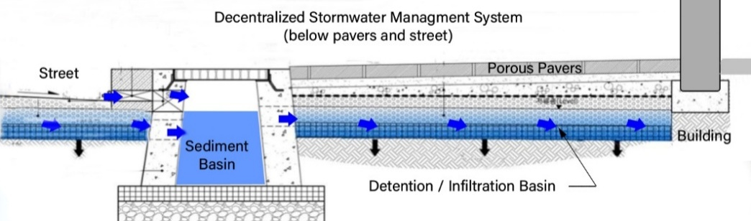
In addition to storage and infiltration, the PLCC medium would act as a filter to adsorb and sequester toxic heavy metals and other microparticles that might be present in the surface stormwater runoff. For example, Martemianov et al. (2017) have shown that aerated concrete (i.e., aerocrete) has an adsorption capacity exceeding activated carbon and vermiculite-based adsorbents concerning heavy metal cations. Arsenic anions are adsorbed in amounts comparable to the ones of activated carbon-supported adsorbents.
Fig. 7 Conceptual schematic of PLCC base (blue) as primary component in a decentralized Stormwater Management System

To better understand the flow, absorption capacity, and durability of LCC and PLCC, the University of Utah has conducted additional constant head testing of PLCC specimens to define further design properties, including infiltration rates, hydraulic conductivity, storage capacity, infiltration rates, and strength and stiffness properties of LCC and PLCC (i.e., shear strength and resilient modulus) (Bartlett et al., 2024; Seely, 2024).
Constant head permeability testing was performed on sixteen 76.2 x 152.4 mm specimens created using AQUAERIX-LB™ foaming agent (Masloff et al., 2022) having a dry density ranging from 375 to 419 kg/m³ with an average of 408 and a standard deviation of 17.5 kg/m³. The total density ranged from 806 to 1005 kg/m³ with an average of 921 and a standard deviation of 84 kg/m³. The average hydraulic conductivity was 1.48⁻³ m/s, with a standard deviation of 1.37x10⁻³ m/s, an average absorption capacity of 51.3%, and a standard deviation of 7.37%. The buoyant uplift force varied from 1.90 to -0.047, averaging 0.771 kN /m³ with a standard deviation of 0.220 kN/m³. Additional constant head testing of seven larger specimens (152.4 x 304.8 mm) produced an average hydraulic conductivity of 1.23x10⁻³ m/s with a standard deviation of 4.91x10⁻⁴ m/s. The hydraulic conductivity for both series of tests falls within the medium permeability range (Table 1).
Unpublished data from UMKC (2018) for PLCC dry densities ranging from 400 to 480 kg/m³ suggest ASTM C1701 infiltration rates as high as 1700 and 400 cm/hr, respectively. Also, in many geotechnical applications and systems, a nonwoven geotextile is used as a separation layer between the cellular concrete and the basal soil or at the top of the system to separate the cover soil from the top surface of the LCC. Because nonwoven geotextiles are often needle-punched, this gives them a 3D structure more resistant to clogging woven alternatives, especially in applications with high fines content or biological activity. Geotextiles allow water to pass through while trapping fine particles when it is placed between fine and coarse materials (like soil and aggregate). Besides filtration, nonwoven geotextiles keep dissimilar materials separate, preventing fines from a subgrade layer from migrating upward into an LCC or PLCC base layer, helping maintain the system's structural integrity.
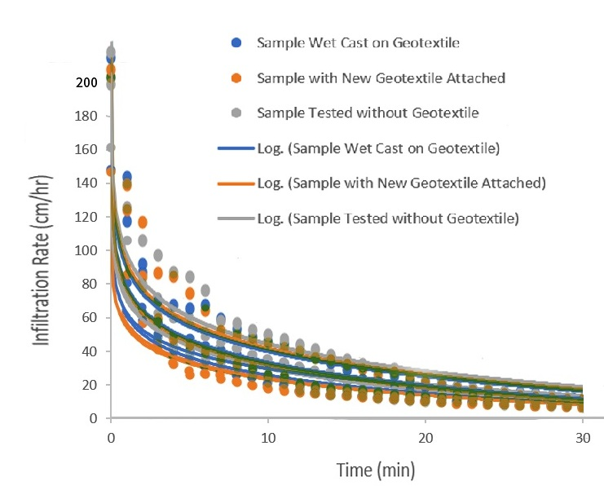
However, when a wet, cement-based LCC or PLCC mixture is applied to a nonwoven geotextile fabric, there is the possibility of obstructing the fabric's pores at this interface and reducing the system's overall infiltration or drainage rate. To explore this, we prepared four 152.4 x 304.8 mm specimens. We consecutively tested four air-dried specimens using three variations that included (1) wet casting of PLCC on the basal geotextile and infiltration testing after curing, (2) removing and replacing the original geotextile of from the wet cast and replacing it with a new geotextile attached to the base of the specimen and redoing the infiltration testing, and (3) removing the geotextile entirely and retesting (Bartlett et al., 2024). The 2.4 mm thick nonwoven geotextile fabric has a permittivity of 1.4 s⁻¹ and a water flow of 360 liters/min per 0.093 m² based on ASTM D 4491.
Fig 8 Results of infiltration testing of PLCC for specimens prepared with and without a non-woven geotextile.
Using the same PLCC specimens for each variation (1,2,3) allowed us to eliminate the significant uncertainty in the infiltration rate caused by random variation caused by the PLCC mixing and casting processes. In all cases, the specimens were subjected to constant head gravity flow (i.e., vertical hydraulic gradient = 1) for 1 hour. Steady state flow was achieved after about 30 minutes. The average infiltration rates at t = 10 min. are 32.1, 30.2, and 34.6 and 12.6, 11.0, and 13.7 at t = 30 min for variations 1, 2, and 3, respectively (Fig. 8). Therefore, these data suggest that wet casting on the PLCC and the dry placement of the geotextile (i.e., variations 1 and 2) reduced the infiltration rates by 7.2 and 12.7 percent for t = 10 min and by 8.0 and 19.7 percent for t = 30 min, respectively when compared with the specimens tested without a nonwoven fabric (i.e., variation 3).
We also observed the wet casting of the PLCC on the geotextile created a strong adhesion bond at this interface during curing. This bonding occurred because the PLCC mix had infiltrated the surface of the nonwoven geotextile during the casting of the specimens. Therefore, we conclude that a PLCC-nonwoven geotextile interface has the potential for long-term plugging from the accumulation of fine-grained particles at this interface. However, additional studies regarding this potential are warranted, including applying and evaluating other geosynthetic or natural filter materials.

Durability

Unconfined Compressive Strength (UCS) of LCC
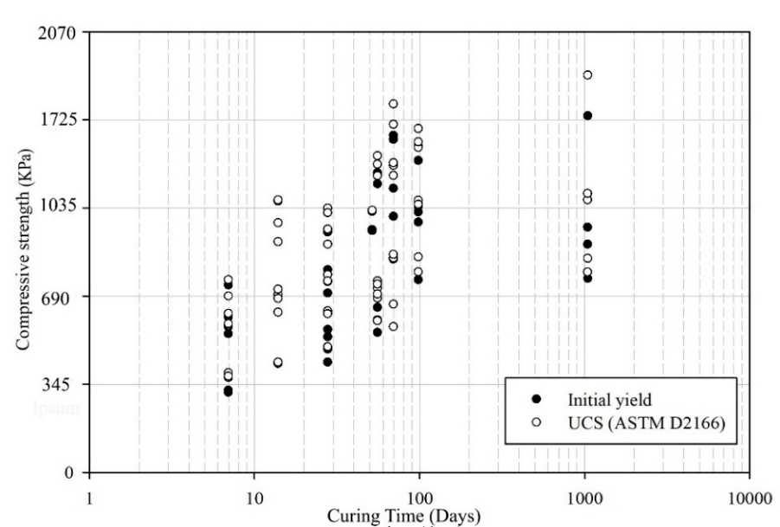
We believe that the source of the unconfined compressive strength (UCS) is complex and primarily results from a combination of chemical bonding of the cement achieved during cement hydration and curing and a minor component from matric and osmotic suction. Notwithstanding, we recognized that the UCS cannot be guaranteed during the system's design life due to the potential for degradation from environmental factors and other loading conditions; hence, a resistance factor of less than 1.0 is warranted for LRFD design for long-term conditions. In some cases, shear strength results from triaxial compression testing may be more appropriate, mainly where significant cracking of the LCC may occur due to environmental conditions, cyclic loading, or significant confining pressures placed on the LCC. However, the UCS test is relatively quick, inexpensive, and requires no specialized equipment beyond what is found in a typical material testing laboratory. Because of this, engineering practice primarily utilizes the UCS as an indicator of the quality of the LCC mix and its initial compressive strength.
Seely (2024) performed UCS testing on air-dried specimens throughout the curing process to understand LCC's strength gain with time. The test program included 57 UCS tests with curing ages ranging from 7 to 99 days and a dry density from 308 to 324 kg/m³. This series of tests was subsequently terminated at 1,050 days of curing. We note that most specimens exhibited an initial reduction in strength before reaching the ultimate unconfined strength or at least showed a substantial deviation from the initial straight-line portion of the stress-strain curve. This strength loss was identified and recorded as the initial yield strength (Fig. 9). We believe this yield strength is the most appropriate strength for allowable stress design because the subsequent deformation required to reach the peak strength may not be desirable in most engineered systems. These UCS data (Fig. 9) were fitted with an exponential decay model (Eq. 1). All regression coefficients are significant at p < 0.0001. This p-value means that the probability any regression coefficient is equal to zero is 1x10⁻⁴ or less, which is highly improbable). However, our evaluations suggest no significant strength gain after about t = 70 days for practical purposes.
Fig. 9 Initial yield and the peak UCS of the air-dried LCC specimens as a function of time
UCS (KPa)=990(1-e ^{(-0.1043·t)}) (Eq. 1)
The specimens in the test program were also subjected to various submergence times to explore the possible effects of water infiltration. The UCS test programs suggest that the unconfined strength and its modulus are minorly reduced by increasing the degree of saturation in the specimens (Seely, 2024).

Unconfined Compressive Strength (UCS) of PLCC
Very few test results in the engineering literature are available for PLCC. UMKC (2018) suggests that samples with cast (i.e., fresh) densities of 400 and 480 kg/m³ experienced compressive strength reductions of 30% and 23%, respectively, when saturated when compared with the initial dry state strength of 1,100 and 1.,550 kPa, respectively.
We performed UC testing on 12 specimens with cast densities from 385 to 465 kg/m³ and found an average peak strength of 660 KPa and a standard deviation of 200 KPa (Bartlett et al., 2024). All specimens exhibited a similar failure pattern, with rupture beginning at the bottom and propagating upward. This failure behavior may be linked to the production process, where lighter fresh PLDCC tended to segregate and form at the top of the molds. We did not explore the effects of saturation on the strength of the PLCC.

Triaxial Compression Strength (CIDTx) of LCC
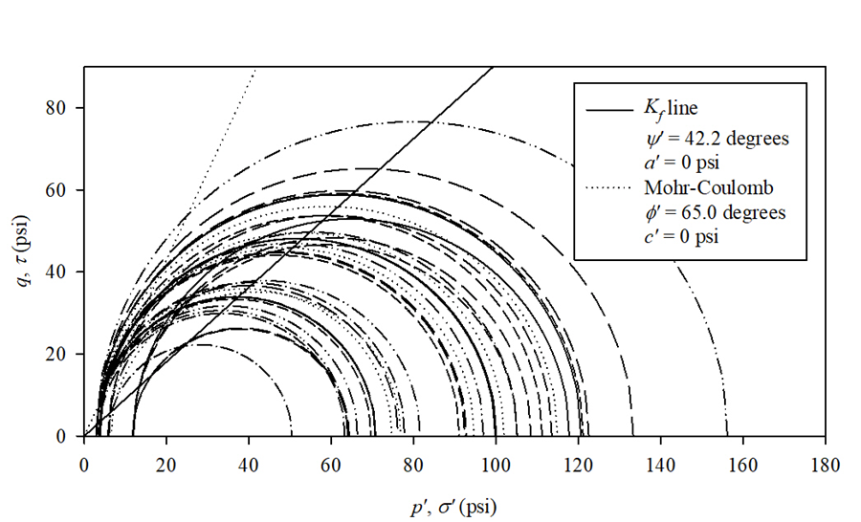
The advantages of isotropically consolidated drained triaxial strength testing (CIDTx) are greater than those of UCS testing. The triaxial device includes an allowance for back-pressure saturation, consolidation and confinement of the test specimen, and shearing under drained and undrained conditions. Therefore, the consolidation and loading of the specimens can more closely replicate field conditions. The equipment required to perform the tests is specialized and less common than that of the UCS, but it is still relatively common in specialized geotechnical testing laboratories. Proper test performance requires more advanced training and time than the UCS test and, therefore, is more costly.
Fig. 10 Mohr’s circles, Kf line, and Mohr-Coulomb failure envelope for the initial yield points for all triaxial tests on LCC specimens.
Tiwari et al. (2017) have suggested a conservative value for the effective friction angle of 35° be used for saturated design purposes. These authors have also reported that the partially saturated friction angle of 40° was obtained through direct shear testing, but the degree of saturation for this test is unknown. The authors suggest that the effective friction angle for design may be increased to 40° for Class-II or Class-IV LCC when subjected to normal stresses up to 1,000 kPa.
We found that the degree of saturation significantly influences the strength and modulus in CIDTx compression more than the effect of confinement pressure (Seely 2024). Our data on LCC specimens suggests near zero cohesion and an effective friction angle of 65° for partially saturated conditions as a reasonable mean estimate for cases below 80 kPa confinement (Fig. 10). Further, we found a mean Poisson's ratio of 0.23, which equates to an at-rest lateral earth pressure coefficient of 0.30. These mean values are recommended for all degrees of saturation (Seely 2024).

Resilient Modulus Testing of LCC
The Resilient Modulus (RM) test allows for an estimation of the modulus of elasticity of a material when subjected to rapid loading at low strain levels. The state of stress varies throughout the test and is designed to simulate the stress states when a pavement base and subbase materials experience traffic loads. The material's RM is used to estimate the structural layer coefficients used directly in mechanistic-empirical pavement design. A primary objective of our investigation was to assess the possible range of values of the RM of LCC for engineering applications. To our knowledge, this information does not exist in the published literature. This information will improve the profession's understanding of LCC's long-term durability, contributing to its future implementation. Also, as part of this durability study, we explored the possible effect(s) that water (as measured by saturation degree) has on the RM.
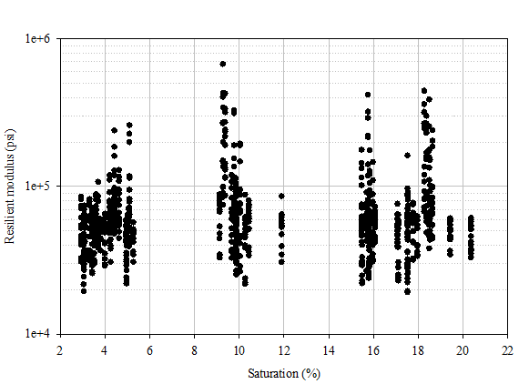
The RM tests followed AASHTO T-307 (AASHTO Technical Subcommittee: 1a, Soil and Unbound Recycled Materials 2017) (Seely 2024). The tests were performed on LCC with dry densities ranging from 303 to 333 kg/m³ using a calibrated GeoComp LoadTrac II load frame in conjunction with a three-phase stepper motor cyclic actuator and a Cyclic-RM Actuator Controller. The test specimen was placed in a triaxial cell and isolated with a latex rubber membrane. The triaxial cell was placed and centered in a load frame, and the cell pressure was controlled by regulated compressed air through the Cyclic-RM Actuator Controller. The deviator stress was applied from the three-phase stepper motor cyclic actuator, which the Cyclic-RM Actuator Controller also controls. The displacement measurements are taken with two linear displacement transducers to compute the axial strain from the applied deviatoric stress. The deviator load is a haversine-shaped load pulse for 0.1 seconds followed by a 0.9-second rest period. The RM tests were performed under a nominal range of confinement from 21 to 138 kPa and a nominal deviatoric stress range from 21 psi to 276 kPa, typical test ranges for base and subbase materials. The confining pressure and deviator stresses varied from an initial conditioning sequence, 0, followed by 15 additional test sequences. The average RM measured was 489 MPa, with a maximum of 4627 and a minimum of 131 MPa. The data indicate an increase in RM values with increased confining stress, deviatoric stress, and dry unit weight, which was expected.
Figure 11. Plot of Resilient Modulus vs saturation for LCC.
The average RM of 489 MPa is comparable to the compacted granular materials results of Davich et al. (2004). We note that the RM results did not correlate significantly with the degree of saturation (Fig 11). These favorable RM results suggest that LCC's stiffness is not significantly affected by the presence of water in the LCC matrix. Thus, LCC can be used as a base or subbase material over the saturation and stress conditions typically experienced by base and subbase materials in pavement systems.

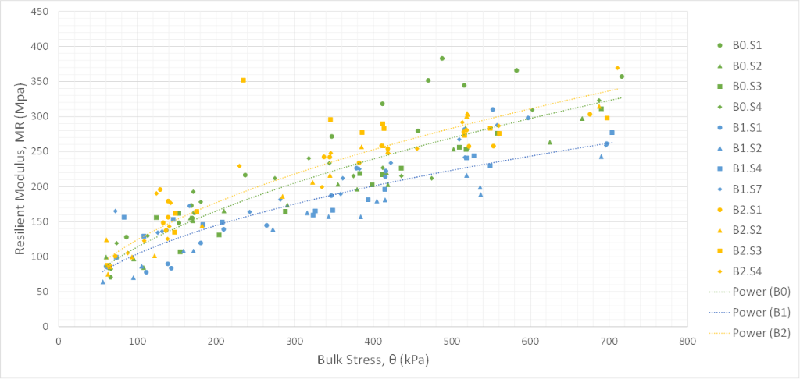
Resilient Modulus Testing of PLCC

We also performed RM testing of PLCC specimens with cast densities of 400 and 480 kg/m³ using the test protocols and methods used for LCC. The average RM value at a bulk stress of 100 kPa is about 110 MPa, and 320 MPa at a bulk stress of 700 kPa for a slightly nonlinear relationship (Fig. 12). The average RM for all tests is about 240 MPa at a bulk stress of 400 kPa. Therefore, we conclude that the RM for PLCC is about 50 percent of the RM values obtained for LCC, on average, for relatively unsaturated conditions. Nevertheless, PLCC RM values are comparable to or greater than coarse sand at bulk stress values of 100 kPa or higher (Bartlett et al. 2024).
Figure 12 Relation of Resilient Modulus and Bulk Stress for PLCC specimens

Freeze-Thaw Testing of LCC
Ni et al. (2020) suggest that LCC has good freeze-thaw resistance because circular voids restrain frozen water's expansion forces. Tikalsky et al. (2004) conclude that LCC's freeze-thaw characteristics depend on the initial penetration depth, absorption, and absorption rate for 28-day compressive strengths. One of the mixtures in this study (M3) classifies as a lightweight cellular concrete with an oven-dried density of 370 kg/m³ with a 28-day cure UC strength of 1,090 KPa. This mixture showed excellent freeze-thaw resistance through 300 cycles. The 24-hour and 28-day absorption rates were 15 and 24% by volume. Other mixes with poorer freeze-thaw resistance generally had high absorption (as high as 80% by mass) and low early-age compressive strength.

Freeze-Thaw Testing of PLCC
When freeze-thaw testing was performed in damp conditions according to ASTM D560 Standard Test Methods for Freezing and Thawing Compacted Soil-Cement Mixtures, all densities had excellent performance through 50 cycles, which is 4 times the test length used for comparable soil-cement. Under fully-saturated freeze-thaw cycling, only 35 pcf (560 kg/m³) samples were tested after 50 cycles.

Conclusions
This paper comprehensively evaluated the hydraulic properties of low-density cellular concrete (LCC) and permeable low-density cellular concrete (PLCC), focusing on their applicability in coastal area geotechnical, stormwater management and roadway systems constructed atop soft ground conditions. The results of laboratory and field tests underscore the stark contrast in performance between closed-cell LCC and PLCC in terms of permeability, water absorption, and buoyant uplift potential.
Closed-cell LCC exhibited low to very low hydraulic conductivity, typically ranging from 9.6×10⁻⁸ to 1.0×10⁻⁶ m/s, classifying it as a low-permeability material. This classification makes LCC unsuitable for applications requiring substantial flow, drainage, or water storage. However, its limited permeability may offer advantages in cases where restricted water movement is desired, such as in embankments, levees, roadways, and reclaimed ground, provided buoyancy forces are adequately counteracted. The laboratory results confirmed that the hydraulic conductivity of LCC decreases with increasing dry density, while modest confining pressures also slightly reduce flow rates.
While LCC may serve niche applications requiring low permeability and hydraulic isolation, PLCC offers a more versatile and high-performing solution for decentralized stormwater management and geotechnical stabilization, meriting further research into long-term filtration performance and compatibility with geosynthetics. For example, PLCC demonstrated significantly higher hydraulic conductivity, water absorption capacity, and infiltration rates. With hydraulic conductivities as high as 1.48×10⁻³ m/s and absorption capacities exceeding 50%, PLCC is well-suited for stormwater detention, infiltration, and filtration applications. Case studies, including the Mission Rock Project and Louis Armstrong International Airport, illustrate PLCC's utility in managing hydrostatic uplift pressures and accommodating subsurface flow, particularly in areas susceptible to sea level rise or with compressible subgrades.
Pilot testing for the Mission Rock Project further validated PLCC's structural integrity and performance under real-world conditions and hydrostatic uplift pressures. The goals of the Pilot were to demonstrate construction methods and materials related to PLCC placement and its ability to support heavy vehicle loads (i.e., standard SF Fire Department Fire Truck) and excavation and repair of a typical water line. Moreover, other studies suggest a promising role in improved stormwater quality due to PLCC's heavy metal adsorption capacity.
In addition, this paper presents the mechanical and durability properties of LCC and PLCC. The test data demonstrate LCC offers a favorable balance between ultra-low density and structural performance. LCC exhibited compressive strength gain up to 70 days of curing, reaching an average compressive strength of 990 kPa. Our data on LCC specimens suggests near zero cohesion and an effective friction angle of 65° for partially saturated conditions as a reasonable mean estimate for cases between 10 and 80 kPa confinement. This relatively high drained friction angle supports the suitability of LCC for applications requiring frictional resistance without reliance on cohesive strength. However, for some systems, direct shear or direct, simple shear testing may be appropriate (e.g., retaining wall reinforcement, sliding, and slope stability) due to the potential for anisotropy in the shear resistance. Further, we found a mean Poisson's ratio of 0.23, which equates to an at-rest lateral earth pressure coefficient of 0.30. These mean values are recommended for design for all degrees of saturation.
The resilient modulus (RM) values for LCC averaged 489 MPa and were not sensitive to changes in saturation levels. An LCC mix with an oven-dried density of 370 kg/m³ with a 28-day cure UC strength of 1,090 Kpa showed excellent freeze-thaw resistance through 300 cycles (Tikalsky et al., 2004). While exhibiting lower RM values (average 240 MPa), PLCC maintained structural integrity during 50 cycles of freeze-thaw testing in saturated states, suggesting good freeze-thaw performance. However, more testing may be appropriate. Also, the higher hydraulic conductivity and water retention capacity make PLCC suitable for stormwater drainage and filtration functions. It may be beneficial where heavy metal sequestration, subterranean water flow, storage, and infiltration are required. Future research should explore PLCC's long-term field performance, filtration efficiency in pollutant-laden environments, and optimization of mix designs for targeted functional outcomes.
Overall, both LCC and PLCC present robust and sustainable solutions for coastal and pavement applications, particularly in environments challenged by consolidation settlement, bearing capacity issues, soft subgrades, variable saturation, and freeze-thaw exposure. We believe that LCC is a suitable base and subbase material for roadway and other systems. However, in roadway applications, we believe PLCC should be limited to a subbase material because of its lower RM values.

References
AASHTO Technical Subcommittee: 1a, Soil and Unbound Recycled Materials. 2017. T 307-99 Standard Method of Test for Determining the Resilient Modulus of Soils and Aggregate Materials. Washington D.C.: AASHTO.
Alimohammadi V., Maghfour M., Nourmohammadi D., Azarsa P. Gupta R., Saberian M. 2021. Stormwater Runoff Treatment Using Pervious Concrete Modified with Various Nanomaterials: A Comprehensive Review, Sustainability 2021, 13(15), 8552; https://doi.org/10.3390/su13158552.
American Concrete Institute (ACI), Guide for Cast-in-Place Low-Density Cellular Concrete, 2006. ACI 523.1R-06.
Amran M., Onaizi A. M., Fediuk R., Danish A., Vatin N. I., Murali G., Abdelgader H.S., Mosaberpanah M.A., Cecchin D., Azevedo A. 2022. An Ultra-Lightweight Cellular Concrete for Geotechnical Applications - A Review, Case Studies in Construction Materials, Volume 16.
Amran, Y. H. M., N. Farzadnia, and A. A. Abang Ali. 2015. "Properties and applications of foamed concrete; a review." Construction and Building Materials, 101: 990–1005. https://doi.org/10.1016/j.conbuildmat.2015.10.112.
Anderson J., Bartlett, S. F., Dickerson N., and Poepsel P., 2012, Development of Seismic Design Approach for Freestanding Freight Railroad Embankment Comprised of Lightweight Cellular Concrete, ASCE GeoCongress 2012: State of the Art and Practice in Geotechnical Engineering https://doi.org/10.1061/9780784412121.177.
Armaghani, J.,2011. Structural Evaluation of Pervious Concrete on Cellular Lightweight Concrete (CLPC) Base, Global Sustainable Solutions, 27 p.
Averyanov, S. 2018. Analysis of Construction Experience of Using Lightweight Cellular Concrete as a Subbase Material. Thesis, University of Waterloo, 94 p.
ASTM C1701 / C1701M-17a. Standard Test Method for Infiltration Rate of In Place Pervious Concrete, ASTM International, West Conshohocken, PA, 2017.
ASTM D18 Committee. 2016. D5084-16a Test Methods for Measurement of Hydraulic Conductivity of Saturated Porous Materials Using a Flexible Wall Permeameter. ASTM International.
ASTM D3385-18 Standard Test Method for Infiltration Rate of Soils in Field Using Double-Ring Infiltrometer. ASTM International.
ASTM D2434-19. Standard Test Method for Permeability of Granular Soils (Constant Head). ASTM International.
ASTM D4491-23, Standard Test Methods for Water Permeability of Geotextiles by Permittivity, ASTM International, West Conshohocken, PA, 2023,
Averyanov S. 2018. Analysis of construction experience of using lightweight cellular concrete as a subbase material. Thesis. University of Waterloo, 94 p.
Bartlett, S. F., Peters, S. Arulmoli, A., 2020a. Mission Rock Lightweight Cellular Concrete Technical Advisory Panel (TAP) Technical Review Report (Addendum) Vol. 1 – Main TAP Report, 120 p.
Bartlett, S. F., Peters, S. Arulmoli, A., 2020b. Response to Comments and Questions Memo, dated June 25, 2020, on the Mission Rock LCC Technical Advisory Panel Review Report. Attachment 1.
Bartlett, S. F., Camargo-Gontscharow, T., Huang Y., 2024. Development of a Stormwater Detention/Infiltration System for Urban Highways Using Permeable Lightweight Cellular Concrete, Phase I, Technical Report for Project ID: 2021-UU-01, National Center for Transportation Infrastructure Durability & Life-Extension, 175 p.
Davich, P., J. Labuz, B. Guzina, and A. Drescher. 2004. Small Strain and Resilient Modulus Testing of Granular Soils. 117. St. Paul, Minnesota: Minnesota Department of Transportation.
Inti, S., Evans, T. W., Flores, M., Solanki, J.S., Chandramouli, C. V., 2021. Permeable Low-Density Cellular Concrete (PLDCC) as a Replacement for Aggregate Layers in Permeable Parking Lots, Development in the Built Environment, 2021.
Kozłowski, M., and M. Kadela. 2018. "Mechanical characterization of lightweight foamed concrete." Advances in Materials Science and Engineering, 2018: 1–8. https://doi.org/10.1155/2018/6801258.
Martemianov D., Xie B.-B., Yurmazova T., Khaskelberg M., Wang F., We C.-H. i, Preis S. 2017. Cellular concrete-supported cost-effective adsorbents for aqueous arsenic and heavy metals abatement, Journal of Environmental Chemical Engineering, Volume 5, Issue 4, 2017, Pages 3930-3941, ISSN 2213-3437, https://doi.org/10.1016/j.jece.2017.07.063.
Masloff B. and Palladino R. 2012. Lightweight Drainable Cellular Concrete. Patent No. US 8,172,937 B2.
Masloff, B., Feller, J. and Gomez, M., 2022. Low Buoyancy Cellular Concrete, U.S. Patent Application Publication US2022/0048817. Feb. 17, 2022.
Narayanan, N., and K. Ramamurthy. 2000. Structure and properties of aerated concrete: a review. Cement and Concrete Composites, 22 (5): 321–329. https://doi.org/10.1016/S0958-9465(00)00016-0.
Ni F. M., Oyeyi A.G. and Tighe S. 2020. The potential use of lightweight cellular concrete in pavement application: a review, International Journal of Pavement Research and Technology 13 (2020) 686-696.
Panesar, D. K. 2013. Cellular concrete properties and the effect of synthetic and protein foaming agents, Constr. Build. Mater. https://doi.org/10.1016/j. conbuildmat.2013.03.024.
Seely, D.D.B., 2024. Engineering Behavior of Type I Lightweight Cellular Concrete and the Effects of Partial Saturation and Confinement, Dissertation, Dept. of Civil and Environmental Engineering, University of Utah, 201 p.
Sutmoller N., Gomez M., and Kevern J. 2019. Soft Soil Remediation with Permeable Low-Density Cellular Concrete (PLDCC), MATEC Web of Conferences 271, 02002 (2019), Tran-SET 2019, https://doi.org/10.1051/matecconf/201927102002.
Sutmoller N., and Gomez M. 2022. An Introduction to Low-Density Cellular Concrete and Advanced Engineered Foam Technology - NAT2022. Society for Mining, Metallurgy & Exploration, 2022.
Taylor S., and Halsted G., Guide to Lightweight Cellular Concrete for Geotechnical Applications, 2021. PCA Special Report SR1008P, National Concrete Pavement Technology Center, 58 p.
Tikalsky P.J., Pospisil J., MacDonald W. 2004. A method for assessment of the freeze-thaw resistance of preformed foam cellular concrete. Cement and Concrete Research 34 (2004) 889–893
Tiwari B., Ajmera B., Maw R., Cole R., Villegas, D. and Palmerson, P., 2017. Mechanical Properties of Lightweight Cellular Concrete for Geotechnical Applications, J. of Mater. Civ. Eng. 2017, 29(7); 06017007.
Tiwari, B., Wykoff, J., and Villegas, D., 2020. Review of State of Practice – Use of Lightweight Cellular Concrete (LCC) Materials in Geotechnical Applications, California Nevada Cement Association, 68 p.
UMKC (University of Missouri Kansas City). 2018. Basic Characterization of Permeable Concrete. Report presented to Aerix Industries.
U.S. Environmental Protection Agency. 2012. "Cool Pavements." In: Reducing Urban Heat Islands: Compendium of Strategies. Draft. https://w—ww.epa.gov/heat-islands/heat-island-compendium.

